**VNjd; Njhl;lk;**

VNjd; Njhl;lj;jpNy Njtd; jhd; rpU\;bj;j Mjhk; Vthis nfhz;LNgha; itj;jhh;. mJkl;Lky;yhky; mq;Nf Njtd; thrkhAk; ,Ue;jhh;. VNjd; vd;gJ kdpjh;fs; kj;jpapNy Njtd; thrkhapUf;f cz;lhf;fg;gl;l ,lkhFk;. me;j VNjdpypUe;Jnfhz;L MjhKk; VthSk; mth;fsJ re;jjpaiuAk;> G+kpapd; rfy kpUf[Ptd;fisAk;> g+kpapd; rfy epakq;fisAk; Mz;Lnfhs;s Ntz;Lk; vd;gNj NjtDila jpl;lkhf ,Ue;jJ. me;j VNjd; Njhl;lk; vq;Nf ,Ue;jJ? me;j Njhl;lk; ,d;dKk; ,Uf;fpd;wjh? vd;gJ Fwpj;J fpwp];jth;fs; kj;jpapNy gy;NtW fUj;Jf;fs; ,Uf;fpd;wJ. me;j VNjd; vq;Nf ,Ue;jJ vd;W ehk; ,g;NghJ ghh;g;Nghk;.

VNjd; vq;fpUf;fpd;wJ vd;gJ Fwpj;J ehk; Vd; ghh;f;fNtz;Lk;? kDf;Fyj;jpd; Njhw;wk; vd;gJ VNjdpNy Muk;gpj;jJ. kDf;Fyj;jpd; tPo;rpAk; VNjdpNyjhd; ele;jJ. NjtDila ,ul;rpg;gpd; jpl;lk; vd;gJ kPz;Lk; VNjidAk; kdpjidAk; gioa epiyf;F jpUg;GtNjahFk;. Mjhikf; nfhz;L Njtd; vd;d jpl;lj;ij itj;jpUe;jhNuh mNj jpl;lj;ij gpe;jpd Mjhkhfpa ,NaRtpd; %yk; (1nfhhp:11:45) epiwNtw;w Njtd; rpj;jk; nfhz;lhh;. ,e;j ,ul;rpg;gpd; jpl;lNk Ntjhfkk; KOtJkhf nfhLf;fg;gl;bUf;fpd;wJ. NjtDila ,ul;rpg;gpd; jpl;lk; epiwNtWk;NghJ ,NaR ,uz;lhk; MjhkhfTk;> rig ,uz;lhk; VthshfTk; ,e;j VNjd; Njhl;lj;jpNy ,Ue;J mth;fs; ,ul;rpf;fg;gl;l Mjhkpd; re;jjpaiuAk;> g+kpapd; rfy [PtuhrpfisAk;> G+kpapd; rfy epakq;fisAk; Mz;Lnfhs;thh;fs;. NjtDila ,ul;rpg;gpd; jpl;lj;jpw;F %ykhf ,Ug;gJ VNjd; Njhl;lkhFk;. NjtDila ,e;j ,ul;rpg;gpd; jpl;lj;ij Ghpe;Jnfhs;tjw;F VNjd; vq;fpUe;jJ vd;gij mwpe;Jnfhs;Sjy; mtrpakhdjhFk;. vdNtjhd; ehk; Kjypy; VNjd; vq;fpUf;fpd;wJ vd;gij ghh;f;fg;Nghfpd;Nwhk;.

VNjd; vq;fpUe;jJ vd;gij vg;gb fz;Lgpbg;gJ. mij njhy;nghUs; Muha;rp %ykhf fz;Lgpbf;f KbAkh? tpQ;Qhdj;jpd; %ykhf fz;Lgpbf;f KbAkh? fz;bg;ghf KbahJ. Njtd; rk;ge;jg;gl;l fhhpaq;fis mtuJ thh;j;ijfs; %ykhfNt ehk; fz;Lgpbf;fNtz;Lk;. NjtDila thh;j;ijfs; Ntjj;jpNyjhd; nfhLf;fg;gl;bUf;fpd;wJ. ekf;F Njitahd vy;yh fhhpaq;fSk; me;j Ntjj;jpNy NjtDila thh;j;ijahf nfhLf;fg;gl;bUf;fpd;wJ. NjtDila thh;j;ijfshd Ntjj;jpd; trdq;fs; %ykhf VNjd; vq;Nf ,Uf;fpd;wJ vd;gijf; Fwpj;J ehk; Muhag;Nghfpd;Nwhk;.

**VNjdpd; Muk;gfhy ngah;:**

Njtd; Mjhk; VthSf;fhd Njhl;lj;ij cz;Lgz;Zfpd;wNghJ mjd; ngah; VNjd; my;y. Ntjj;jpy; vy;yh ngah;fSk; VNjh xU mh;j;jg; ngah;fshfNt (fhuzg; ngah;fs;) ngUk;ghYk; ,Uf;Fk;. xU mh;j;jKk; ,y;yhky; Ntjj;jpNy ngUk;ghYk; ve;j ngaUk; itf;fg;gl;bUf;ftpy;iy. VNjd; vd;gJk; fz;bg;ghf xU mh;j;jg; ngah; my;yJ fhuzg;ngauhfNt ,Ue;jpUf;f Ntz;Lk;. mh;j;jg; ngah; my;yJ fhuzg;ngah; vd;why; me;j ,lj;jpw;F itj;jpUf;Fk; ngahpd; mh;j;jj;ij Ghpe;Jnfhz;lhNy me;j ,lj;jpd; jd;ik (gpd;ddp) ekf;F njhpAk;gb ,Uf;Fk;. cjhuzkhf ehk; VNjhk; vd;w ngaiu ghh;f;fyhk;. VNjhk; vd;gjw;fhd vgpNua mh;j;jk; rpfg;G vd;gjhFk;. Vrh rptg;ghd gapw;wq;$Of;fhf jdJ Nr\;l Gj;jpughfj;ij myl;rpak; nra;jjhy; me;j rpfg;G gapw;wq;$opd; ngahpy; mtd; VNjhk; vd;W miof;fg;gl;lhd; (Mjp:25:30). Vrh rpte;j epwj;ij cilatd; (Mjp:25:25). MdhYk; mtdJ rpte;j epwj;jpd; fhuzkhf mtDf;F VNjhk; vd;w ngah; tutpy;iy. rptg;ghd gapw;wq;$opd; epkpj;jNk mtDf;F VNjhk; vd;W ngah; te;jJ. VNjhk; vd;wTld; mtd; me;j rpfg;ghd gapw;wq;$Of;fhf jdJ Kjw;Ngw;Whpikia tpl;Lf;nfhLj;jJjhd; Qhgfk; tUk;. mjdhy;jhd; mtDf;F VNjhk; vd;Wk; Ntjj;jpNy ngah; itf;fg;gl;lJ. ,e;j VNjhk; vd;gJ VrhTf;fhd xU fhuzg;ngauhFk;. mNjNghy VNjDk; xU fhuzngah;jhd;. VNjd; vd;gjd; mh;j;jk; vd;d? VNjd; vd;gjw;F vgpNua nkhopapy; ,d;gk;> Nghpd;gk; vd;W mh;j;jkhFk;. RNkhpa nkhopapy; VNjd; vd;gjw;F Gy;ntsp vd;W mh;j;jk;. VNjd; vd;w ,lkhdJ xU nropg;ghd Nghpd;gj;ij nfhLf;ff;$ba ,lkhf ,Ue;jjhy; nropg;ghd Gy;ntsp vd;W mh;j;jg;gLj;Jk; VNjd; vd;w ngah; RNkhpa nkhopapy; Kjypy; itf;fg;gl;bUf;fpd;wJ. mjd; gpd;dh; mNj mh;j;jk; nfhLf;Fk; mNj thh;j;ijapy; vgpNuaj;jpYk; miof;fg;gl;lJ.

,e;j VNjd; vd;w thh;j;ijahdJ [yg;gpusaj;jpw;F gpd;dh; te;j thh;j;ijahFk;. VNjd; vd;w thh;j;ij [yg;gpusaj;jpw;F Kd;dNu ,Ue;jpUe;jhy; me;j nkhopapd; mh;j;jNk ekf;F Ghpe;jpUf;fhJ. Vnddpy; [yg;gpusaj;jpw;F Kd;dh; ,Ue;j vy;yh nkhopfSk; ghNgy; NfhGuk; fl;lg;gl;lg; gpd;dh; mope;Jtpl;lJ. VNjd; vd;gjw;F gz;ila RNkhpa nkhopapYk;> vgpNua nkhopapYk; mh;j;jk; ,Ug;gjhy; VNjd; vd;w ngauhdJ [yg;gpusaj;jpw;F gpwF RNkhpa kw;Wk; vgpNua nkhopfs; Njhd;wpa gpwF mjw;F itf;fg;gl;l ngauhfNt ,Uf;fNtz;Lk;. Mjhk; fhyj;jpy; me;j Njhl;lj;jpw;F fz;bg;ghf VNjd; vd;w ngah; ,Ue;jpUf;fhJ. mg;NghJ Ngrg;gl;l nkhopapy; jhd; me;j Njhl;lj;jpw;F ngah; ,Ue;jpUf;Fk;. mJTk;$l Nghpd;gk;> nropg;ghd Gy;ntsp vd;gij Fwpf;Fk; mg;Nghija nkhopapy; xU fhuzg;ngauhfNt mjw;F itf;fg;gl;bUf;Fk;.

**Mjhk; Vths; Ngrpa nkhop vgpNuakh?**

rpyh; Mjhk; Vths; NgrpaNj vgpNua nkhopjhd; vd;Wk;> mjdhNy MjpKjy; vy;yh ngah;fSk; vgpNua nkhopapNyNa itf;fg;gl;bUe;JJ vd;Wk;> mjdhNy VNjd; vd;w ngaUk; me;j Njhl;lj;jpw;F Muk;gj;jpNyNa itf;fg;gl;bUf;fyhk; vd;Wk; NfhUfpd;whh;fs;. ghNgy; NfhGuk; fl;lg;gl;l gpwF xUtDila re;jjpah; Ngrpa ghi\ahdJ mth;fsJ %jhijah; ngahpNyNa miof;fg;gl;lJ. fhdhdpd; re;jjpah; Ngrpa nkhop fhdhdpa nkhopahFk;. mNjNghy vgpNua nkhopAk; VNgh; vd;gtdpd; re;jjpahy; Ngrg;gl;l nkhopNa MFk;. ahh; ,e;j VNgh;? VNgh; Nrkpd; ehd;fhk; jiyKiwahFk; (Mjp:11:10-14). ,e;j VNghpd; re;jjpapy; te;jtd;jhd; Mgpufhk;. mjdhNyNa Mgpufhk; $l vgpNuad; vd;Nw miof;fg;gl;lhd; (Mjp:14:13). VNgUf;F gpwFjhd; vgpNua nkhopNa Muk;gkhdJ. Mk; VNghpd; re;jjpah; Ngrpa nkhopNa vgpNua nkhop. mg;gbapUf;Fk;NghJ me;j vgpNua nkhop vg;gb [yg;gpusaj;jpw;F Kd;dh; ,Ue;jpUf;f KbAk;? fz;bg;ghf vgpNua nkhop [yg;gpusaj;jpw;F Kd;dh; ,Ue;jpUf;f tha;g;gpy;iy. NkhNr fhyj;jpy; ,];uNayh;fs; Ngrpa nkhop vgpNua nkhop. vdNt NjtdJ thh;j;ijfs; ,];uNayh;fSf;F GhpAk;gb vgpNua nkhopapy; nfhLf;fg;gl;lJ. fhuzg;ngah;fs; vy;yhk; (mJ egUila ngauhf ,Ue;jhYk;> CUila ngauhf ,Ue;jhYk;) vgpNua nkhopapNyNa khw;wp mh;j;jk; khwhky; nfhLf;fg;gl;bUe;jJ. gioa Vw;ghl;by; ve;j Chpd; ngaUk;> kdpjh;fspd; ngaUk; [yg;gpusaj;jpw;F Ke;ja nkhopapy; ,Uf;ftpy;iy. vgpNua nkhopapy; nkhopahf;fk; nra;Nj Njtdhy; nfhLf;fg;gl;lJ.

Njtd; NkhNrf;F Kjy; Ntjhfkj;ij nfhLf;Fk;NghJ Mjhk; Vths; ,Ue;j Njhl;lk; vq;fpUe;jJ vd;W ,];uNayh;fs; Ghpe;Jnfhs;tjw;fhf mth;fs; fhyj;jpy; ,Ue;j Chpd; ngaiuNa itj;J mth;fSf;F Ghpaitj;jhh;. (c-k;) Mjhk; gilf;fg;gl;lNghJ Mtpyh Njrk; vd;W xU Njrk; ,y;iy. Mtpyh vd;gtd; $\pd; kfdhthd;. mtd; gpwe;j gpd;dh;> ghNgy; NfhGuk; fl;lg;gl;l gpd;dh;jhd; mtdJ re;jjpapdh; FbNawp Mtpyh NjrNk cUthfpaJ (mNjNghyj;jhd; mrPhpa NjrKk;). ,e;j Mtpyh Njrk;> mrPhpa Njrq;fnsy;yhk; Mjhkpd; fhyj;jpNy ,y;yNt ,y;iy. Mdhy; NkhNr fhyj;jpNy ,Ue;jJ. Mdhy; Mjhk; fhyj;jpy; ,Ue;j igNrhd; MW NkhNr fhyj;jpy; ,y;iy. Mjhk; fhyj;jpy; ,Ue;j Mdhy; NkhNr fhyj;jpy; ,y;yhj igNrhd; MwhdJ vq;Nf XbaJ vd;gij Njtd; NkhNrf;Fk;> ,];uNayh;fSf;Fk; tpsf;Ftjw;fhf xU cf;jpia Ntjj;jpNy ifahs;fpd;whh;. NkhNr fhyj;jpy; ,Ue;j xU ,lj;ij itj;J NkhNr fhyj;jpy; ,y;yhj igNrhd; MW vt;topahf XbaJ vd;gij tpsf;FtNj me;j cf;jp MFk;. mg;gb nrhd;dhy;jhd; Mjhk; fhyj;jpy; igNrhd; ejp vq;Nf XbaJ vd;gij NkhNrf;Fk; ,];uNay; [dq;fSf;Fk; Ghpaitf;f KbAk;. mjdhy;jhd; igNrhd; MwhdJ NkhNr fhyj;jpy; ,Ue;j Mtpyh Njrj;ij Rw;wp XbaJ vd;W Njtd; Ntjj;jpNy $Wfpd;whh;.

VNjd; vd;gJ NkhNr fhyj;jpy; ,Ue;j xU ,lj;jpd; my;yJ Njrj;jpd; ngauhFk;. Nghpd;gk; nfhLf;ff;$ba> Gy;ntspfs; epiwe;j gFjpahf ,Ue;jjhy; me;j Njrj;jpw;F VNjd; vd;W ngah; itj;jpUe;jhh;fs;. NkhNr fhyj;jpy; kl;Lky;y mjw;F gpwFk; gy E}w;whz;Lfs; me;j ,lkhdJ VNjd; Njrk; vd;W toq;fg;gl;L te;jpUf;fpd;wJ. jPU uh[h fhykhfpa fp.K.Mwhk; E}w;whz;L tiu VNjd; vd;w ngahpy; me;j Njrk; ,Ue;jpUf;fpd;wJ (vNr:28:13). Mjhk; Vths; thrkhapUe;j Njhl;lkhdJ> NkhNr fhyj;jpy; ,Ue;j> VNjd; Njrj;jpy; ,Ue;j> xU Njhl;lkhf ,Ue;jjhy; Njtd; me;j Njhl;lj;ij Fwpj;J $Wk;NghJ mij VNjd; Njrj;jpy; cs;s xU Njhl;lk; vd;W nghUs;gLk;gb mij VNjd; (Njrj;jpd;) Njhl;lk; vd;W $Wfpd;whh;. mjdhNy VNjd; Njhl;lk; vd;w ngah; Mjhk; Vths; rpU\;bf;fg;gl;lNghNj mjw;F ,Ue;j ngah; vd;W ehk; vz;zNtz;lhk;. Mjhk; Vths; tho;e;j Njhl;lkhdJ NkhNr fhyj;J VNjd; Njrj;jpy; ,Ue;jJ vd;gij tpsf;Ftjw;fhfNt Ntjk; mij VNjd; Njhl;lk; (vNjd; Njrj;jpypUe;j Njhl;lk;) vd;W $Wfpd;wJ.

**VNjd; Njrk;**

VNjd; Njhl;lk; vq;fpUe;jJ vd;gij ehk; fz;Lgpbf;f Ntz;Lnkd;why; mJ ,Ue;j VNjd; Njrk; vq;fpUe;jJ vd;gij Kjypy; ehk; fz;Lgpbf;f Ntz;Lk;. Ntj trdq;fspd; mbg;gilapy; VNjd;Njrk; vq;fpUe;jJ vd;gij ehk; ,g;NghJ ghh;g;Nghk;.

**Vrh:37:12@ 2uh[h:19:12** “*vd; gpjhf;fs; mopj;Jtpl;l NfhrhidAk;> MuhidAk;> Nuj;Nrg;igAk;> njyhrhhpypUe;j VNjdpd; Gj;jpuiuAk; mth;fSila Njth;fs; jg;Gtpj;jJz;Nlh?”* vNrf;fpah uh[htpd; fhyj;jpy; mrPhpah uh[hthfpa rdnfhpg; vUrNyk; kPJ gilnaLj;jNghJ mtDila jsgjpahd ug;rhf;Nf nrhd;d thh;j;ijNa Nkw;nrhd;d trdq;fshFk;. vNrf;fpah uh[htpd; fhyk; fp.K.700 MFk;. mrPhpa uh[;[pak; mg;NghJ ty;yurhf ,Ue;jJ. rdnfhpg;gpd; Kd;Ndhh;fs; fhyj;jpypUe;Nj mth;fs; ty;yurhfNt ,Ue;jpUf;fpd;whh;fs;. mijNa rdnfhpg;gpd; jsgjpahd ug;rhf;Nf ,q;F jpkpNuhL $Wfpd;whd;. mth;fspd; Kd;Ndhh;fs; ve;j Njrq;fisnay;yhk; mopj;jhh;fs; vd;W ,q;F $Wfpd;whd;. mth;fs; mopj;j Njrj;jpy; VNjDk; xd;W. VNjdpd; Gj;jpuh; vd;W $wg;gl;bUg;gjhy; mJ xU jdpegUila ngah; vd;W vz;zNtz;lhk;. xU Njrj;ij Fwpj;J $Wtjw;fhd Ntjhfk nkhopeiljhd; mJ. ,e;j trdj;jpd; %yk; ehk; vd;d mwpe;Jnfhs;syhk;? rdnfhpg;gpd; Kd;Ndhh;fs; VNjd; Njrj;ij ifg;gw;wp mij jq;fSila uh[;[paj;Jld; ,izj;jpUf;fpd;whh;fs;. NkhNr fhyj;jpypUe;j mNj VNjd; Njrk; vNrf;fpah uh[h fhyj;jpYk; ,Ue;jpUf;fpd;wJ. vNrf;fpah uh[h fhyj;jpy; mrPhpa uh[;[paj;jpw;Fl;gl;l me;j gFjpahfj;jhd;; me;j VNjd; Njrk; ,Ue;jpUf;fpd;wJ vd;gij ug;rhf;Nfapd; thf;fpaj;jpypUe;J ehk; Ghpe;Jnfhs;syhk;. ug;rhf;Nf fhy mrPhpa uh[;[pakhdJ ,d;iwa vfpg;jpd; xU gFjp> <uhd;> <uhf;> JUf;fpapd; xU gFjp> rphpah> nygdhd;> ,];uNay; (rkhhpah) Mfpatw;iw cs;slf;fpajhf ,Ue;jJ. vdNt VNjd; NjrkhdJ mrPhpah uh[;[paj;jpw;Fl;gl;l ,e;j Njrq;fSf;Fs;jhd; ,Uf;fNtz;Lk; vd;gNj Ntj trdq;fs; %ykhf VNjd; Njrj;ijf; Fwpj;J ehk; fz;Lgpbj;j Kjy; jftyhf ,Uf;fpd;wJ. vdNt ehk; VNjd; Njrj;ij mrPhpa uh[;[paj;jpd; tiuglj;jpw;F ntspNa cs;s Njrq;fspy; NjlNtz;ba mtrpakpy;iy.

**MNkh:1:5 – ngj;VNjd;** **(*Beth-Eden):*** *“ehd; jk];Ftpd; jho;g;ghis cilj;J> Fbfis MNtd; vd;Dk; gs;sj;jhf;fpYk;> nrq;Nfhy; nrYj;Jfpwtidg; ngj;VNjdpYk; ,uhjgbf;Fr; rq;fhuk;gz;ZNtd;”* jk];Ftpd; ghuj;ijf; Fwpj;J $Wk;NghJ MNkh]; jPh;f;fjhprp “ngj;VNjd;” vd;w thh;j;ijia gad;gLj;Jfpd;whh;. “ngj;VNjd;” (*Beth-Eden)* vd;gjw;F “VNjdpd; tPl;lhh;” vd;W mh;j;jk;. mjhtJ VNjd; Njrj;jhh; vd;W mh;j;jkhFk;. MNkh]; fhyj;jpy; jk];FthdJ VNjd; VNjd; Njrj;jij Mz;Lnfhz;bUe;jJ (nrq;Nfhy; nrYj;jpf;nfhz;bUe;jJ). Ntjj;jpy; $wg;gl;l jk];F vd;gJ Muhk; lkh];f]; uh[;[pak; vd;W tuyhw;wpy; miof;fg;gLfpd;wJ (Kingdom of Aram-Damascus). ,e;j uh[;[pakhdJ fp.K.1200- fp.K.732 tiu ,Ue;jJ. mJ ,d;iwa rphpahtpd; jiyefuhfpa jk];Fit R+o;e;jpUe;j uh[;[pakhFk;. ,J ,d;iwa rphpahtpd; njw;F gFjpapy; ,Ue;jJ. ,e;j uh[;[pak; mrNfy; (Hazael) fhyj;jpy; mjd; mjpfgl;r gug;gsit cilajhf ,Ue;jJ. ,tdJ fhyj;jpy; tlf;Nf ,d;iwa rphpahtpd; tlf;NfAs;s rpy gFjpfs;> njw;Nf ,];uNaypy; fypNyah fly;tiuAs;s gFjpfs;> Nkw;Nf vh;Nkhd; kiytiu ,tdJ MSiff;F cl;gl;ljhf ,Ue;jJ. mJ jpfpyhj;gpNyrhpdhy; KbTf;F nfhz;Ltug;gl;lJ (2uh[h:16:6-9). mjd; gpwF jk];F uh[;[pakhdJ ngj;VNjdpYk; ,y;iy. cyf tiuglj;jpYk; ,y;iy. jk];Ftpd; mopitf;Fwpj;J mjpypUe;J 30-40 tUlq;fSf;F Kd;ghfNt MNkh]; jPh;f;fjhprp ,e;j jPh;f;fjhprdj;ij $wpapUf;fpd;whh;. ,e;j trdj;jpypUe;J VNjd; NjrkhdJ Muhk; lk];f]; uh[;[paj;jpw;F cl;gl;l xU Njrk; vd;gJ ekf;F njhpatUfpd;wJ. VNjd; 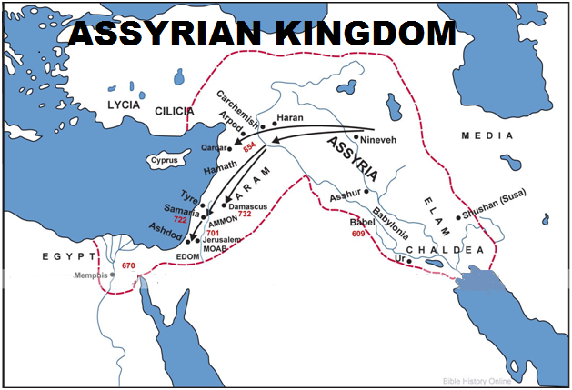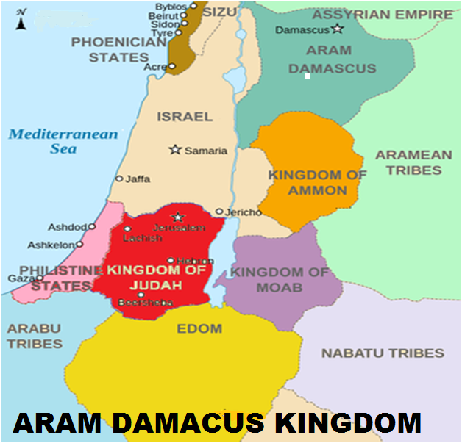NjrkhdJ mrPhpah Njrj;jpypUe;J ,g;NghJ Muhk; jk];F uh[;[paj;jpw;Fs; RUf;fg;gl;Ltpl;lJ. ehk; ,g;NghJ VNjd; Njrj;ij Muhk; jk];f]; uh[;[paj;jpw;Fs; kl;LNk NjlNtz;Lk;.

**vNr:28:13:** rPNjhd; vd;gtd; fhdhdpd; %j;j kfdhthd;. mtdJ re;jjpaNu jPU kw;Wk; rPNjhdpy; tho;e;Jte;jhh;fs;. jPUit rhh;e;jth;fs; tuyhw;wpy; gPdPrpah;fs; vd;W miof;fg;gLfpd;whh;fs;. mth;fs; kpfr;rpwe;j flNyhbfs;. mth;fs; cyfk; KOtJk; fg;gy;fis nrYj;jp tzpfk; nra;jjhy; jPU vd;w NjrkhdJ ituk;> it^hpaq;fshy; epiwe;jpUe;jJ. vNr:28:13y; jPU VNjdpypUe;jhd; vd;W $wg;gl;bUf;fpd;wJ. mjhtJ jPU uh[hTk; VNjid ifg;gw;wp itj;jpUe;jhd;. VNjdhdJ jPU uh[;[paj;jpw;F cl;gl;l xU Njrkhf ,Ue;jJ vd;W ,e;j trdk; $Wfpd;wJ. vNrf;fpNay; jPh;f;fjhprp fhyj;jpy; jPU uh[h VNjd; Njrj;ij cilatdhf ,Ue;jhd;.

vNr:28:14y; “eP fhg;ghw;Wfpwjw;fhf mgpN\fk;gz;Zg;gl;l NfUg;” vd;W $wg;gl;bUg;gjhy; ,ij VNjdpypUe;j rhj;jhd; vd;W gyUk; vz;Zfpd;whh;fs; (ehDk; xU fhyj;jpy; mt;thW gpurq;fNk nra;jpUf;fpd;Nwd;). ,g;gb $Wgth;fsplk; ehd; rpy Nfs;tpfis Kd;itf;fpd;Nwd;:

* vNrf;fpNay; 27k; mjpfhuj;jpd; Muk;gj;jpypUe;J jPUTf;fhd vr;rhpg;Gf; Fwpj;Nj $wg;gl;L tUfpd;wJ. 28k; mjpfhuj;jpy; jPUTf;fhd vr;rhpg;gpw;F gpwF rPNjhDf;fhd vr;rhpg;G Fwpj;J $wg;gl;bUf;fpd;wJ. ,ilapy; cs;s ,e;j trdq;fs; kl;Lk; vg;gb rhj;jhid Fwpf;Fk;. jPUTf;Fk; rPNjhDf;Fk; ,ilNa rhj;jhd; vg;gb te;jJ?
* 16k; trdj;jpy; “cd; tpahghuj;jpd; kpFjpahy; cd; nfhLik mjpfhpj;jJ” vd;W nfhLf;fg;gl;bUf;fpd;wJ. rhj;jhd; vd;d tpahghuk; nra;jhd;?

vdNt vNr:28y; $wg;gl;bUg;gJ rhj;jhd; my;y. mg;gbahdhy; Nf&g; vd;W $wg;gl;bUf;fpwNj> Nf&g; vd;why; thdJ}jh;fis my;yth Fwpf;Fk; vd;W rpyh; Nfl;fyhk;. Xt;nthU Njrj;jpw;Fk; Njtd; xU ghJfhty; J}jid (Nf&g;)

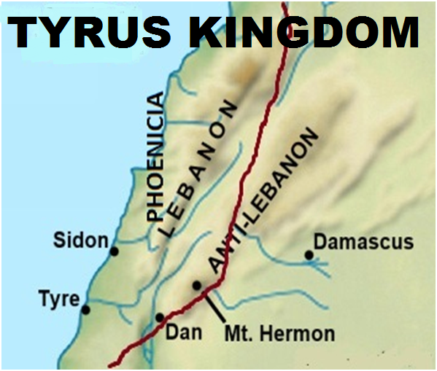 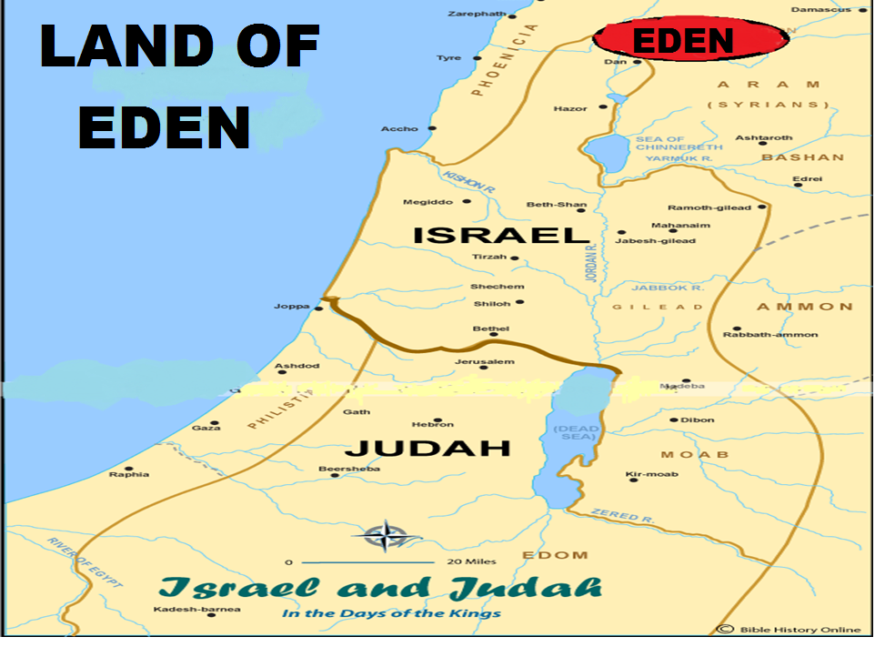

Vw;gLj;jpapUf;fpd;whh;. me;j ghJfhty; J}jd; me;je;j Njrj;jpd; ghJfhty; rk;ge;jg;gl;l Ntiyia nra;thd;. xU Njrj;jpd; ghJfhty; J}jidg; Nghd;W ghJfhty; nra;Ak; Ntiyia jPUTk; nra;jjhy; Nf&g; vd;W Ntjk; jPU Njrj;ij miof;fpd;wJ. ve;j Njrj;ij ghJfhf;Fk; Ntiyia jPU nra;jJ? jPU NjrkhdJ ,];uNaypd; tl vy;iyapy; ,Ue;jJ. vdNt tlf;fpypUe;J ,];uNay; kPJ ve;j jhf;FjYk; tuhjgbf;F ,];uNaypd; tlvy;iy fhtyd; Ntiyia jPU nra;jjhy; Ntjk; mij Nf&g; vd;W miof;fpd;wJ. Mk; jPU ,];uNay; Njrj;jpd; Nf&gPd; J}jdhf nrayhw;wpajhy; mt;thW miof;fg;gl;lJ. mjdhy; ,e;j trdj;ijf;nfhz;L mJ rhj;jhid Fwpf;Fk; trdk; vd;W ehk; fUjf;$lhJ. me;j jPU uh[;[paj;jpd; mjpfgl;rkhd gug;gsT tlf;Nf nga;Ul;> fpof;Nf vh;NkhDk; mij rhh;e;j gFjpfs;> njw;Nf fypNyahtpy; rpy gFjp Mfpatw;iw cs;slf;fpajhf ,Ue;jJ. jPU VNjdpypUe;jhd; vd;W $wg;gl;bUg;gjhy; VNjd; NjrkhdJ xU fhyj;jpy; jPU uh[;[paj;jpw;F cl;gl;l gFjpahf ,Ue;jJ vd;gJ ekf;F ,jd; %ykhf GhpatUfpd;wJ. vdNt ehk; VNjd; Njrj;ij ,e;j jPU uh[;[paj;jpw;Fs;Nsjhd; Njl Ntz;Lk;.

**njyhrhh;** - **Telassar (Vrh:37:12@ 2uh[h:19:12):** jPUTf;Fs;jhd; VNjd; ,Ue;jJ vd;gij $Wk; NtW xU trd Mjhuj;ijAk; jUfpd;Nwd;. “***njyhrhhpypUe;j VNjdpd; Gj;jpuiuAk; mth;fSila Njth;fs; jg;Gtpj;jJz;Nlh?”*** ,e;j trdj;jpypUe;J VNjd; Gj;jpuh; (VNjd; Njrk;) njyhrhhpypUe;jJ vd;W njhpatUfpd;wJ. njyhrhh; (Telassar) vd;gJ fpNuf;f %y thh;j;ijapypUe;J te;jjhFk;. Mjp fpNuf;fj;jpy; njyhrh (***Thalassa***) vd;why; fly; vd;W mh;j;jk;. fly; tzpfj;jpy; ty;yik ngw;wpUe;j jPU Njrj;jhiu (gPdPrpah;fs;) Fwpf;fTk;> mth;fs; jq;fpapUe;j gFjpfis Fwpf;fTk; gad;gLj;jg;gl;l fpNuf;f thh;j;ijNa njyhrh kw;Wk; njyhrh; vd;w thh;j;ijfshFk;. vdNt njyhrhh; vd;gJ flNyhbfshd fhdhdpd; %j;j kfdhfpa rPNjhdpd; re;jjpah; FbapUe;j jPU NjrkhFk;. me;j jPU Njrj;jpy; my;yJ jPU uh[;[paj;jpy; VNjd; ,Ue;jJ vd;gijNa “***njyhrhhpypUe;j VNjdpd; Gj;jpuiuAk;”*** vd;w trdk; ekf;F njhptpf;fpd;wJ.

VNjdhdJ jk];F uh[;[paj;JlDk; ,Ue;jUf;fpd;wJ. jPU uh[;[paj;JlDk; ,Ue;jpUf;fpd;wJ. mg;gbnad;why; ehk; vNjid ve;j uh[;[paj;jpw;Fs;jhd; NjlNtz;Lk;? VNjd; NjrkhdJ jPU uh[;[paj;jpw;Fk;> Muhk; lk];f]; uh[;[paj;jpw;Fk; ,ilgl;l gFjpahfNt ,Uf;fNtz;Lk; vd;w KbTf;F ehk; tuyhk;. me;j ,uz;L uh[;[paj;jpw;Fk; ,ilg;gl;l gFjp ,d;iwa nygdhd; kw;Wk; rPhpah vy;iyapy; cs;s Mz;b nygdhd; kiyj; njhluhFk; (Anti Lebanon Mountains). ,e;j kiyj;njhlUk; mij rhh;e;j gFjpfSNk VNjd; NjrkhFk;.

**VNjd; kiy (ghpRj;j gh;tjk;)**

VNjd; Njrj;ij ehk; Xustpw;F fz;Lgpbj;Jtpl;Nlhk;. mJ jPUTf;Fk;> jk];Ftpw;Fk; ,ilNa rhpahf ve;j ,lj;jpy; ,Ue;jJ vd;W mLj;jjhf ehk; ghh;f;fNtz;Lk;. Njtd; jPUit VNjdpNy ,Ue;jha; vd;W kl;Lk; $wtpy;iy. 13k; trdj;jpNy “ghpRj;j gh;tjj;jpy; cd;id itj;Njd;” vd;Wk; $Wfpd;whh;. mjhtJ jPU uh[;[pakhdJ ghpRj;j gh;tjj;ijak; cilatdhf ,Ue;jhd; vd;W Ntjk; $Wfpd;wJ. ghpRj;j gh;tjk; vd;whNy Njtd; thrk; nra;Ak; kiyahFk; (ghpRj;jh; thrk; nra;Ak; kiy). VNjd; Njrj;jpy; cs;s xU Njhl;lj;jpy; Njtd; Mjhk; Vthis nfhz;L itj;Jtpl;L> mth; mNj Njrj;jpy; cs;s gh;tjj;jpy; FbapUe;jhh;. Njtd; thrkhapUe;j me;j ghpRj;j gh;tjkhdJ VNjd; Njrj;jpy;> VNjd; Njhl;lj;jpw;F mUfhikapNyNa ,Ue;jJ VNjd; Njhl;lj;jpw;F ePiu nfhz;L te;j MwhdJ me;j kiyapy;jhd; cw;gj;jp MfpapUf;f Ntz;Lk;. jPU uh[;[paj;jpypUe;j ,e;j ghpRj;j gh;tjj;ij ehk; fz;Lgpbj;Jtpl;lhy; mjd; mUNf ,Ue;j VNjd; Njhl;lj;ij ehk; fz;Lgpbj;Jtplyhk;. me;j ghpRj;j gh;tjk; vq;Nf ,Uf;fpd;wJ vd;gij ehk; ,g;NghJ Muha;e;J ghh;g;Nghk;.

rPNahNd ghpRj;j gh;tjk; vd;W Ntjk; $Wfpd;wJ (rq;:2:6). vUrNykpw;Fk; rPNahd; vd;W ngaUz;L. Mdhy; vUrNyik jPU uh[;[pak; xUNghJk; Mshjjhy; vUrNyikj; jtpu rPNahd; vd;W NtW VjhtJ ,lkpUf;fpd;wjh vd;W Ntjj;jpy; Muha;e;J ghh;f;fNtz;Lk;. rq;:48:2y; rPNahd; gh;tjk; tljpirapy; ,Ug;gjhf $wg;gl;bUf;fpd;wJ. vUrNykpw;Fk; rPNahd; vd;W ngah; ,Ug;gjhy; mjw;F tlf;fpy; ,e;j rPNahd; ,Ug;gjhy; tljpir rPNahd; vd;W ,J miof;fg;gLfpd;wJ (tlf;fpy; fhrp vd;w Ch; ,Ug;gjhy; mNjNghd;W njw;Nf cs;s Ch; njd;fhrp vd;W miof;fg;gLtJNghy). vUrNykpw;F tlf;fpy; ,Ue;j rPNahd; vJ?

vh;Nkhd; jhd; Kjypy; rPNahd; vd;W miof;fg;gl;lJ. vh;NkhDk; rPNahDk; xd;Nw (cgh:4:47). *“Nahh;jhDf;F ,g;Gwj;jpy; #hpNahja jpirapy; mh;Ndhd; Mw;wq;fiuapYs;s MNuhNth; njhlq;fp* *vh;Nkhd; vd;Dk; rPNahd; kiytiuf;FKs;s NjrKk;”*. ,e;j trdj;jpy; “vh;Nkhd; vd;Dk; rPNahd; kiytiuf;FKs;s NjrKk;” vd;W $wg;gl;bUf;fpd;wJ. mjd;; mh;j;jk; vd;d? vh;NkhNd rPNahd; kiy vd;gJjhd; mjd; mh;j;jkhFk;. ,e;j rPNahd; kiyahfpa vh;Nkhd; kiyAk; ghpRj;j gh;tjk; vd;Nw Ntjj;jpy; miof;fg;gLfpd;wJ.

rpyh; cgh:4:47y; sion vd;Wjhd; nfhLf;fg;gl;bUf;fpd;wJ zion vd;W nfhLf;fg;gltpy;iy vd;W $Wthh;fs;. mg;gbgl;lth;fSf;fhf ,d;DnkhU trd Mjhuj;ijAk; ehk; ghh;g;Nghk;. rq;:133:3y; “vh;Nkhd; NkYk;> rPNahd; gh;tjq;fs;NkYk; ,wq;Fk; gdpf;Fk; xg;ghapUf;fpwJ” vd;W $wg;gl;bUf;fpd;wJ. “As the dew of Hermon, ***and as the dew*** that descended upon the mountains of Zion” vd;W mq;F Mq;fpyj;jpy; nfhLf;fg;gl;bUf;fpd;wj. Mq;fpyj;jpy; **“*and as the dew”*** vd;w thf;fpak; ,l;lhypf;]py; nfhLf;fg;gl;bUf;fpd;wJ. ,l;lhypf;]py; nfhLf;fg;gl;lhy; vd;d mh;j;jk;. Xhp[pdypy; ,y;iy. Ghpe;Jnfhs;tjw;fhf Nrh;f;fg;gl;l thf;fpak; vd;W mh;j;jk;. gy Mq;fpy Ntjhfkq;fspy; kjvy; ,l;lhypf;]py; nfhLf;fg;gl;l me;j thf;fpak; ePf;fg;gl;Nl nfhLf;fg;gl;bUf;fpd;wJ. me;j ,l;lhypf;]py; nfhLf;fg;gl;l thf;fpaj;ij epf;fptpl;L ghh;j;jhy; “As the dew of Hermon, that descended upon the mountains of Zion” vd;Wjhd; me;j thf;fpak; ,Uf;fNtz;Lk;. jkpopy; jtwhd nkhopngah;g;ghy; rPNahDk;> vh;NkhDk; jdpj;jdp kiyfs; vd;W jtwhf mh;j;jk; nfhs;sk;gb ,Uf;fpd;wJ. mjd; rhpahd nkhopahf;fkhdJ “rPNahd; gh;tjq;fspd; NkypUe;J ,wq;Fk; vh;Nkhdpd; gdpf;F xg;ghapUf;fpd;wJ” vd;WjhdpUf;f Ntz;Lk;. rPNahd; kiyapypUe;Jjhd; vh;Nkhdpd; gdp ,wq;Ffpd;wJ. vdNt rPNahDk;> vh;NkhDk; xd;Nw. Ntjj;jpy; rPNahd; vd;W miof;fg;gLk; gy ,lq;fspy; mJ vh;Nkhd; kiyiaNa Fwpf;f gad;gLj;jg;gl;bUf;fpd;wJ. vdNt vh;Nkhd;jhd; ghpRj;j gh;tjkhfpa VNjd; kiyahFk; (VNjd; Njrj;jpy; cs;s kiy).

,];uNaypd; cah;e;j kiyjhd; jdJ ghpRj;jkiy vd;W Ntjk; $Wfpd;wJ (vNr:20:40). Vh;Nkhd; kiyNa ,];uNaypy; kpf cah;e;jkiy (vUrNyk; kiy my;y). jPU ,Ue;j ghpRj;j kiy vd;gJ vh;NkhNd vd;gij ,e;j trdKk; cWjpnra;fpd;wJ.

VNdhf;F Gj;jfj;jpYk; ,e;j vh;Nkhd; kiyapNyNa thdJ}jh;fs; thrkhapUe;jhh;fs; vd;W $wg;gl;bUf;fpd;wJ. G+kpapy; kD\ Fkhuj;jpfis ngz;nfhz;l tpOe;JNghd J}jh;fs; ,e;j vh;Nkhd; kiyapypUe;Jjhd; ,wq;fp te;jhh;fs; vd;W VNdhf;F Gj;jfKk; $Wfpd;wJ. Njtd; thrkhapUe;j ,lj;jpy;jhd; thdJ}jh;fSk; thrkhf ,Ug;ghh;fs;. vh;Nkhd; kiyNa thdJ}jh;fs; thrkhapUe;j> Njtd; thrkhapUe;j ghpRj;j kiy vd;gjw;F Ntjj;jpw;F ntspNa cs;s Mjhuk; ,JthFk;.

Mjhk; ghtk; nra;Ak; Kd; Njtd; ,e;j ghpRj;j kiyahfpa VNjd; kiyapy; (vh;Nkhd; kiy> rPNahd; kiy) thrkhapUe;jhh;. ,J ,d;iwa Mz;b nygdhd; kiyapd; njd;gFjpapy; ,Uf;fpd;wJ. vh;Nkhd; kiyahdJ fhdhdpah;fSf;fhdJ. fhdhd; Njrk; ,];uNayh;fSf;F thf;Fjj;jk; nra;ag;gl;lJ. mJ NkhNr fhyj;jpNyNa ,];uNayh;fshy; Rje;jhpj;Jf; nfhs;sg;gl;l gh;tjkhFk; (cgh:3:8). mJNt ,];uNayh;fsJ tlf;F vy;iyahFk;. ,J rhpahf jPU uh[;[paj;jpw;Fk;> jk];F uh[;[paj;jpw;Fk; ,ilg;gl;l gFjpapy; ,Uf;fpd;wJ. mjdhy;jhd; mJ rpy rkak; jPU uh[;[paj;JlDk;> rpy rkak; Muhk; lk];f]; uh[;[paj;JlDk; ,Ue;jJ.

**VNjd; Njhl;lk;:**

VNjd; Njrj;ij fz;Lgpbj;Jtpl;Nlhk;. Mjhk; Vths; fhyj;jpy; Njtd; thrkhapUe;j ghpRj;j gh;tjkhfpa VNjdpd; kiyiaAk; ,g;NghJ ehk; fz;Lgpbj;Jtpl;Nlhk;. VNjd; Njhl;lj;ij ,g;NghJ ehk; fz;Lgpbf;f Ntz;Lk;. VNjd; Njhl;lkhdJ VNjd; Njrj;jpw;Fs;> vh;Nkhd; kiyf;F mUNfjhd; ,Ue;jpUf;f Ntz;Lk;. VNjDf;F jz;zPiu nfhz;L te;j MW vh;Nkhd; kiyapypUe;jjhd; cw;gj;jpahapUf;f Ntz;Lk;. Ntjk; fpof;Nfjhd; VNjd; Njhl;lk; ,Ue;jJ vd;W $Wfpd;wJ (Mjp:2:8). mJ NjtDf;F fpof;Nf> Njtd; thrk; nra;Ak; ,lj;jpw;F fpof;Nf vd;W ehk; Ghpe;Jnfhs;sNtz;Lk;. Mk; Njtd; jhd; thrk; nra;j vh;Nkhd; kiyf;F fpof;Nf VNjd; Njhl;lj;ij cUthf;fpapUe;jhh;. vh;Nkhd; kiyapd; fpof;Nf yPgNdhd; gs;sjhf;F ,Ue;jJ.

,d;iwa nygdhDf;Fk; Ntjhfk yPgNdhDf;Fk; tpj;jpahrk; cz;L. ,d;iwa nygdhd; Mz;b nygNdhd; kiyf;F Nkw;fhf cs;sJ. Ntjhfk yPgNdhd; vh;Nkhdpd; gs;sj;jhf;fpy;> vh;NkhDf;Ff; fPOk; (NahR:11:16)> Mz;b nygdhd; kiyj; njhlUf;F fpof;fhfTk; ,Ue;jJ. vh;NkhDf;F fpof;Nf ,e;j Ntjhfk yPgNdhd; gs;sjhf;fpy;jhd; VNjd; Njhl;lk; ,Ue;jJ. ,d;iwa Nfhyd; i`l; (Golan Heights) mUNfjhd; VNjd; Njhl;lk; ,Ue;jpUf;f Ntz;Lk;.

yPgNdhd; gs;sj;jhf;fpyjhd; VNjd; Njhl;lk; ,Ue;jJ vd;gjw;F NtW VjhtJ Mjhuk; ,Uf;fpd;wjh? NjtDila tdj;jpy; (vNjdpy;) NfJU kuq;fs; ,Ue;jJ vd;W $wg;gl;bUf;fpd;wJ (vNr:31:8>9). NfJU kuk; vd;whNy yPgNdhd; jhd;. vdNt yPgNdhd;jhd; NjtDila Njhl;lkhfpa VNjdhf ,Uf;f KbAk;. ,e;j vh;NkhDk;> yPgNdhDk; Ntjhfkj;jpd;gb ,];uNaYf;F cl;gl;lJk;> ,];uNaypd; tlf;F kw;Wk; tlfpof;F vy;iyahfTk; ,Ue;jJ.

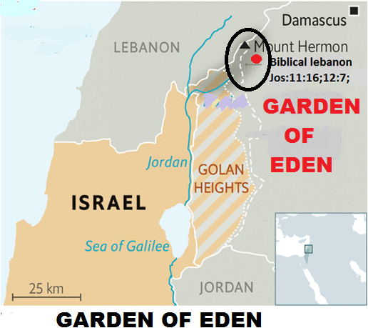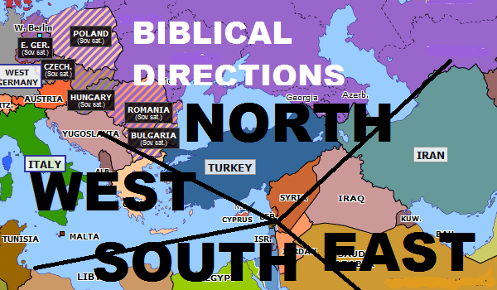

**Vh;Nkhid ikakhf nfhz;lNj Ntjhfk jpirfs;:**

Ntjhfkj;jpy; Njtd; thrkhapUe;j vh;Nkhd; kiyNa cyfj;jpd; ikakhfTk; mij mbg;gilahff; nfhz;Nl tlf;F> njw;F> fpof;F> Nkw;F vd jpirfs; mwpag;gLfpd;wd. ehk; fpof;Nf VNjd; Njhl;lk; ,Ue;jJ vd;W Kd;G ghh;j;Njhk;. vjd; fpof;Nf vd;W mjpNy $wg;gltpy;iy. mJ vh;Nkhd; kiyapd; fpof;Nf vd;W ehk; Ghpe;Jnfhz;Nlhk;. Vnddpy; Njtd; thrkhapUe;j vh;Nkhd; kiyNa (VNjNd) cyfj;jpw;fhd ikakhf ,Ue;jJ. ,ij Ntjj;jpy; $wg;gl;l jpirfs; %ykhf ehk; mwpe;Jnfhs;syhk;.

jhdpNay; 11k; mjpfhuj;jpy; fpNuf;f uh[hthd kfhmnyf;rhz;lh; Fwpj;J $wg;gl;bUf;fpd;wJ. mtdJ fhyj;jpw;F gpwF mtdJ uh[;[pak; “thdj;jpd; ehY jpirfspy; gFf;fg;gLk;” vd;W jhdp:11:4y; $wg;gl;bUf;fpd;wJ. ehd;fhf gphpf;fg;gl;lJ vd;W $wg;glhky; thdj;jpd; ehd;F jpirfspy; gphpf;fg;gl;lJ vd;W $wg;gl;bUf;fpd;wJ (thdk; vd;gJ VNjdpd; xU ngah; vd;gij Fwpj;J gpd;dh; tphpthf ghh;g;Nghk;). ,e;j gphptpd; %ykhf cyfj;jpd; ehd;F jpirfs; ekf;F NehpilahfNt tpsf;fg;gl;bUf;Fk;. kfh mnyf;];z;lUf;Fg;gpd; mtdJ uh[;[pak; mtdJ jsgjpfs; ehd;F NgUf;F gFf;fg;gl;lJ. mJ vg;gb gFf;fg;gl;lJ vd;W tuyhw;wpypUe;Nj ehk; njhpe;Jnfhs;s KbAk;. tlf;F uh[;[pakhd yprpNkf;f]; uh[;[pak; (Lysimachus – kf;fNjhdpah> gy;Nfhpah> JUf;fp mlq;fpa fUq;fliy xl;b cs;s uh[;[pak; - Pergamene Kingdom). Nkw;F uh[;[pak; fh]d;lh; uh[;[pak; (cassander - Greace). fpof;F uh[;[pak; nrY}f;f]; (seleucus – rphpah Kjy; ,e;jpah tiu) uh[;[pak;. jhykpapd; (Ptolemy- vfpg;J) njw;F uh[;[pak;. ,e;j ehd;F gphpTfSk; Ntjhfk jpirfspd; mbg;gilapNyNa gphpf;fg;gl;lJ. mnyf;rhz;lUf;F gpwF mtdJ uh[;[pakhdJ ehd;F jpirfshf gphpf;fg;gl;l fhhpakhdJ> Ntjhfkj;jpy; vh;NkhidAk;> VNjidAk; ikakhf itj;Nj jpirfs; gphpf;fg;gLfpd;wd vd;gij cWjpgLj;Jfpd;wJ. vh;Nkhd; kw;Wk; VNjNd cyfj;jpd; ikak; vd;gij NtW rpy trdq;fs; %ykhfTk; ehk; cWjpgLj;JNthk;.

**fpof;F:** Nfjhh; vd;gJ Nahh;jhd; Mw;wpw;F fpof;fhf ,Uf;fpd;w ,d;iwa N[hh;ld; ehl;by; mlq;fpa gFjpahFk;. NtjkhdJ NfjhiuAk;> fhj;NrhiuAk; Nrh;j;J fPo;jpir Gj;jpuh; vd;W $Wfpd;wJ (vNu:49:28). rphpah> N[hh;lhd; Nghd;w Njrq;fs; fpof;F Njrq;fs; vd;W miof;fg;gLfpd;wJ. mNjhL <uhf;> <uhd;> Mg;fhdp];jhd;> ghfp];jhd; Mfpa vy;yh Njrq;fSk; Ntjj;jpd;gb fpof;F Njrq;fNs.

ghgpNyhdpah;fshy; A+jh;fs; rpiwahff; nfhz;L nry;yg;gLk;NghJ mk;Nkhdpah;fs; A+jh;fis Fwpj;J ghpahrk; nra;jhh;fs;. mjw;fhf mth;fisAk; Njtd; NeGfhj;Ner;rUf;F xg;Gf;nfhLj;jhh;. mjpypUe;J ehd;F tUlk; fopj;J NeGfhj;Ner;rh; mk;Nkhdpah;fis mopj;Jg;Nghl;lhd; (vNr:25:1-4). mk;Nkhdpah;fis ghgpNyhDf;F xg;Gf;nfhLj;j fhhpaj;ij NtjkhdJ fpof;F Njrj;jhUf;F Rje;jukhf xg;Gf;nfhLf;fg;gLthh;fs; vd;W $Wfpd;wJ. ghgpNyhd; rhk;uh[;[pakhfpa <uhf;Fk; fpof;F gFjpNa vd;gJ ,jd; %yk; cWjpahfpd;wJ.

**tlf;F:** VNjDf;F tlf;Nf cs;s Njrq;fs; tlNjrq;fs; vd;W miof;fg;gLfpd;wJ. Fwpg;ghf JUf;fp kw;Wk; mjd; mUNf cs;s Njrq;fshd Mh;kPdpah> M[h;ig[hd;> [hh;[pah Mfpa gFjpfis cs;slf;fpa NjrNk tlNjrk; vd;W Ntjj;jpy; miof;fg;gLfpd;wJ. u\;ahTk; $l Ntjj;jpd; ghh;itapy; tljpir uh[;[paNk.

**njw;F:** mNugpa jPgfw;gKk;> kj;jpajiuf; flYf;F njw;Nf cs;s vfpg;Jk; Ntjj;jpy; njw;F vd;W miof;fg;gLfpd;wJ (Mjp:20:1@ kj;:12:42@ Vrh:30:6@ jhdp:11:5). R+h; tdhe;juk; kw;Wk; fhNj]; Mfpait njd; Njrj;jpy; ,Ue;jJ vd;W Mjp:20:1y; $wg;gl;bUf;fpd;wJ. mitnay;yhNk mNugpa jPgfw;gj;jpy; cs;s gFjpfshFk;. vdNt Ntjj;jpd;gb vh;NkhDf;F njw;Nf cs;s Njrq;fs; njd; Njrq;fNs. vUrNyKk; me;j njd;Njrq;fspy;jhd; mlq;Fk;.

**Nkw;F:** kj;jpajiuf;fly; kw;Wk; mjw;F tlf;fhfTk;> JUf;fpf;F Nkw;fhfTk; cs;s Njrq;fs; Nkw;F NjrkhFk; (Fwpg;ghf fpNuf;f Njrk; - jhdp:8:5).

Ntjhfk jpirfSf;F vh;NkhDk;> VNjd; Njhl;lKk; ikakhf ,Ug;gjd; %yKk; vh;Nkhd; kiyAk; mij rhh;e;j gFjpANk VNjd; vd;gJ cWjpahfpd;wJ.

**tljpir uh[;[pak;> tlNjrk;:**

Ntjj;jpy; tlNjrk; vd;W gy jPh;f;fjhprdq;fspy; $wg;gl;bUf;fpd;wJ. JUf;fpia ahh; ifapy; itj;jpUf;fpd;whh;fNsh mJNt Ntjj;jpy; tlNjrk; vd;W miof;fg;gl;lJ. mnyf;rhz;lUf;F gpd;dh; JUf;fpia jiyefuhf nfhz;L yprpNkf;fRf;F uh[;[pak; gphpf;fg;gl;lJ (kf;fNjhdpah> gy;Nfhpah> JUf;fp mlq;fpa fUq;fliy xl;b cs;s uh[;[pak;). vdNt mtd; tljpir uh[hthdhd;. yprpNkf;f]plkpUe;J nrY}f]; mtdJ uh[;[paj;ij ifg;gw;wpdhd;. mg;NghJ nrY}f;f]; tljpir uh[hthdhd;. ,ij Fwpj;J jhdpNay; 11k; mjpfhuj;jpy; $wg;gl;bUf;fpd;wJ. ahh; JUf;fp my;yJ JUf;fpapd; xU gFjpia itj;jpUf;fpd;whh;fNsh mth;fisNa tljpir uh[h vd;W Ntjk; $Wfpd;wJ. ghgpNyhd; NjrkhdJ cz;ikapy; fpof;F NjrkhFk;. ghgpNyhd; uh[;[pakhdJ JUf;fpapd; xU gFjpia cs;slf;fpajhf ,Ue;jjhy; mJ tlf;F Njrk; my;yJ tlf;F vd;W rpy ,lq;fspy; miof;fg;gl;lJ (vNu:1:14@15). ghgpNyhd; tlNjrk; vd;W miof;fg;gLfpd;wJ vd;why; mJ mjd; ngUikia Fwpf;Fk; tz;zk; $wg;gLk; thh;j;ijahFk;. mJ tlNjrj;ijAk; cs;slf;fpa ty;yuR vd;gij mwptpf;fNt Ntjk; ghgpNyhid tlNjrk; vd;W $Wfpd;wJ. mg;gbahdhy; ,d;iwa fhyf;fl;lj;jpy; vJ tlNjrk;? JUf;fp jdp ehlhf ,Ug;gjhy; JUf;fpia jdpahfTk; tlNjrk; vd;W $wyhk;. JUf;fpia cs;slf;fpa Nel;Nlh Njrq;fis ehk; ,g;NghJ tlNjrk; vd;W $wyhk;. JUf;fp Nel;NlhtpypUe;J gphpe;J u\;ahTld; Nrh;e;jhy; u\;ahitAk;$l ,dp tUq;fhyj;jpy; tl Njrk; vd;W $wyhk;. JUf;fpAk; mij rhh;e;j ehLfSk; ve;j $l;lzpapy; ,Uf;fpd;wNjh me;j Njrq;fNs tlNjrkhFk;.

**ehd;F MWfs;**

VNjd; Njrk; vd;gJ jPU uh[;[paj;jpw;Fk;> jk];F uh[;[paj;jpw;Fk; ,ilNa ,Ue;j Mz;b nygdhd; kiy kw;Wk; mij rhh;e;j gFjpfs; vd;W ghh;j;Njhk;. me;j Mz;b nygdhd; kiyapd; njd;Nfhbapy; cs;s kiyahd vh;Nkhd; kiyNa Njtd; thrkhapUe;j kiyahfpa ghpRj;j gh;tjk; vd;Wk; mjd; fpof;Nf ,Ue;j> NfJU kuq;fs; epiwe;j gFjpahd yPgNdhNd VNjd; Njhl;lk; vd;Wk; ghh;j;Njhk;. VNjd; Njhl;lk; ,Ue;j ,lj;ij ,g;NghJ ehk; fz;lgpbj;Jtpl;Nlhk;. mLj;J ekJ kdjpy; Vw;gLk; Nfs;tp vd;d? vh;Nkhd; kiyAk; mij rhh;e;j gFjpfSk; vNjd; vd;W $Wfpd;wPh;fNs. mg;gbahdhy; VNjdpy; Xba ehd;F MWfs; vJ vd;gNj me;j Nfs;tpaha; ,Uf;Fk;. ,ij Fwpj;J ehk; ,g;NghJ ghh;g;Nghk;. yPgNdhdhfpa VNjd; Njhl;lj;jpw;F fh;j;jUila gh;tjkhfpa vh;Nkhd; kiyapypUe;J xU MW Gwg;gl;L te;jJ. mjw;F VNjdpd; MW vd;W ehk; ngah; itj;Jf;nfhs;Nthk;. VNjd; Njrj;ij flf;Fk; tiu mJ xNu MwhfNt XbaJ. VNjd; Njrj;ij fle;j gpwF mJ ehd;F MWfshf gphpe;jJ (Mjp:2:10). xNu ,lj;jpy; mJ ehd;F MWfshf gphpatpy;iy. Kjypy; fpof;fpy; xd;Wk;> njw;fpy; xd;wkhf ,uz;lhf gphpe;jJ. njw;F Mw;wpypUe;J igNrhDk;> fPNfhDk; gphpe;jJ. fpof;F Mw;wpypUe;J Ig;gpuhj;Jk;> ,njf;NfYk; gphpe;jJ. me;j ehd;F MWfSk; vq;Nf XbaJ vd;gijAk; Ntjj;jpd; %yNk ehk; tphpthf Muha;e;J ghh;g;Nghk;.

**igNrhd; MW**

VNjd; Mw;wpd; njd; fpisapypUe;j gphpe;j Kjy; Mw;wpw;F igNrhd; vd;W ngah;. me;j igNrhd; MwhdJ Mtpyh Njrj;ij Rw;wp XbaJ (Mjp:2:11). igNrhd; Mw;iw fz;Lgpbf;f ekf;F Ntjj;jpy; ,Uf;Fk; xNu jftyhdJ mJ Mtpyh Njrj;ij Rw;wp XbaJ vd;gJjhd;. vdNt igNrhd; ejp vq;F XbaJ vd;gij fz;Lgpbf;f ehk; Mtpyh Njrk; vq;fpUe;jJ vd;gij Kjypy; fz;Lgpbf;fNtz;Lk;.

Mtpyh vd;gJ fhkpd; Ngud; mjhtJ fhkpd; %j;j kfdhfpa $\pd; kfdhthd;. MtpyhTk; mtdJ re;jjpaUk; FbapUe;j NjrNk Mtpyh NjrkhFk;. Mtpyh NjrkhdJ [yg;gpusaj;jpw;F gpe;ja NjrkhFk;. NkhNr fhyj;jpy; igNrhd; ejp Xltpy;iy. Mdhy; Mtpyh Njrk; ,Ue;jJ. vdNt igNrhd; MW vJ topahf XbaJ vd;gij Njtd; NkhNrf;Fk;> ,];uNayh;fSf;Fk; mth;fs; fhyj;jpy; ,Ue;j Mtpyh Njrj;ij mbg;gilahf itj;J tpthpf;fpd;whh;. ,e;j Mtpyh Njrk; vq;fpUe;jJ vd;gij fz;Lgpbj;Jtpl;lhy; igNrhd; MW vq;F XbaJ vd;gij ehk; fz;Lgpbj;Jtplyhk;. Mtpyh Njrk; vq;fpUe;jJ vd;W Ntjj;jpy; nfhLf;fg;gl;bUf;fpd;wjh? Mtpyh Njrk; vq;fpUe;jJ vd;W Ntjj;jpy; Nehpilahf nfhLf;fg;gltpy;iy. Mdhy; Mtpyh Njrj;jpw;Fk; R+Uf;Fk; ,ilg;gl;l gFjpapy; mkNyf;fpah; FbapUe;jhh;fs; (1rhK:15:7) vd;Wk; Mtpyh Jtf;fp #h; tdhe;juk; kl;Lk; ,];kNayh;fs; (Mjp:25:18) FbapUe;jhh;fs; vd;Wk; $wg;gl;bUf;fpd;wJ. mjhtJ Mtpyh NjrkhdJ mkNyf;fpah; Njrj;jpd; xU vy;iyapYk;> ,];kNay; Njrj;jpd; xU vy;iyapYk; ,Ue;jJ vd;W $wg;gl;bUf;fpd;wJ. mkNyf;fpah; vq;F FbapUe;jhh;fs;> ,];kNayh; vq;F FbapUe;jhh;fs; vd;W fz;Lgpbj;Jtpl;lhy; mjd; xU vy;iyapypUe;j Mtpyh Njrj;ij ehk; fz;Lgpbj;Jtpl KbAk;.

,];kNay; Mgpufhkpd; mbikg;ngz;zhfpa MfhUf;F gpwe;jtd;. mtdJ re;jjpapdNu ,];kNayh;. mkNyf;fpah; vd;gth; Vrhtpd; re;jjpapduhthh; (vz;:24:20). mkNyf;fpahpd; jfg;gdhd Vrh ahf;Nfhgpw;F Ke;jpnaOk;gpatd;. vdNtjhd; “mkNyf;F Ke;jpnaOk;gpdtd;” vd;W vz;:24:20y; nfhLf;fg; gl;bUf;fpd;wJ. ehk; khk;r ,];uNayh; kl;LNk Mgpufhkpd; re;jjp vd;W vz;zf;$lhJ. Mgpufhkpd; mbikg;ngz;zhd Mfhhpd; re;jjpapduhfpa ,];kNaYk; Mgpufhkpd; re;jjpNa. ahf;Nfhgpd; mz;zzhfpa VrhTk; Mgpufhkpd; re;jjpNa. Nyhj;Jk; $l Mgpufhkpd; re;jjpjhd;. mtd; MgpufhNkhL tpRthrj;NjhL fhdhd; Njrk; Nehf;fp Gwg;gl;L te;jjhy; mtd; Mgpufhkpd; tpRthr re;jjpahf ,Uf;fpd;whd;. Njtd; Mgpufhkpw;F ,uz;L thf;Fjj;jq;fis nfhLj;jhh;. xd;W Mtpf;Fhpa thf;Fjj;jk;. kw;nwhd;W G+kpf;Fhpa thf;Fjj;jkhFk;. cdf;Fs; G+kpapd; rfy [dq;fSk; MrPh;tjpf;fg;gLk; vd;gJ Njtd; Mgpufhkpw;F nfhLj;j Mtpf;Fhpa thf;Fjj;jkhFk;. me;j thf;Fjj;jkhdJ ahf;Nfhgpd; re;jjpauhfpa ,];uNayh;fSf;F kl;LNk chpaJ. Njtd; fhdhdpauJ Njrj;ijjhd; Mgpufhkpw;Fk; mtdJ re;jjpapdUf;Fk; thf;Fjj;jk; nra;jhh; (Mjp:12:5-7). ,J Njtd; Mgpufhkpw;F nfhLj;j G+kpf;Fhpa thf;Fjj;jkhFk;. me;j thf;Fjj;jkhdJ ahf;NfhG> ,];kNay;> Vrh> Nyhj;J vy;NyhUf;Fk; nghUe;Jk;. Vnddpy; ,th;fs; vy;NyhUk; Mgpufhkpd; khk;r re;jjpapdNu.

fhdhd; Njrk; vd;gJ fhdhdpd; re;jjpah; FbapUe;j ,lk;. mJ jPUtpy; njhlq;fp> fhrh tiu te;J gpd;dh; nrq;flypd; tyJ fpisahd fy;g; Mg; mf;Nfhgh tiu te;J> gpd;dh; njw;Nf Nfuhh; tiu te;J cg;Gf;flypd; gf;fthl;by; Vwp> Nahh;jhDf;F ,izahf yPgNdhd; tiu nrd;W vh;Nkhd; kiy topahf kPz;Lk; jPUit miltNj fhdhDila vy;iyahFk;. Njtd; Mgpufhkpw;F thf;Fjj;jk; nra;j ,e;j fhdhd; Njrj;jpw;Fs;jhd; Mgpufhkpd; re;jjpauhfpa mkNyf;fpaUk;> ,];kNayUk; ,Ug;ghh;fs;. vdNt mkNyf;fpah; Njrj;jpd; vy;iyiaAk;> ,];kNayh; Njrj;jpd; vy;iyiaAk; xl;bapUe;j Mtpyh NjrkhdJ ,e;j fhdhd; Njrj;jpd; vy;iyia xl;bjhd; ,Uf;fNtz;Lk;. ,JNt Mtpyh Njrk; Fwpj;J ekf;F fpilf;fg;gl;l Kjy; jftyhf ,Uf;fpd;wJ.

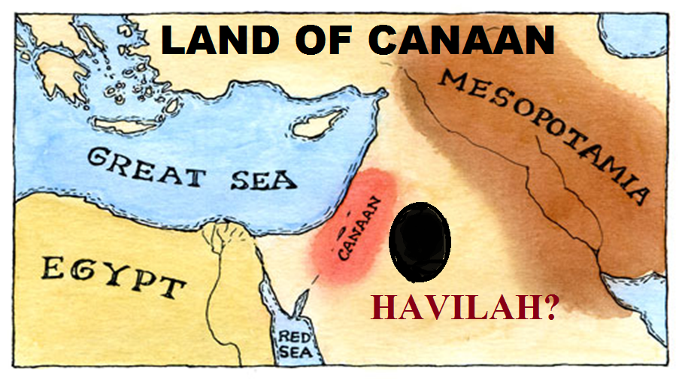 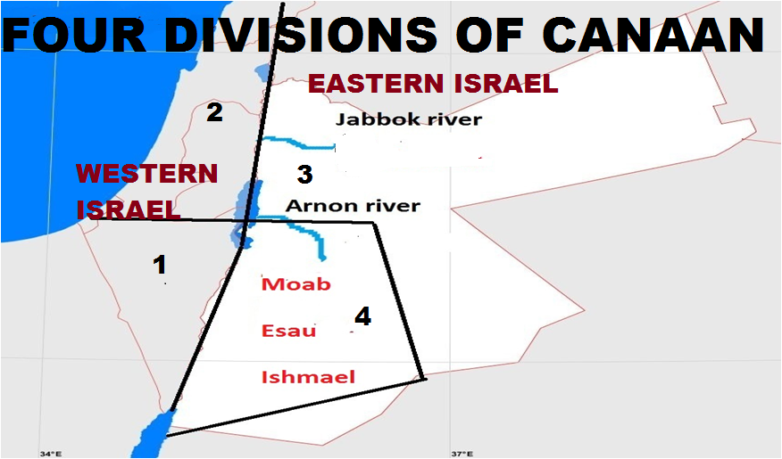

fhdhd; Njrj;jpy; Vrhtpd; re;jjpapdUk; ,];kNayUk; ve;j gFjpapy; FbapUe;jhh;fs; vd;W ehk; mLj;jjhf ghh;f;fNtz;Lk;. fhdhd; Njrj;jpy; fpl;ljl;l ehd;fpy; %d;W gq;if Njtd; ahf;Nfhgpd; re;jjpauhfpa ,];uNayh;fSf;F nfhLj;jhh;. ,];uNayh;fs; Nahh;jhDf;F Nkw;F gFjp KOtijAk; Mf;fpukpj;J ,Ue;jhh;fs;. Nahh;jhdpd; fpof;Nf mh;Ndhd; njhlq;fp vh;Nkhd; kiy tiuAs;s gFjpfspy; ,];uNayh;fs; FbapUe;jhh;fs; vd;W cgh:3:8@ kw;Wk; NahR:12:1y; $wg;gl;bUf;fpd;wJ. ,g;gb fhdhd; Njrj;jpy; ehd;fpy; %d;W gq;if ,];uNayh;fs; Rje;jhpj;Jf;nfhz;lhh;fs;. kPjKs;s ehd;fpnyhU gq;fpy;jhd; Mgpufhkpd; kw;w %d;W re;jjpaUk; FbNawpapUe;jhh;fs;.

mh;Ndhd; Mw;wpw;F tlf;Nf Nyhj;jpd; ,uz;L re;jjpaUs; xUtuhd mk;Nkhdpd; Gj;jpuh;fs; kl;Lk; ahNghf; Mw;wpd; mUNf xU rpwpa ,lj;jpy; FbapUe;jhh;fs;. cgh:3:16 kw;Wk; NahR:12:2 Mfpait ahg;Nghf;F MWjhd; mk;Nkhdpah;fSila vy;iy vd;W $Wfpd;wJ. mk;Nkhdpahpd; Njrj;ij Njtd; ,];uNayh;fSf;F nfhLf;ftpy;iy (cgh:2:37). Vnddpy; mJ Nyhj;jpd; re;jjpf;F Njtd; Mgpufhk; %yk; thf;Fjj;jk; nra;j gFjpahFk;. mk;Nkhdpah;fSk; fhdhd; Njrj;jpd; xU gFjpiajhd; Rje;jhpj;jpUe;jhh;fs;. mth;fsJ Njrj;ij Njtd; ,];uNayh;fSf;F nfhLf;fhjNj fhdhd; Njrj;jpw;F ,];uNayh;fs; kl;Lk; chpikahsh;fs; my;y vd;gijAk;> Nyhj;jpd; re;jjpaUf;Fk;> Mgpufhkpd; kw;w khk;r re;jjpaUf;Fk; mjpy; chpik cz;L vd;gijAk; ekf;F cWjpnra;fpd;wJ.

mh;Ndhd; Mw;wpw;F tlf;Nf mk;NkhdpaUf;F nfhLf;fg;gl;l ,lk; jtpu fhdhd; Njrj;jpy; nkhj;j ehd;fpy; %d;W gq;Fk; ,];uNayh;fSf;Nf nfhLf;fg;gl;bUe;jJ. mg;gbnad;why; mh;Ndhd; Mw;wpw;F njw;F gFjpapy; jhd; (ehd;fpnyhU gq;F) Nyhj;jpd; ,d;ndhU re;jjpauhd Nkhthgpah;> kw;Wk; Vrhtpd; re;jjpauhfpa mkNyf;fpah;> kw;Wk; ,];kNaypd; re;jjpaUk; FbapUe;jpUf;f KbAk;. vdNt Mtpyh NjrKk; mh;Ndhd; Mw;wpw;F njw;Nf cs;s fhdhd; Njrj;jpd; xU vy;iyia xl;bf;nfhz;bUf;Fk; xU NjrkhfNt ,Uf;fKbAk;. ,J Mtpyh Njrj;ijf; Fwpj;J ekf;F fpilf;Fk; ,uz;lhtJ jftyhFk;.

mh;Ndhd; Mw;wpw;F njw;fhf Nyhj;jpd; ,d;DnkhU re;jjpahd Nkhthgpah; FbapUe;jhh;fs;. mh;Ndhd; MwhdJ Nkhthgpd; tlvy;iyahf ,Ue;jJ (vz;:21:13@ 22:36) vd;W Ntj trdk; $Wfpd;wJ. Nkhthg; vd;gJ cg;Gf;fliy xl;b mh;NdhDf;F njw;Nf ,Ue;j gFjpahFk;. mg;gbnad;why; kPjKs;s mkNyf;fpaUk;> ,];kNayUk; fhdhd; Njrj;jpd; ehd;fhk; gq;fpy; Nkhthgpw;F njw;fhfj;jhdpUf;f Ntz;Lk;.

mkNyf;fpah;fs; kw;Wk; ,];kNayh;fs; ,UtUk; Mtpyh njhlq;fp R+h; tdhe;juk; tiu ,Ue;jhh;fs; vd;W $wg;gl;bUf;fpd;wJ. R+h; tdhe;jukhdJ vfpg;jpw;F vjpuhf ,Ue;jJ vd;W $wg;gl;bUf;fpd;wJ (1rhK:15:7@ Mjp:25:18). fhrhtpypUe;J> Vrpahd; NfNgh; tiuf;Fk;> Vrpahd; NfNghpypUe;J ,Ue;J rPdha; ngdpRyhtpd; njd; vy;iy KbAk; tiuf;Fkhd gFjp vfpg;jpd; vjph;gFjpjhd;. mjhtJ rPdha; ngdpRyhtpd; fpof;F vy;iyf;F fpof;Nf cs;s vy;yh gFjpAk; vfpg;jpw;F vjpuhd gFjpjhd;. mjpNy ngUk;gFjpia ,];uNayh;fs; Vw;fdNt Rje;jhpj;Jf; nfhz;lhh;fs;. ,];uNayh;fSila gFjpf;Fs; R+h; tdhe;juk; ,y;iy. vdNt R+h;tdhe;jukhdJ ,];uNaypd; njd; vy;iyf;F njw;fhfj;jhd; ,Uf;fNtz;Lk;. vdNt R+h; tdhe;juk; vd;gJ ,];uNaypd; njd; vy;iyapy; njhlq;fp mg;gbNa nrq;fly; fiu topahf nrd;W rPdha; ngdpRyh KbAk; ,lj;jpw;F vjph; jpirtiu ePz;L ,Uf;Fk; ,lkhFk;. ,e;j R+h; tdhe;juNk mkNyf;fpah;fSf;Fk;> ,];kNaYf;Fk; njd; vy;iyahf ,Ue;jJ. Vnddpy; R+h; tdhe;jukhdJ fhdhd; Njrj;jpd; njd; vy;iyahfTk; ,Ue;jJ. mkNyf;fpah;fSk;> ,];kNayh;fSk; ,e;j fhdhd; Njrj;jpw;F cl;gl;lth;fshf ,Ue;j fhuzj;jpdhy;> R+h; tdhe;jukhdJ mkNyf;fpah;fSf;Fk;> ,];kNayh;fSf;Fk;$l njd; vy;iyahfj;jhdpUf;Fk;. Nkhthgpw;F njw;Nf R+h;thdhe;juk; tiuf;Fk; cs;s fhdhd; Njrj;jpd; gFjpfspNyjhd; mkNyf;fpaUk;> ,];kNayh;fSk; ,Ue;jpUf;f Ntz;Lk;.

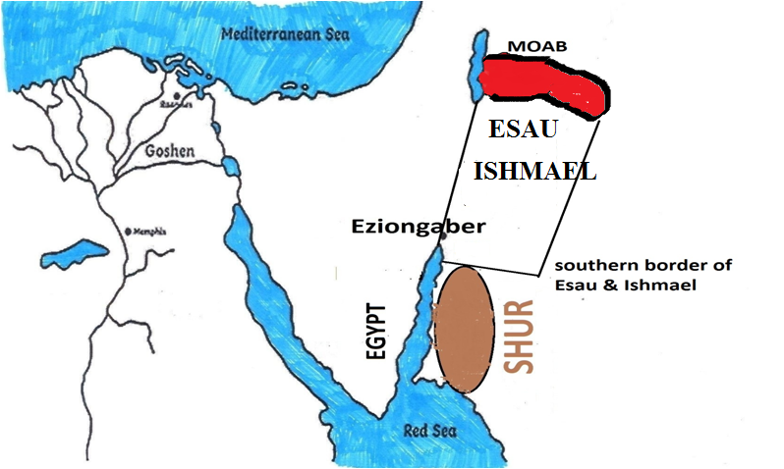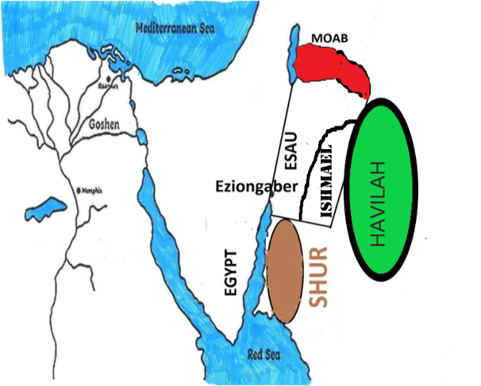

,jpNy Nkhthgpw;F njw;F gFjpapy; ,];kNayh;fs; ve;j gFjpapy; tho;e;jhh;fs;> mkNyf;fpah;fs; vq;F tho;e;jhh;fs; vd;W vg;gb fz;Lgpbg;gJ? Vrhtpw;F VNjhk; vd;Wk; xU ngah; cz;L (Mjp:36:8). Adom vd;gjw;F rptg;G vd;W mh;j;jk;. vdNt mtDk; mtdJ re;jjpapdUk; FbNawpa ,lKk; VNjhk; vd;Nw miof;fg;gl;lJ. VNjhkpah; nrq;flypd; mUNf FbapUe;j fhuzj;jhy;jhd; mf;flYf;Fk; $l nrq;fly; vd;W ngah; te;jJ (nrq;fly; vd;gjw;fhd ngah; fhuzk; vd;W cyfj;jhh; gy fhuzq;fis $Wthh;fs;. Mdhy; vNjhkpdpkpj;jNk - Vrhtpdpkpj;jNk nrq;flYf;F mg;ngah; te;jJ). 1uh[h:9:26 trdKk; mkNyf;fpahpd; Njrkhd VNjhkhdJ nrq;fly; mUNf ,Ue;jJ vd;gij cWjpgLj;Jfpd;wJ. ,jd; %yk; mkNyf;fpah; (Vrhtpd; re;jjpah;) Nkhthgpd; njw;Nf cs;s nrq;fliy xl;b Nkw;F gFjpapNy FbapUe;jhh;fs; vd;gJ cWjpahfpd;wJ. mkNyf;fpah; Nkhthgpw;F njw;Nf nrq;fly; Xukhf FbapUe;jhh;fs; vd;why; kPjKs;s ,lkhdJ ,];kNayh;fSf;fhdjhFk;. mg;gbahdhy; ,];kNayh;fs; fhdhd; Njrj;jpd; njd;fpof;F gFjpapy; Nkhthgpw;F njw;Nf> mkNyf;fpah;fSf;F fpof;fhfNt FbapUe;jpUf;f KbAk;.

mkNyf;fpah;fspd; NjrKk;> ,];kNayhpd; NjrKk; tlnjd; iluf;\dpy; ,y;yhky;> tlfpof;F kw;Wk; njd;Nkw;F iluf;\dpy;jhd; ,Ue;jpUf;f Ntz;Lk;. tlf;F njw;F iluf;\dpy; ,itfs; ,Ue;jnjd;why; mjd; ,d;DnkhU vy;iyapy; Nkhthg;jhd; ,Uf;Fk;. tlfpof;F> njd;Nkw;F iluf;\dpy; ,Ue;jhy;jhd; me;j ,uz;L Njrq;fspy; tlfpof;F vy;iyapy; Mtpyh Njrk; ,Uf;f KbAk;. mg;gbnad;why; Mtpyh NjrkhdJ Nkhthig xl;b mkNyf;F kw;Wk; ,];kNaypd; tlfpof;F vy;iyapy; fhdhd; Njrj;ij xl;bagb ,Ue;jpUf;fNtz;Lk;. mJ ,d;iwa N[hh;ld; kw;Wk; rTjp mNugpah Mfpa Njrq;fspd; xU gFjpahf ,Ue;jJ. NkhNr fhyj;jpy; Mtpyh NjrkhdJ fhdhd; Njrj;ijg;Nghy xU nghpa Njrkhf ,Ue;jJ. Mtpyh Njrj;jpy; nghd; tpise;jJ vd;W Ntjk; $Wfpd;wJ. ,d;W rTjp mugpahtpd; ,e;j gFjpfspy;jhd; mjpfkhd jq;f Ruq;fq;fs; ,Uf;fpd;wd. rTjp mNugpahtpd; jq;fr; Ruq;fq;fSk; ,e;j gFjpNa Mtpyh Njrk; vd;gij cWjpnra;fpd;wJ. NkYk; N[hh;lhdpy; Mtpyh Njrk; ,Ue;j gFjpfspy; kpfg;nghpa mstpyhdhyhd jq;f ,Ug;G ntFtpiutpy; fz;Lgpbf;fg;gLk; vd;gij ehd; ,e;j Gj;jfj;jpd; thapyhf cWjpahf njhptpf;fpd;Nwd;.

ehk; vjw;fhf Mtpyh Njrj;ij Muha;e;J ghh;j;Jf;nfhz;bUf;fpd;Nwhk;? me;j Njrj;ij Rw;wpjhd; igNrhd; ejp XbaJ vd;w fhuzj;jpdhy;jhd; Mtpyh Njrj;ij ehk; Muha;e;J Njbf;nfhz;bUf;fpd;Nwhk;. ,g;NghJ Mtpyh Njrj;ij fz;Lgpbj;Jtpl;Nlhk;. ,e;j Njrj;ij Rw;wpjhd; igNrhd; mW XbapUf;fNtz;Lk;. igNrhd; MwhdJ fhdhd; Njrj;jpd; tlKidapYs;s vh;Nkhd; kiyapy; njhlq;fp ,d;iwa N[hh;lhd; ehl;by; njw;F Nehf;fp Xb> mNugpa jPgfw;gj;jpw;Fs; Eioe;J> rTjpmNugpahtpd; tlgFjpapy; Xb ngh;rpa tisFlhtpy; fye;jpUf;fNtz;Lk;. ,e;j MW NkhNr fhyj;jpy; Xltpy;iy. me;j MW NkhNr fhyj;jpy; ,Ue;jpUe;jhy; mJ ve;j topahf XbaJ vd;W NkhNrf;F Njtd; tpsf;fNtz;ba mtrpakpUe;jpUf;fhJ.

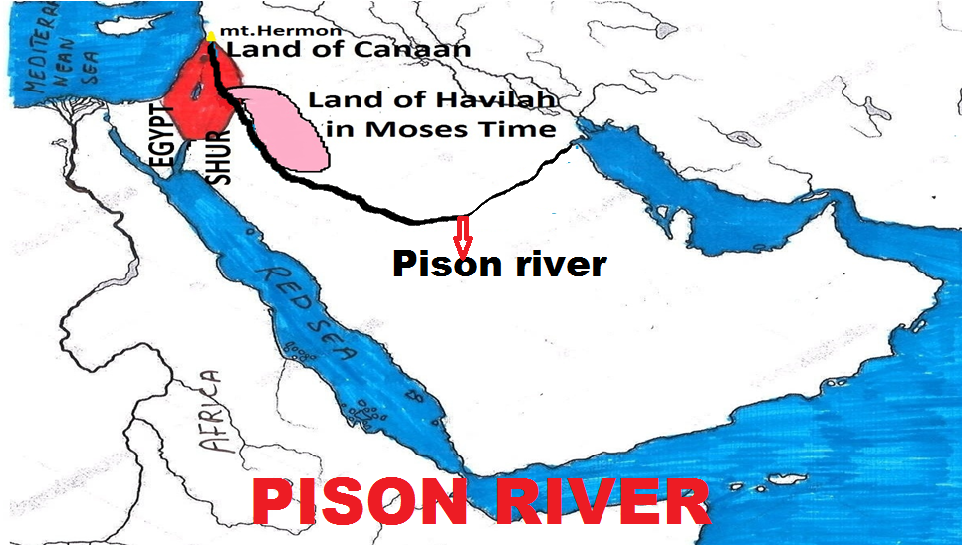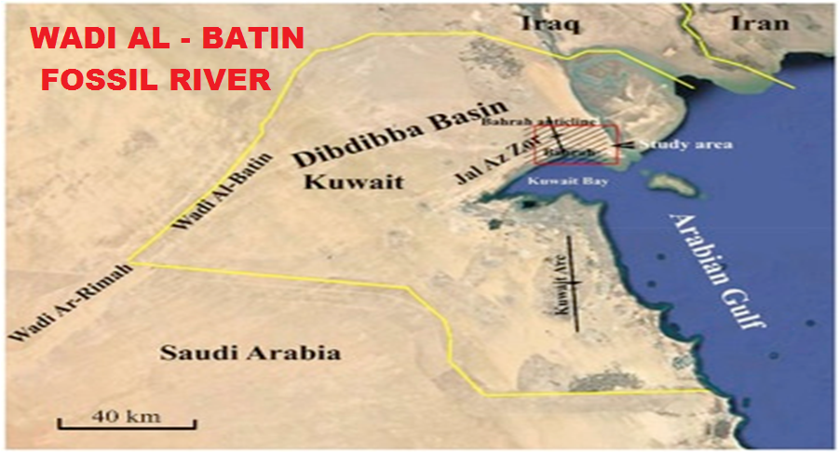

**nraw;if Nfhs; glk;:** igNrhd; MW ,e;j topNajhd; XbaJ vd;gjw;F Ntjhfkj;jpw;F ntspNaAk; xU Mjhuk; ,Uf;fpd;wJ. nraw;ifNfhs; %yk; vLj;j glj;jpy; mNugpa jPgfw;gj;jpd; kj;jpapy; xU MW 3500 Mz;LfSf;F Kd;dh; XbapUf;fpd;wJ vd;W fz;Lgpbj;jpUf;fpd;whh;fs;. mJ tw;wpa Mwhf ("Fossil River") fhzg;gLfpd;wJ. mjd; ngah; Wadi Al-Batin.mJNt igNrhd; Mw;wpd; xU gFjpahf ,Uf;fyhk;. mJ Fitj;jpd; mUNf ngh;rpa tisFlhtpy; fyf;fpd;wJ. ,g;NghJ ghiytdkhf ,Uf;Fk; mNugpa jPgfw;gkhdJ xU fhyj;jpy; ,e;j igNrhd; Mwhy; kpfTk; nropg;ghd gFjpahf ,Ue;jpUf;fpd;wJ.

**fPNfhd; MW**

mLj;jjhf ,uz;lhtJ Mwhd fPNfhd; Mw;iwf; Fwpj;J ghh;g;Nghk;. “me;j (fPNfhd;) MW vj;jpNahg;gpah Njrk; KOtijAk; Rw;wp XLk;” vd;W Ntjj;jpy; $wg;gl;bUf;fpd;wJ. fPNfhd; Mw;iw fz;Lgpbf;f Ntjk; ekf;F nfhLj;jpUf;Fk; xNu jfty; vj;jpNahg;gpah vd;w NjrNk. ,d;iwa fpwp];jth;fs; gyUk; vj;jpNahg;gpah vd;wTld; Mg;gphpf;ff; fz;lj;jpypUf;Fk; vj;jpNahg;gpahNt mJ vd;W vz;Zfpd;whh;fs;. mjdhy; fPNfhd; MwhdJ Mg;gphpf;fhtpy;jhd; XbapUf;Fk; vd;W fUJfpd;whh;fs;. Mdhy; Mg;gphpf;fhtpy; cUthd vj;jpNahg;gpah vd;w ehL ,g;NghJ cUthd ehlhFk;. mg;gbahdhy; Ntjhfkj;jpy; $wpa vj;jpNahg;gpah vJ? mJ vq;Nf ,Ue;jJ vd;gij ehk; fz;Lgpbj;jhy;jhd; fPNfhd; MW vq;Nf XbaJ vd;gij ehk; fz;Lgpbf;f KbAk;.

Njtdhy; NkhNrf;F nfhLf;fg;gl;l Kjy; Ie;J Gj;jfj;jpy; vj;jpNahg;gpah vd;w thh;j;ijNa fpilahJ vd;gJ cq;fSf;F njhpakh? vj;jpNahg;gpah vd;gJ xU fpNuf;f thh;j;ijahFk;. Ntjhfkk; NkhNrf;F nfhLf;fg;gLk;NghJ fpNuf;f nkhopNa fpilahJ. vj;jpNahg;gpah vd;gjw;F gad;gLj;jg;gl;bUf;Fk; rhpahd vgpNua thh;j;ij $\; vd;gNjahFk;. Mk; $\pd; re;jjpah; FbapUe;j gFjpNa $\; my;yJ $\; Njrk; vd;W Ntjhfkj;jpy; toq;fg;gl;lJ. strong concordancey; vj;jpNahg;gpah vd;w thh;j;ijf;F H3568vd;w vz; nfhLf;fg;gl;bUf;fpd;wJ. mjw;F fhkpd; xU kfDila ngah; kw;Wk; mtdJ re;jjpapdh; FbapUe;j Njrj;jpd; ngah; vd;Nw mjpy; mh;j;jk; nfhLf;fg;gl;bUf;fpd;wJ. Ntjhfkj;jpy; vj;jpNahg;gpah> vj;jpNahg;gpad; vd;W tUk; ,lq;fspnyy;yhk; $\; vd;Nw ,Ue;jpUf;f Ntz;Lk;. vj;jpNahg;gpah vd;gJ gpw;fhyj;jpy; Nrh;f;fg;gl;l thh;j;ijNa. fPNfhd; MwhdJ $\pd; re;jjpapdh; FbapUe;j $\; Njrj;ij Rw;wpNa XbaJ. $\; Njrk; vd;gJ vj;jpNahg;gpah vd;Nw ekf;F gof;fg;gl;Ltpl;ljhy; ehKk; ,q;F mij vj;jpNahg;gpah Njrk; vd;Nw miog;Nghk;.

vj;jpNahg;gpah vd;gjw;F fpNuf;f nkhopapy; jPapy; vhpe;j Kfj;ij cilatd; (jPQ;r %Q;rd; - burnt face) vd;W mh;j;jkhFk;. Vd; $\pd; re;jjpapdUf;F jPapy; vhpe;j Kfj;ij cilatd; vd;W mh;j;jg;gLj;Jk; vj;jpNahg;gpad; vd;w ngah; te;jJ? ,jw;F ehk; Ntjhfkj;jpNyNa tpilia NjLNthk;. vNu:13:23y; “$\pad; (vj;jpNahg;gpad;) jd; Njhiy khw;wf;$LNkh” vd;W nfhLf;fg;gl;bUf;fpd;wJ. Mk; $\pd; re;jjpah; fWg;gpdj;jhuhf ,Ue;j fhuzj;jpdhy; jq;fsJ Njhypd; epwj;ij khw;w KbahJ. me;j fUj;jpy;jhd; Ntjj;jpy; ,t;thW $wg;gl;bUf;fpd;wJ. $\pd; re;jjpah; fWg;G epwj;jpy; jPapy; vhpe;jth;fisg;Nghd;w NjhYld; ,Ue;jjhy;jhd; mth;fis fpNuf;fj;jpy; vj;jpNahg;gpah;fs; vd;W mioj;jhh;fs;. mtDk; mtd; re;jjpah; FbapUe;j gFjpAk; vj;jpNahg;gpah vd;W miof;fg;gl;lJ. ,e;j trdj;jpy; $\pd; re;jjpah; vy;yhUk; fWg;G epwj;jth; vd;W kiwKfkhf $wg;gl;bUf;fpd;wJ. $\pd; re;jjpah; vy;NyhUk; Rj;j fWg;G vd;W $wptpl KbahJ fWg;G Kjy; gpuTd; tiuapyhd epwj;jpy; ,Ue;jhh;fs;.

fhkpd; gps;isfspy; $\; kl;LNk fWg;G epwj;jhdhf ,Ue;jhd;. ,d;W fpwp];jth;fspy; gyUk; fhkpd; vy;yh re;jjpaUk; fWg;G epwj;jpypUe;jhh;fs; vd;W jtwhf vz;Zfpd;whh;fs;. fhk;> Nrk;> ahg;Ngj;jpd; glj;ij tiuAk;NghJ fhkpd; glj;ij kl;Lk; fWg;ghf tiue;J itf;fpd;whh;fs;. fhuzk; fhKk; mtdJ nkhj;j re;jjpaUk; fWg;G vd;W mth;fs; epidf;fpd;whh;fs;. fhkpd; gps;isfs; nkhj;jk; ehd;F Nguhth;. $\;> kp];uhaPk;> g+j;> fhdhd; MfpNahh;fNs fhkpd; ehd;F gps;isfshth;. ,jpy; kp];uhaPk;> G+j;; fhdhd; Mfpa %d;WNgUk; nts;is epwj;jth;fNs. fhkpd; re;jjpahpy; $\pd; re;jjpah; kl;LNk fWg;G Kjy; gpuTd; tiuapyhd epwj;jpypUe;jhh;fs;. mjdhy;jhd; Ntjj;jpy; mth;fis Fwpj;J $Wk;NghJ “$\pad; (vj;jpNahg;gpad;) jd; Njhiy khw;wf;$LNkh” vd;W nfhLf;fg;gl;bUf;fpd;wJ. fhkpd; vy;yh re;jjpaUk; fWg;ghf ,Ue;jpUe;jhy; “fhkpad; jd; Njhiy khw;w KbANkh” vd;Wjhd; Ntjj;jpNy $wg;gl;bUf;Fk;. vdNt Ntjj;jpd;gb $\pd; re;jjpah; kl;LNk fWg;gpdj;jhh;. fhkpd; vy;yh re;jjpaUk; fWg;G epwk; fpilahJ. fhk; $l fWg;G epwj;jhd; my;y.

$\pd; re;jjpah; vq;F FbapUe;jhh;fs; vd;gij vg;gb ehk; fz;Lgpbg;gJ? ,jw;F Mjp:10:5y; gjpy; nfhLf;fg;gl;bUf;fpd;wJ. “mtdtd; ghi\apd;gbNaAk;> mtuth;fs; Nfhj;jpuj;jpd; gbNaAk;> [hjpapd;gbNaAk;> NtWNtW Njrq;fsha;g; gFf;fg;gl;ld” Nfhj;jpuk; vd;why; vd;d? cjhuzkhf A+jh Nfhj;jpuk; vd;gJ A+jhtpd; gps;isfshy; cz;lhd Nfhj;jpuk;. mth;fsJ Kjy; jfg;gdhfpa A+jhthy; me;j Nfhj;jpuk; mwpag;gl;lJ. mNjNghy me;j Nfhj;jpuj;jhh; jq;fpapUe;j NjrKk; mth;fsJ Kjy; gpjhthfpa A+jhtpd; ngauhy; A+Njah vd;W miof;fg;gl;lJ. vdNt xU Njrj;jpDila my;yJ xU ChpDila ngaiuf; nfhz;L me;j Njrj;jpy; my;yJ me;j Chpy; ve;j re;jjpah; FbapUe;jhh;fs; vd;gij fz;Lgpbj;Jtpl KbAk;. $\pw;F Nrgh> Mtpyh> rg;jh> uhkh> rg;jpfh vd;W Ie;J kfd;fs; ,Ue;jhh;fs; (Mjp:10:7). ,th;fs; jtpu epk;Nuhj;Jk; mtdJ Fkhud;jhd; (Mjp:10:8). Mfnkhj;jk; $\pw;F MW kfd;fs; ,Ue;jhh;fs;. ,th;fs; ngahpy; Njrq;fNsh Ch;fNsh ,Uf;fpd;wjh vd;gij ehk; ,g;NghJ Muha;e;J ghh;g;Nghk;. Mtpyh vd;gtdJ re;jjpapdh; FbapUe;j NjrkhdJ mkNyf;fpah; Njrkhd VNjhkpw;Fk;> ,];kNaypd; re;jjpapdh; FbapUe;j Njrj;jpw;Fk; tlfpof;fpy; fhdhd; Njrj;ij xl;b ,Ue;jJ vd;W ehk; Vw;fdNt ghh;j;Jtpl;Nlhk;.

**epk;Nuhj;J**

mLj;jjhf epk;Nuhj;jpd; re;jjpah; vq;F FbNawpapUe;jhh;fs; vd;W ghh;g;Nghk;. mtNd [yg;gpusaj;jpw;F gpd;dh; te;j ,uz;lhk; cyfj;jpd; Kjy; uh[h Mthd;. $\pd; re;jjpapypUe;Nj Kjy; uh[h cz;lhdhd;. ,jpypUe;J $\pd; re;jjpapdNu typikahdth;fs; vd;gJ ekf;F njhpatUfpd;wJ. ghNgy; NfhGuk; fl;Lk;NghJ Njtd; vy;yhUila nkhopfisAk; jhWkhwhf;fp ghgpNyhdpypUe;J vy;yh [dq;fisAk; rpjwbf;fpd;whh;. mg;NghJ epk;Nuhj;Jk; mtdJ re;jjpaUk; ghgpNyhd; efuj;jpypUe;J tlf;fhf efh;e;J ,d;iwa ilf;hP]; vd;W miof;fg;gLk; ejpapd; kWfiuapy; FbNawpdhh;fs;. mJNt Kjypy; epk;Nuhj;J Njrk; vd;W miof;fg;gl;lJ (kPfh:5:6). gpw;fhyj;jpy; epk;Nuhj;jpd; re;jjpia mq;fpUe;J Juj;jptpl;L Nrkpd; kfdhd mR+Uk; mtdJ re;jjpaUk; mq;F FbNawpajhy; mjw;F mrPhpahNjrk; vd;W ngah; te;jJ (Mjp:10:11). 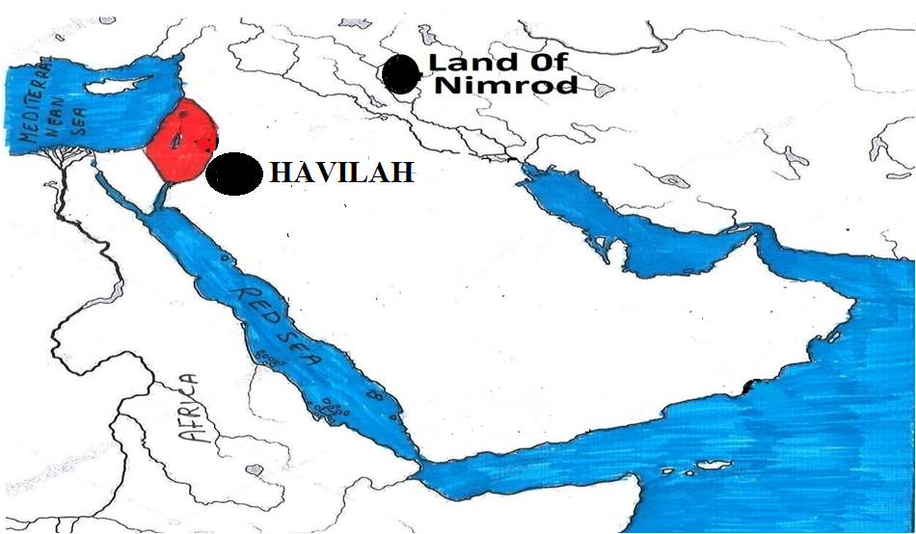 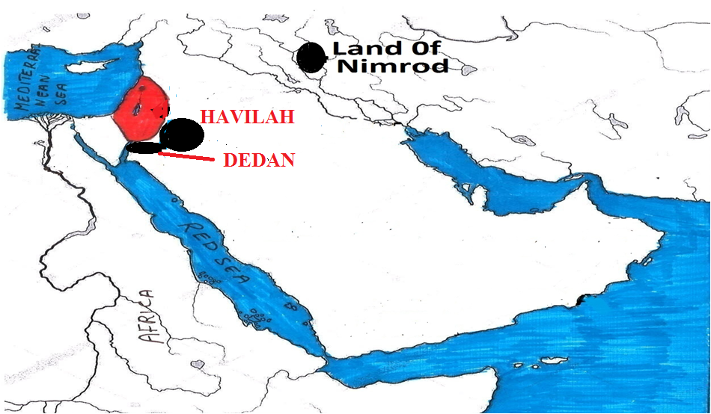

**uhkh – Raamah**

mLj;jjhf $\pd; ,d;DnkhU kfdhd uhkh kw;Wk; mtdJ re;jjpaUila FbapUg;G Fwpj;J ghh;g;Nghk;. uhkh FbapUg;G Fwpj;J Ntjj;jpy; xNu xU ,lj;jpy;jhd; kiwKfkhf Fwpg;gplg;gl;bUf;fpd;wJ (vNr:27:22). mJ xU th;j;jf efuk; vd;w jfty; kl;LNk ekf;F vNr:27:22y; ,Ue;J fpilf;fg;ngWfpd;wJ. th;j;jf efuk; vd;why; mJ xU flw;fiu efukhfNt ,Uf;fNtz;Lk;. Vndd;why; me;j fhyq;fspy; th;j;jfq;fnsy;yhk; fly; %ykhfNt ele;jJ. uhkh vq;Nf FbapUe;jhd; vd;gjw;F Ntjj;jpy; NtW ve;j jftYk; nfhLf;fg;gltpy;iy. mg;gbahdhy; uhkh vq;Nf FbapUe;jhd; vd;gij ehk; vt;thW fz;Lgpbf;fKbAk;? uhkhtpd; ngahpy; Njrk; ,y;yhtpl;lhYk; mtdJ kfd;fsJ ngahpy; Njrq;fs; ,Uf;fpd;wJ. kfd;fs; ngahpYs;s Njrj;ij nfhz;L ehk; uhkhtpd; ,Ug;gplj;ij fz;Lgpbg;Nghk;. mjw;fhfj;jhd; Njtd; uhkhtpd; ,uz;L kfd;fspd; ngaiuAk; ekf;F nfhLj;jpUf;fpd;whh;. uhkhtpw;F ,uz;L kfd;fs; ,Ue;jhh;fs;. xUtDila ngah; N\gh kw;wtDila ngah; Njjhd; (Mjp:10:7).

**Njjhd;:** jkpopy; jpjhd; vd;W ,e;j ,lj;jpy; nfhLf;fg;gl;bUf;fpd;wJ. mj jtwhd nkhopngah;g;ghFk;. kw;w ,lq;fspnyy;yhk; Njjhd; vd;Nw nfhLf;fg;gl;bUf;fpd;wJ. vdNt ehk; ,tid Njjhd; vd;Nw $WNthk;. Njjhdpd; re;jjpapdh; FbapUe;jjhy; me;j gFjpf;F Njjhd; vd;W ngah; te;jJ. NjjhDk; xU flw;fiu efukhFk; (vNr:27:15). Vnddpy; mth;fs; kpfr;rpwe;j th;j;jfh;fshf ,Ue;jpUf;fpd;whh;fs; vd;W $wg;gl;bUf;fpd;wJ. ahidj; je;jq;fisnay;yhk; mth;fs; tzpfk; nra;jpUf;fpd;whh;fs;. mNugpahtpNyh> kj;jpa fpof;F gFjpfspNy ahidfs; fpilahJ. ahid je;jq;fis mth;fs; tzpfk; nra;jpUf;f Ntz;Lnkd;why; fpof;F Mg;gphpf;fh my;yJ ,e;jpah my;yJ njd;fpof;fhrpah ehLfSld; fly; tzpfj;jpy; <Lgl;bUf;f Ntz;Lk;. vdNt mth;fs; flw;fiuapNyNa FbapUe;jhh;fs; vd;gJ cWjpahfpd;wJ. ,J Njjhidf; Fwpj;J ekf;F fpilf;Fk; Kjy; jftyhf ,Uf;fpd;wJ.

VNjhik Njtd; Njkhd; Jtq;fp Njjhd; tiuf;Fk; mopg;Ngd; vd;W $Wfpd;whh; (VNr:25:13). fh\;kPh; Kjy; fd;dpahFkhp tiu vd;why; vd;d mh;j;jk;. ,e;jpahtpd; tlvy;iy Kjy; njd;vy;iy tiu vd;W mh;j;jkhFk;. VNjhkpw;fhd epahaj;jPh;g;G Fwpj;J Njtd; ,q;F $Wfpd;whh;. VNjhkpw;F epahaj;jPh;g;G nfhLf;Fk;NghJ Njkhd; Jtq;fp Njjhd; tiuf;Fk; mopf;fg;gLk; vd;gjpypUe;J ehk; vd;d Ghpe;Jnfhs;s Kbfpd;wJ? NjkhDk; NjjhDk; VNjhkpd; tlf;F njw;F vy;iyfshfNth my;yJ fpof;F Nkw;F vy;iyfshfNth ,Uf;Fk;. VNjhikf; Fwpj;J Vw;fdNt ehk; njspthf ghh;j;Jtpl;Nlhk;. mJ fhdhd; Njrj;jpy; nrq;fliy xl;ba gFjpahf ,Ue;jJ. VNjhkpd; njw;F vy;iy kl;LNk flyhf ,Ug;gjhYk;> Njjhd; xU flw;fiu efuk; vd;W Vw;fdNt ehk; ghh;j;jpUg;gjhYk;> NjjhdhdJ VNjhkpd; njd; vy;iyapNyAk;> NjkhdhdJ VNjhkpd; tl vy;iyapYk; ,Uf;Fk; CuhfTNk ,Uf;fKbAk;. vdNt VNjhkpd; njd; vy;iy KbAk; ,lj;jpy; ,Uf;Fk; R+h; tdhe;juj;jpy; jhd; Njjhd; ,Uf;f Ntz;Lk;. nrq;flypd; ,e;j fiuapy; ,Ue;Jnfhz;Ljhd; Njjhdpah;fs; ,e;jpah my;yJ fpof;F Mg;gphpf;fh my;yJ njd;fpof;fhrpah ehLfspypUe;J ahidj; je;jj;ij ,wf;Fkjp nra;jpUg;ghh;fs;.

**N\gh:** uhkhtpd; mLj;j kfd; N\gh.N\ghitf; Fwpj;J $wk;NghJ jkpo; Ntjhfkq;fspy; Nrgh vd;W ,q;F nfhLf;fg;gl;bUf;fpd;wJ. mJ jtwhd nkhopngah;g;ghFk;. $\pd; %j;j kfd; ngaUk; Nrghjhd;. N\ghit Nrgh vd;W nkhopngah;j;jhy; $\pd; %j;j kfDf;Fk;> uhkhtpd; kfDf;Fk; tpj;jpahrk; ,y;yhky; Ngha;tpLk;. Mq;fpy nkhopngah;g;Gfspy; ,uz;L ngaUf;Fk; tpj;jpahrk; ,Uf;fpd;wJ. $\pd; %j;j kfdJ ngah; Seba vd;Wk;> uhkhtpd; kfdJ ngah; Sheba vd;Wk; Mq;fpyj;jpy; nfhLf;fg;gl;bUf;fpd;wJ. mNjNghy jkpopYk; $\pd; %j;j kfdJ ngah; Nrgh vd;Wk;> uhkhtpd; kfdJ ngauhdJ N\gh vd;w tlnkhop “\” TlDk; Fwpg;gplgl;bUf;f Ntz;Lk;. ehk; uhkhtpd; kfid N\gh vd;Nw miog;Nghk;. N\ghtpd; re;jjpah; rNgah; vd;Wk; miof;fg;gLthh;fs;.

,tdJ re;jjpapy; te;jtNs N\gh Njrj;J uhzpahths;. Mk; N\gh Njrj;J uhzpAk; fWg;gpdj;jhNs. N\gh Njrj;jhUk; tzpfh;fshf ,Ue;jpUf;fpd;whh;fs;. vNrf;fpNay; 27:22k; mjpfhuj;jpy; jPU vd;w jPTld; ahuhnuy;yhk; th;j;jfk; nra;jhh;fs; vd;W $wg;gl;bUf;fpd;wJ. jPUTld; th;j;jfk; nra;aNtz;Lkhdhy; me;j Njrk; fz;bg;ghf flw;fiuapNyjhd; mike;jpUf;fNtz;Lk;. vdNt N\ghTk; xU flw;fiu NjrNkahFk;. ,J N\ghtpd; ,Ug;gplk; Fwpj;J ekf;F fpilf;Fk; Kjy; jftyhFk;.

**vNr:23:39-42:** vNr:23:39y; ,];uNaypy; elf;Fk; xU tpf;fpufMuhjid jpUtpohitf; Fwpj;Jf; $wg;gl;bUf;fpd;wJ. 40k; trdj;jpNy me;j tpf;fpufMuhjid jpUtpohtpw;F J}uNjrj;jpypUe;J tUgth;fSf;F miog;G nfhLj;jy; Fwpj;J $wg;gl;bUf;fpd;wJ. mjd;gpwF mjhtJ J}uNjrj;jpypUe;J te;jth;fspd; “re;jbapd; ,iur;ry; mlq;fpd gpd;G [dj;jpushd GU\iuAk; mioj;jDg;gpdhh;fs;” (tr:42). mg;gb te;jth;fspy; rNgah;fSk; (N\ghtpd; re;jjpah;) xUth; vd;W me;j trdq;fspy; $wg;gl;bUf;fpd;wJ.

* jpushd [dq;fs; tuNtz;Lnkd;why; mJ J}ukhd ,lj;jpypUe;J tuKbahJ. vdNt rNgah; ,];uNaYf;F mUNf ,Uf;Fk; Njrj;jpNyNa ,Ue;jpUf;fpd;whh;fs;. vdNt N\gh ,];uNaYf;F mUNfjhd; ,Uf;f Ntz;Lk;.
* J}uNjrq;fSf;F miog;G tpLj;j gpd;G (tr:40) J}uNjrj;jpypUe;J te;jth;fspd; “re;jbapd; ,iur;ry; mlq;fpd gpd;G” (tr:42) ,e;j miog;G tplg;gLfpd;wJ vd;W mjpy; njspthf $wg;gl;bUf;fpd;wJ. mjhtJ J}u Njrj;jpypUe;J te;jth;fs; nrd;w gpwF me;j tpf;fpuf Muhjid tpohtpw;F mUfpy; cs;sth;fSf;F ,];uNayh;fshy; miog;G tplg;gl;bUf;fpd;wJ vd;gNj me;j trdj;jpd; mh;j;jkhFk;. ,JTk; ,];uNaYf;F kpf mUfpy; N\gh ,Uf;fpd;wJ vd;gij cWjpgLj;Jfpd;wJ.
* 42k; trdj;jpy; “rNgah; tdhe;juj;jpypUe;J nfhz;Ltug;gl;lhh;fs;” vd;W $wg;gl;bUf;fpd;wJ.

rNgauhdth;fs; flw;fiuapy; ,Uf;fNtz;Lk;. ,];uNaYf;F mUfhfTk; ,Uf;fNtz;Lk;. tdhe;jukhfTk; ,Uf;fNtz;Lk; vd;why; mJ ,];uNaypw;F njw;fhfTk;> ,];uNaYf;F mUfhfTk;> nrq;flypd; fiuapYk; cs;s R+h; tdhe;jukhf kl;LNk ,Uf;f KbAk;. Mk; N\ghthdJ NjjhDf;F njw;fhf R+h; tdhe;juj;jpy; ,Uf;fNtz;Lk;. ,J N\ghitf; Fwpj;J ekf;F fpilf;Fk; ,uz;lhtJ jftyhFk;.

**Xg;gPh;:** N\gh Njrj;J uhzp Xg;gPUld; njhlh;Gilatsha; Ntjj;jpy; $wg;gLfpd;whs;.Xg;gPh; vd;gJ N\gh uhzpapd; fl;Lg;ghl;by;jhd; ,Ue;jJ. ehk; Ntj Mjhuq;fisf;nfhz;L ,g;NghJ mij cWjpnra;Nthk;. Xg;gPUf;F Vyhj;jpypUe;J (nrq;fly; gFjp) rhyNkhd; fg;gy;fis mDg;gpdhd; (1uh[h:9:27>28). 1uh[h:10k; mjpfhuj;jpy; N\gh Njrj;J uhzp kw;Wk; rhyNkhDila re;jpg;G Fwpj;J $wg;gl;bUf;fpd;wJ. ,ij vg;gb ehk; Ghpe;Jnfhs;tJ? xd;gjhk; mjpfhuj;jpy; Xg;gPUf;F jq;fk; thq;f fg;gy;fs; nry;fpd;wJ. mLj;j mjpfhuj;jpy; jq;fj;Jld; N\gh Njrj;J uhzp rhyNkhid re;jpf;fpd;whs;. rhyNkhd; fhyj;jpy; Xg;gPiu N\gh Njrj;J uhzpNa Mz;Lnfhz;bUe;jhs;. rhyNkhd; flNyhbfshd jPUtpd; uh[htpd; Ml;fSld; xU fg;giy Xg;gPUf;F 450 jhye;J jq;fk; thq;fptu fg;gYld; mDg;Gfpd;whd;. me;j fg;gyhdJ Vyhj;jpypUe;J N\gh Njrj;J uhzpapd; fl;Lg;ghl;by; ,Uf;Fk; Xg;gPUf;F mDg;gg;gLfpd;wJ. xU jhye;J jq;fk; vd;gJ 25-50 fpNy ,Uf;fyhk; vd;W mDkhdpf;fg;gLfpd;wJ. rhyNkhdpd; Ml;fs; N\gh Njrj;J uhzpaplk; nrd;W 450 jhye;J jq;fj;jpw;fhd gzj;ij nfhLf;fpd;whh;fs;. mg;NghJ me;j Njrj;J uhzpf;F mJ kpfg;nghpa Mr;rhpaj;ij je;jJ. Vnddpy; Mapuf;fzf;fhd fpNyh jq;fj;ij mtsplk; te;J mJtiu ahUk; thq;fNt ,y;iy. mj;ijifa nry;te;jh; ahUk; mg;NghJ cyfj;jpYk; ,y;iy. vdNt mts; jq;fk; thq;f rhyNkhd; mDg;gpa egh;fsplk; rhyNkhidf; Fwpj;J tprhhpf;fpd;whs;. mth;fs; uhzpaplk; rhyNkhdpd; moF> mwpT> Qhdk;> ty;yik> ePjp> mtdJ nry;tnropg;G> mtdJ uh[;[pak;> mtdJ Myak;> mtdJ fiyj; jpwd;> mtdJ Njtd;> mtdJ Njtd; mtNdhL ,Ug;gJ> vj;jid ehLfs; fhzpf;if nfhLj;J mtNdhL el;ghf ,Uf;fpd;wJ Nghd;w vy;yh jfty;fisAk; $Wfpd;whh;fs;. ,e;j jfty;fisnay;yhk; Nfl;l uhzpahy; me;j jfty;fis ek;gNt Kbatpy;iy. rhyNkhid NehpNy re;jpj;J mtdplk; gy tp\aq;fis NgrNtz;Lk; vd;W N\gh Njrj;J uhzp KbTnra;fpd;whs;. rhyNkhd; Nfl;l 450 jhye;J jq;fj;ij mtdJ Ml;fsplk; uhzp nfhLj;Jtpl;L> 120 jhye;J jq;fj;ij rhyNkhDf;F fhzpf;ifahf vLj;Jf;nfhz;L (el;ig Vw;gLj;jpf; nfhs;s) N\gh Njrj;J uhzp xl;lfj;jpy; vUrNykpw;F Gwg;gl;lhs;. N\ghtpypUe;J jq;fk; fhzpf;ifahf rhyNkhDf;F tUk; vd;gij mtdJ jfg;gdhd jhtPJ jdJ rq;fPjj;jpNyNa jPh;f;fjhprdkhf $wpapUe;jhd; (rq;;:72:10>15). me;j jPh;f;fjhprdj;ij epiwNtw;Wk; tpjkhfNt N\gh Njrj;J uhzp rhyNkhDf;F 120 jhye;J jq;fj;ij fhzpf;ifahf nfhz;Lnry;fpd;whs;. rhyNkhDf;F nry;Yk; jq;fk; fg;gypy; nry;fpd;wJ. N\gh Njrj;J uhzpNah xl;lfj;jpy; jq;fj;ij rhyNkhDf;F ghprhf nfhz;L nry;fpd;whs;. mts; rhyNkhdplk; NgRk;NghJ “ck;Kila th;j;jkhdq;fisAk; ck;Kila Qhdj;ijAk; Fwpj;J> ehd; vd; Njrj;jpNy Nfl;l nra;jp nka;ahapw;W” (1uh[h:10:6@ 2ehsh:9:5) vd;W jhd; rhyNkhdhy; mDg;gg;gl;lth;fsplk; tprhhpj;j jftiy ntspg;gLj;Jfpd;whs;. mtSf;F rhyNkhidf; Fwpj;J mth;fs; $wpa fhhpaq;fis ek;Gtjw;F Kjypy; nfhQ;rk; f\;lkhf ,Ue;jJ. MdhYk; rhyNkhid Nehpy; fz;lNghJjhd; mij mts; ek;Gfpd;whs;. NkYk; jdJ Njrj;jpw;F jq;fk; thq;f te;j rhyNkhDila Ml;fs; mtidf; Fwpj;J 50 rjtPfpj fhhpaj;ijf;$l $wtpy;iy vd;W Nehpy; fz;l gpd;dh; jdJ Mr;rhpaj;ij ntspg;gLj;Jfpd;whs;. rhyNkhDf;F jhd; xl;lfk; %ykhf nfhz;L te;j jq;fj;ij ghprspj;jtpl;L nry;fpd;whs;. Xg;gPUf;Fk;> N\gh Njrj;J uhzpf;Fk; cs;s njhlh;ig mwpe;Jnfhs;tjd; %yk; Xg;gPUk; N\ghtpypUe;jJ vd;gij ehk; Ghpe;Jnfhs;syhk;.

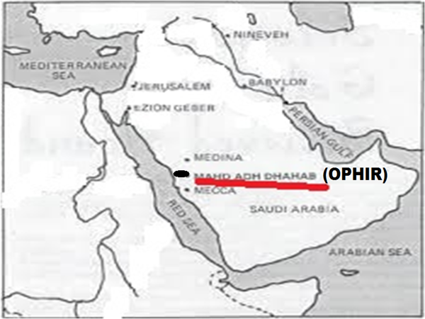 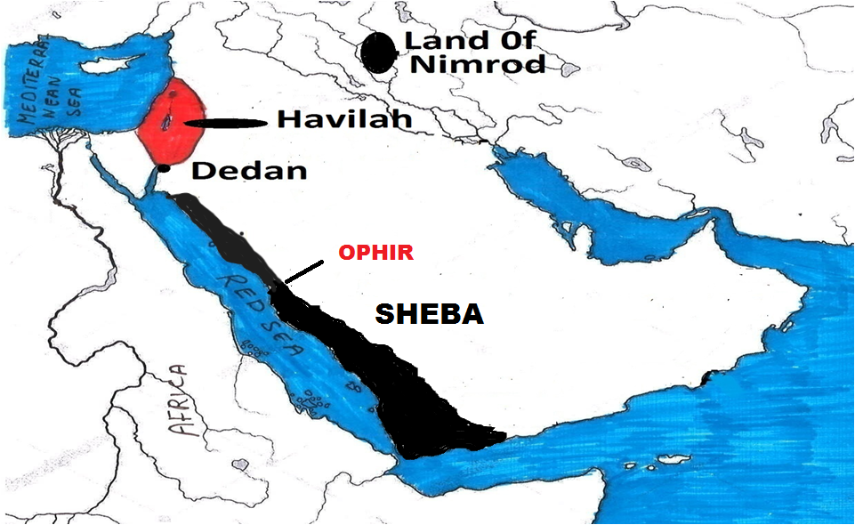

jw;fhyj;jpy; Mahd adh-Dhahab vd;w jq;f Ruq;fk; ,Uf;fpd;wJ. ,J nrq;flypd; fiuapy; mNugpa jPgfw;gj;jpd; Nkw;F kj;jpa gFjpapy; rTjp mNugpahtpy; ,Uf;fpd;wJ. mq;Nf kpy;ypad; fzf;fhd ld;fs; cilf;fg;gl;l ghiw Jfs;fs; fhzg;gLfpd;wJ. me;j kz;Jfs;fs; 3000 Mz;LfSf;F Kd;dh; Njhz;lg;gl;lJ vd;W ep&gpf;fg;gl;bUf;fpd;wJ. jq;fk; vLf;fg;gl;lJNghf kPjkhd kz;Jfs;fNs mJ. me;j Ftpf;fg;gl;l fopT kz;Jfs;fspy; ,d;dKk; jq;fj;Jfs;fs; fhzg;gLfpd;wd. ,JNt rhyNkhd; fhyj;jpy; (N\gh Njrj;J uhzp fhyj;jpy;) jq;fk; vLj;j Xg;gPuhf ,Uf;f Ntz;Lk; vd;gjw;fhd Gtpapay; MjhukhFk;. ,e;j Xg;gPiu cs;slf;fpajhfNt N\gh Njrk; ,Uf;fNtz;Lk;. N\gh NjrkhdJ NjjhDf;F njw;fhf R+h; tdhe;juj;jpy; Muk;gpj;J> Xg;gPiu cs;slf;fp Vkd; tiuf;Fk; ,Ue;jJ. mNugpa jPgfw;gj;jpd; Nkw;F flw;fiu KOtijAk; cs;slf;fpa Njrkhf N\gh ,Ue;jJ.

N\gh> Njjhdpd; jfg;gdhfpa uhkhtpd; ,Ug;gplk; mth;fs; ,Uthpd; FbapUg;gpw;Fk; eLthf cs;s flw;fiu gFjpapy; jhd; ,Uf;fNtz;Lk;. ghNgy; NfhGuk; fl;lg;gl;lTld; [dq;fs; gphpe;jNghJ uhkhTk; mtdJ re;jjpaUk; Kjypy; uhkhtpNyjhd; FbNawpapUg;ghh;fs;. gpw;fhyj;jpy; N\gh kw;Wk; Njjhdpah; vz;zpf;ifapy; ngUj;jNghJ mjpy; xUtid tlf;F Nehf;fpAk;> xUtid njw;F Nehf;fpAk; uhkh mDg;gpapUg;ghd;. mJ me;j fhyj;J eilKiwjhd;. uhkhtpd; kw;w re;jjpah; (ngz; top re;jjpah;) njhlh;e;J me;j ChpNyNa trpj;jpUg;ghh;fs;. vdNt uhkhtpd; re;jjpah; NjjhDf;Fk; N\ghtpw;Fk; ,ilg;gl;l ,lj;jpy; ,Ue;jpUg;ghh;fs;. NjjhDk;> N\ghTk; Nrh;e;jNj uhkhtpd; thr];jykhFk;. vdNt uhkhtpd; thr];jyk; vd;gJ vNjhkpd; njd; vy;iy njhlq;fp. Vkd; tiuf;Fk; cs;s gFjpahFk;.

**Nrgh – seba**

mLj;jjhf $\pd; %j;j kfdhfpa Nrghtpd; re;jjpah; vq;F FbapUe;jhh;fs; vd;gJ Fwpj;J ghh;g;Nghk;. *rq;:72:10y; “jh;\Prpd; uh[hf;fSk; jPTfspd; uh[hf;fSk; fhzpf;iffisf; nfhz;LtUthh;fs;@ N\ghtpYk; NrghtpYKs;s uh[hf;fs; ntFkhdq;fisf; nfhz;LtUthh;fs;” vd;W $wg;gl;L ,Uf;fpd;wJ.* ,e;j trdkhdJ rhyNkhd; fhyj;jpy; rhyNkhDf;F ghpRfis nfhLj;J mtdJ el;ig ngwg;NghFk; ehLfs; Fwpj;J jhtPJ jPh;f;fjhprdkhf $WtjhFk;. ,jpy; N\ghTld; Nrh;j;J Nrgh nfhLf;fg;gl;bUf;fpd;wJ. mLj;jLj;J ,Uf;Fk; ehLfis mLj;jLj;J $Wk; xU nkhopeil Ntjj;jpNy gad;gLj;jg;gl;bUf;fpd;wJ (ck;- Nkjpah– ngh;rpah> jPU-rPNjhd;). Ntjhfkj;jpd; ,e;j nkhopeiliaf;nfhz;L ehk; ghh;f;Fk; NghJ N\ghtpw;F mUfpy;jhd; Nrgh ,Uf;fNtz;Lk; vd;W ehk; KbTf;F tuyhk;.

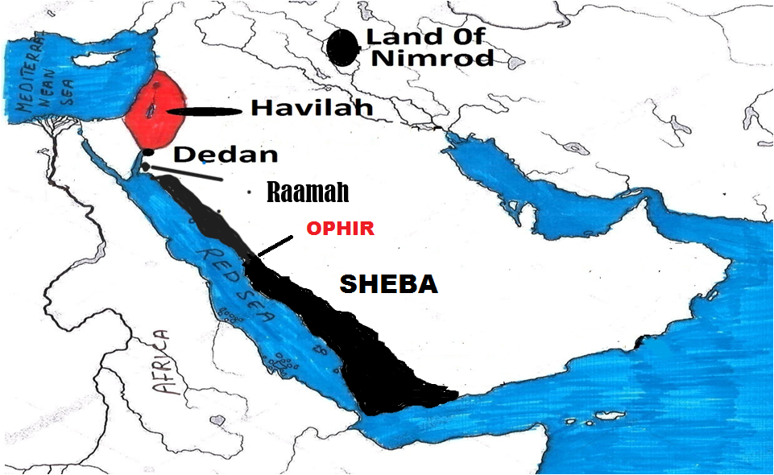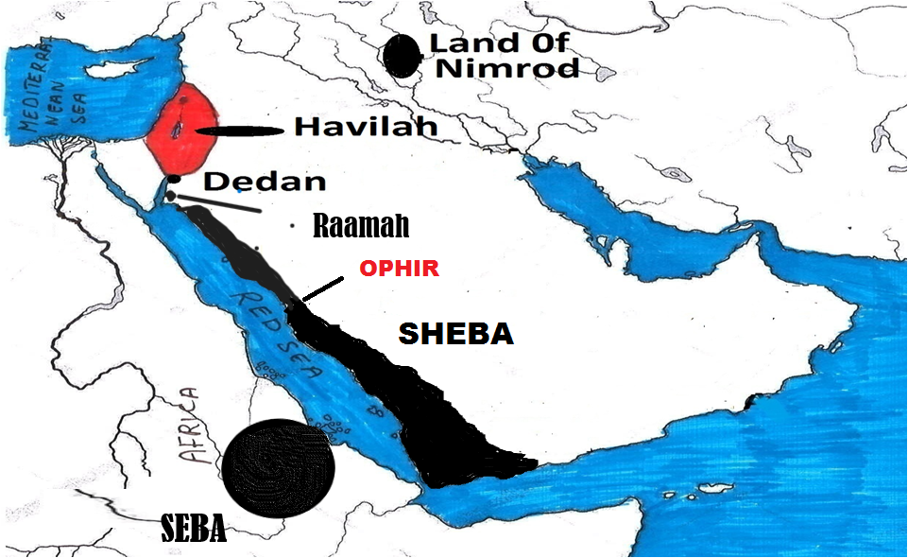

N\ghtpw;F mUNf vd;why; vq;F ,Uf;Fk;? ,jw;F Vrh:43:3 tpilaspf;fpd;wJ. Vrh:43:3y; “*ehd; ,];uNtypd; ghpRj;jUk;> cd; ,ul;rfUkhapUf;fpw cd; Njtdhfpa fh;j;jh;@ cd;id kPl;Fk;nghUshf vfpg;ijAk;> cdf;F <lhf vj;jpNahg;gpahitAk; NrghitAk; nfhLj;Njd;”* vd;W nfhLf;fg;gl;bUf;fpd;wJ. ,jpNy vj;jpNahg;gpahTk;> NrghTk; jdpj;jdpahf nfhLf;fg;gl;bUf;fpd;wJ. $\pd; re;jjpah; nkhj;jkhf FbapUe;j ,lk;jhd; vj;jpNahg;gpah. $\pd; re;jjpahpy; ahh; rw;w tpyfp FbapUe;jhh;fNsh mth;fsJ FbapUg;ghdJ vj;jpNahg;gpahtpy; tuhJ. Vrh:43:3y; NrghTk;> vj;jpNahg;gpahTk; jdpj;jdpahf nfhLf;fg;gl;bUg;gjhy; Nrgh vd;gJ vj;jpNahg;gpahtpy; tuhJ vd;Wk;> vj;jpNahg;gpahtpypUe;J rw;W tpyfp ,Ue;j Njrk; vd;Wk; ekf;F Ghpfpd;wJ. vdNt NrghthdJ nrq;flYf;F Nkw;Nf N\ghtpw;F ,izahf> N\ghTf;F mUfpNy Mg;gphpf;ff; fz;lj;jpy; ,Ue;jpUf;f Ntz;Lk;.

**rg;jh> rg;jpfh:**

ehk; $\pd; re;jjpahpy; ,Jtiu Nrgh> Mtpyh> uhkh> epk;Nuhj;J MfpNahUila ,Ug;gplj;ijf; Fwpj;J ghh;j;Jtpl;Nlhk;. ,d;dKk; ,uz;L re;jjpaUila ,Ug;gplj;ijf; Fwpj;Jjhd; ghh;f;fNtz;Lk;. mjhtJ rg;jh kw;Wk; rg;jpfh MfpNahh;fSila re;jjpah; vq;F FbapUe;jhh;fs; vd;gijf; Fwpj;J kl;LNk ehk; ghh;f;fNtz;Lk;. ,th;fisf; Fwpj;J tpN\rkhd jfty;fs; vJTk; Ntjhfkj;jpy; ,y;iy. ,th;fSila rNfhjuh;fsJ ngahpnyy;yhk; xU Njrk; ,Uf;Fk;NghJ ,e;j ,uz;L rNfhjuh;fs; ngahpy; xUNjrKk; ,y;iy> xU efuKk; ,y;iy. ,th;fisf; Fwpj;J Ntjj;jpy; NtW vq;Fk; $wg;glTk; ,y;iy. Vd; ,th;fisg; gw;wp $wg;gltpy;iy? mth;fsJ ghtj;jpdpkpj;jk; mth;fs; FbNaw nfhLf;fg;gl;l Njrq;fspypUe;J cldbahf Njtdhy; Juj;jg;gl;bUf;fyhk;. ,th;fs; Vd; Juj;jg;gl;lhh;fs;? vq;F nrd;whh;fs;?,g;NghJk; ,Uf;fpd;whh;fsh? vd;gijnay;yhk; Fwpj;J gpd;dh; tphpthf ghh;g;Nghk;. ,th;fs; jq;fsJ rNfhjuh;fspd; mUNfjhd; fz;bg;ghf Muk;gj;jpy; FbapUe;jpUg;ghh;fs;. Mdhy; xU jiyKiw Mtjw;Fs; Juj;jg;gl;bUg;ghh;fs;. Vnddpy; xU jiyKiw ,Ue;jpUe;jhy; fz;bg;ghf me;j re;jjpah; jhq;fs; FbapUe;j Njrj;jpw;F jq;fsJ je;ijah; ngaiu itj;jpUg;ghh;fs;. Mdhy; ,th;fsJ ngahpy; efuq;fs; ,y;yhjjhy; ,th;fs; efuq;fis fl;Ltjw;F Kd;dNu> xU jiyKiwia ghh;g;gjw;F Kd;dNu Juj;jg;gl;bUg;ghh;fs; vd;W A+fpf;f ,lkpUf;fpd;wJ. mth;fs; Juj;jg;gLtjw;F Kd;dh; mNugpa jPgfw;gj;jpd; njw;F kw;Wk; njd;fpof;F gFjpapNy N\ghtpw;F mLj;jLj;J FbapUe;jpUf;f Ntz;Lk; vd;W ehd; mDkhdpf;fpd;Nwd;. NjtdJ fpUigahy; vdJ mDkhdk; rhpahf ,Uf;Fk; vd;Wk; ek;Gfpd;Nwd;.

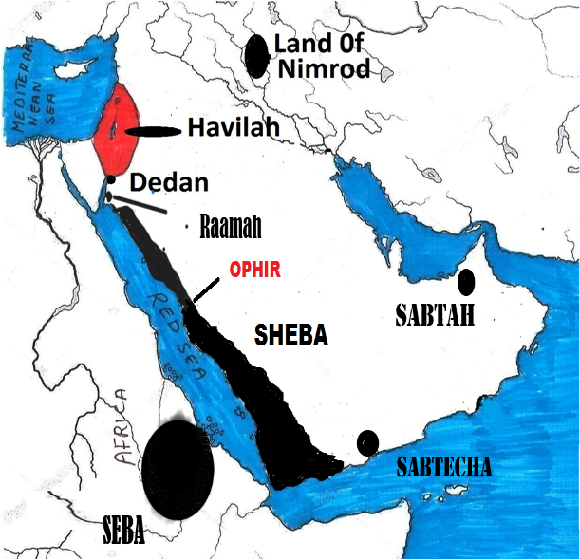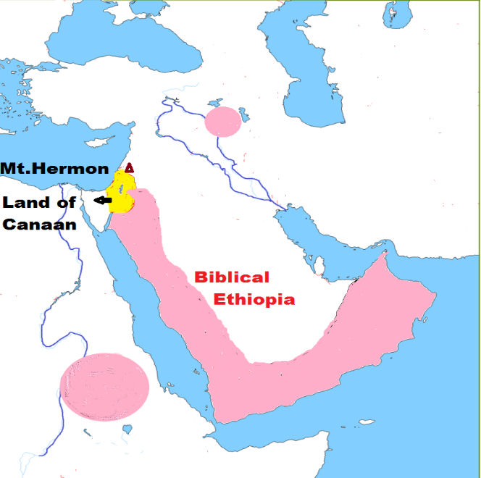

ghNgy; NfhGuk; fl;lg;gl;l cld; nkhop jhWkhwhf;fg;gl;L [dq;fs; rpjwbf;fg;gl;lNghJ $\pd; re;jjpah; ,q;Fjhd; FbNawpdhh;fs;. MdhYk; rg;jh> rg;jpfh kw;Wk; epk;Nuhj;J MfpNahh; cldbahf mth;fs; FbNawpa gFjpfspy; ,Ue;J Juj;jg;gl;ljhy; mth;fs; FbNawpa gFjp vj;jpNahg;gpahtpy; NruhJ. NkYk; nrq;flYf;F Nkw;Nf cs;s NrghthdJ vj;jpNahg;gpahtpy; Nrh;f;fhky; jdpahf nfhLj;jpUg;gjhy; (Vrh:43:3) mJTk; vj;jpNahg;gpahtpy; NruhJ. epk;Nuhj;Jk; jdpahf ,Ue;jjhy; me;j gFjpAk; vj;jpNahg;gpahTld; NruhJ. ,JNghf kPjKs;s vy;yh ,lq;fSNk Ntjk; $Wk; vj;jpNahg;gpahthFk;. Ntjk; $Wk; vj;jpNahg;gpah vd;gJ fhdhd; Njrj;jpd; njd; gFjpapy; Muk;gpj;J Vkdpy; Kbtiltjhf ,Ue;jJ. NkhNr fhyj;jpy; ,JNt vj;jpNahg;gpah vd;W miof;fg;gl;lJ. Mkhk; rNfhjuh;fNs $\pd; re;jjpauhd fWg;gpdj;jhh; Kjy; Kjypy; ,e;j gFjpfspNyjhd; FbNawpdhh;fs;. Mdhy; ,g;NghJ fWg;gpdj;jhh; mNugpahtpy; ,y;yhjjhy; gyUf;Fk; ,e;j $w;whdJ Vw;Wf;nfhs;s fbdkhf ,Uf;Fk;. $\pd; re;jjpapduhfpa fWg;gpdj;jhh; mNugpahtpy; Fwpg;ghf mNugpahtpd; Nkw;F fiu gFjpapy; tho;e;jhh;fs; vd;gjw;F Ntjj;jpypUe;J NtW rpy Mjhuq;fisAk; ,q;F ehk; ghh;g;Nghk;.

**mNugpa jPgfw;gj;jpd; Nkw;F gFjpapy; vj;jpNahg;gpah;fs; (fWg;gpdj;jhh;) ,Ue;jhh;fs; vd;gjw;fhd Ntj Mjhuq;fs;:**

**NkhNrapd; kidtp Mtpyh Njrj;J vj;jpNahg;gpas;:** NkhNr ghh;NthDf;F gae;jpUe;j fhyj;jpNy kPjpahd; Njrj;jpNy ,Ue;jhd;. kPjpahd; Njrk; vq;fpUe;jJ vd;gij ghh;f;fNtz;Lnkd;why; Kjypy; kPjpahd; vd;why; ahh; vd;W ghh;f;fNtz;Lk;. kPjpahd; vd;gJ Mgpufhkpd; %d;whk; kidtpahd Nfj;Juhspd; kfd;fspd; xUtd; (Mjp:25:2). Mgpufhkpd; re;jjpaiuf; Fwpj;J ghh;f;Fk;NghJ ahf;Nfhgpd; re;jjpauhd ,];uNayUf;F fhdhd; Njrj;jpNy ehd;fpy; %d;W gq;F nfhLf;fg;gl;lJ vd;W ghh;j;Njhk;. kPjp cs;s ehd;fpy; xU gq;F fhdhd; Njrj;jpy; Nyhj;J> Vrh> ,];kNayh; MfpNahUila re;jjpah; FbapUe;jhh;fs; vd;W ghh;j;Njhk;. ,th;fs; jtpuTk; Mgpufhkpw;F xU re;jjp cz;L. Mgpufhk; rhuhis jtpu ,d;ndhU ngz;idAk; jpUkzk; nra;jpUe;jhd;. mts; ngah; Nfj;Juhs; (Mjp:25:1). Mfhhpd; re;jjpf;F fhdhd; Njrj;jpy; Rje;jpuk; nfhLf;fg;gl;bUf;Fk; NghJ Mgpufhkpd; ,d;DnkhU kWkidahl;bahd Nfj;Juhspd; gps;isfSf;F Njtd; fhdhd; Njrj;jpy; Rje;juk; nfhLf;fhky; ,Ue;jpug;ghuh? Mfhh;> Nfj;Juhs; ,UtiuANk Ntjk; kWkidahl;b vd;Wjhd; $Wfpd;wJ (Mjp:25:6). mtsJ re;jjpaUf;F Rje;jukhf nfhLf;fg;gl;l ,lk; vJntd;W ehk; ,Jtiu ghh;f;ftpy;iy. kWkidahl;bfspd; re;jjpaiu fpof;fhf mgpufhk; mDg;gpdhd; vd;W Mjp:25:6y; nfhLf;fg;gl;bUf;fpd;wJ.

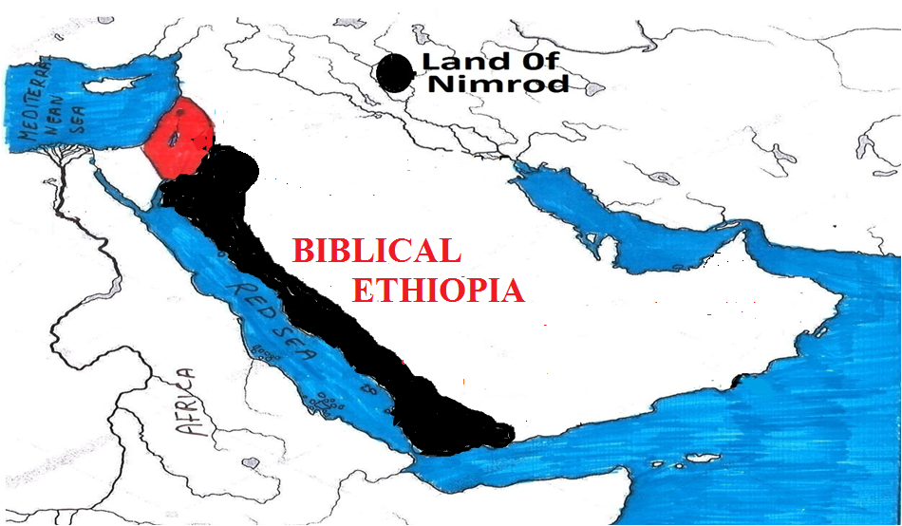

fpof;F Njrk; vd;why; vJ? fhdhd; Njrj;jpw;F Gwk;Ng cs;s fpof;Fg; gFjp vd;W mij ehk; Ghpe;Jnfhs;sf;$lhJ. Mgpufhk; jdJ re;jjpaiu fhdhd; Njrj;jpw;F ntspNa mDg;gpapUg;ghdh? ePjpkhdhd Mgpufhk; Njtd; jdf;F thf;Fj;jk; nfhLj;j fhdhd; Njrj;jpw;F ntspNa cs;s ,lj;ij Rje;jhpj;Jf;nfhs;Sk;gb jdJ re;jjpaiu fz;bg;ghf mDg;gpapUf;fkhl;lhd;. vdNt mtd; mDg;gpa fpof;F vd;gJ fhdhd; Njrj;jpw;Fl;gl;l fpof;Fg;gFjpahFk;. fhdhd; Njrj;jpd; ,lJGuk; NkYs;s gFjp Nkw;fhFk;. tyJGuk; NkYs;s gFjp fhdhd; Njrj;jpd; tlf;F gFjpahFk;. fPNo ,lJ Gwk; cs;s gFjp njw;F> fPNo tyJ Guk; cs;s gFjp fpof;F. mJjhd; (fpof;F) fhdhd; Njrj;jpd; ehd;F gq;Ffspy; ehd;fhk; gq;fhFk;. Mgpufhk; <rhf;NfhL fhdhd; Njrj;jpd; njw;F gFjpapy; thrkhapUe;jhd; (Mjp:20:1). fpof;F gFjpapy;jhd; Nyhj;jpd; xU kfdhfpa Nkhthg;> Vrhtpd; re;jjpah;> Mfhhpd; re;jjpah; FbapUe;jhh;fs; vd;W ehk; Vw;fdNt ghh;j;Njhk;. me;j gFjpapy;jhd; (fhdhdpd; ehd;fhk; ghfj;jpy;) Nfj;Juhspd; re;jjpaUf;Fk; ,lk; xJf;fg;gl;bUe;jJ. Mjp:25:6y; jdJ kWkidahl;bfspd; gps;isfis mq;Nf mDg;gpdhd; vd;W $wg;gl;bUf;fpd;wJ. Mfhh;> Nfj;Juhs; ,UtUNk ,q;F kWkidahl;b vd;W $wg;gl;bUf;fpd;whh;fs;. Mfhhpd; re;jjpaUk;> Nfj;Juhspd; re;jjpaUk; Nrh;j;Nj mDg;gg;gl;lhh;fs;. vdNt ,UtUk; fhdhd; Njrj;jpd; fpof;Nf xNu ,lj;jpy;jhd; ,Ue;jpUg;ghh;fs;. mjhtJ ,];kNaypd; re;jjpaUk; (Mfhhpd; re;jjp)> Nfj;Juhspd; re;jjpaUk; Nrh;e;Nj mLj;jLj;J ,Ue;jpUg;ghh;fs;.

,g;NghJ ehk; Nfj;Juhspd; re;jjpahpy; kPjpahdpah;fs; vq;fpUf;fpd;whh;fs; vd;W ghh;f;fNtz;Lk;. Nfj;Juhspd; re;jjpauhfpa ,e;j kPjpahdpah;fs; vg;NghJk; Nkhthgpah;fNshNl njhlh;Gilath;fshfNt Ntjj;jpy; fhl;lg;gl;bUf;fpd;whh;fs;. mth;fspy; ngUk;ghyhNdhh; NkhthgpYk; ,Ue;jhh;fs; vd;W Mjp:36:35 $Wfpd;wJ. Nkhthgpah;fSld; fye;jpUe;j kPjpahdpah;fis NkhNr Aj;jj;jpy; nfhy;fpd;whd; (vz;:31:7). Vnddpy; gpNyahkpd; MNyhridgb ,e;j kPjpahdpah;fSk;> mth;fsJ ngz;fSNk ,];uNayh;fs; tpgr;rhuk; nra;a fhuzkhf ,Ue;jhh;fs; (vz;:31:16). vdNt ,];kNayh;fSld; ,Ue;j kPjpahdpah;fs; ,];kNay; Njrj;jpy; Nkhthgpw;F mUNf ,Ue;jpUf;f tha;g;G ,Uf;fpd;wJ. ,];kNayh;fs; fhdhd; Njrj;jpd; njd;fpof;Fg; gFjpapy; ,Ue;jhh;fs; vd;W ehk; Vw;fdNt ghh;j;Jtpl;lNlhk;. kPjpahdpah;fSk; mth;fNshL Nrh;e;J fhdhd; Njrj;jpd; njd;fpof;F gFjpfspy; ,Ue;jhh;fs; vd;W ehk; A+fpf;fyhk;. fpwp];jt mwpQh;fs; gyUk; kPjpahd; vd;gJ VNjhkpw;F njw;fhf nrq;flypd; fiuapy; ,Ug;gjhf $Wfpd;whh;fs;. mJ jtwhd jftyhFk;. kPjpahdpah;fs; fhdhd; Njrj;jpw;Fs;jhd; ,Ue;jhh;fs;. NkhNr vfpg;jpypUe;J jg;gpNahb fhdhd; Njrj;jpw;F cl;gl;l ,lj;jpNyjhd; (kPjpahd; Njrj;jpNy) jq;fpapUf;fpd;whd; vd;gJ ekf;F xU GJikahd jftyhfj;jhd; ,Uf;fpd;wJ.

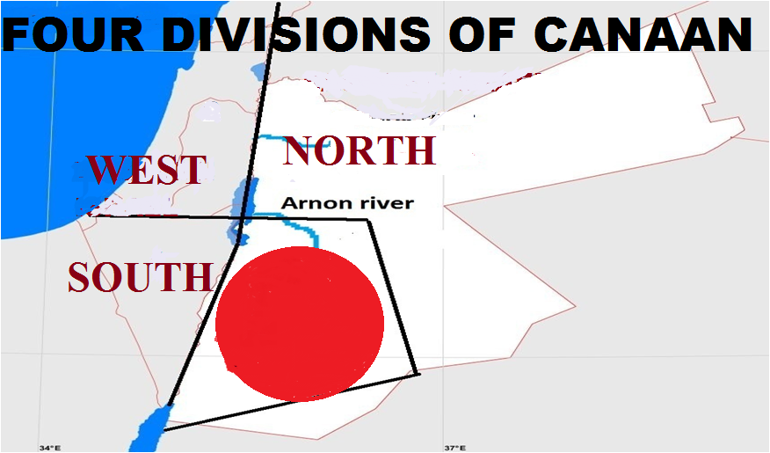 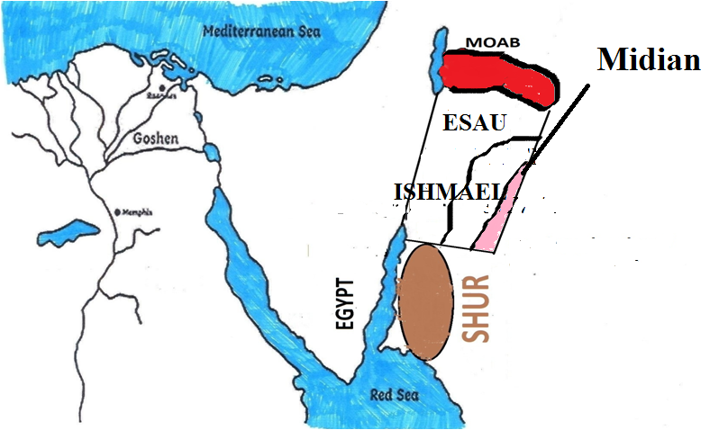

NkhNrapd; khkd; kPjpahd; Njrj;J Mrhhpadhf ,Ue;jhd; (ahj;:3:1). Nkhthgpw;Fk; kPjpahd; Njrj;J Mrhhpah;fNs %g;gh;fshf ,Ue;jpUf;fpd;whh;fs; (vz;:22:4). ,e;j kPjpahd; Njrj;J Mrhhpah;fs; ahh;? ,e;j kPjpahd; Njrj;jpd; fpof;Nf ahh; ,Ue;jhh;fs;? Mtpyh Njrj;jhNu ,];kNay; Njrj;jpw;Fk;> mkNyf;F Njrj;jpw;Fk; tlfpof;F vy;iyapy; ,Ue;jhh;fs; vd;W ehk; Vw;fdNt ghh;j;jpUf;fpd;Nwhk;. ,th;fs; $\pd; re;jjpauhfpa fWg;gpdj;jhh;. vj;jpNahg;gpah vd;W miof;fg;gl;l Njrj;jhuhth;. ,th;fs; gpshf; Nk[pf; vd;W nrhy;yf;$ba ke;jpu fhhpaq;fspy; ifNjh;e;jth;fs;. ,th;fs; gpw;fhyq;fspy; Nkhthg;> VNjhk;> ,];kNay;> kPjpahd; Njrj;jpw;Fs;Sk; Fbngah;e;J mq;Fk; jq;fsJ khe;jphPf tpj;ijapd; %ykhf> uh[hf;fNs MNyhrid Nfl;Fk; mstpw;F ngUk; Mrhhpah;fshf ,Ue;jpUf;fpd;whh;fs;. Mtpyh vd;w vj;jpNahg;gpa Njrj;ij Nrh;e;jth;fNs ,e;j kPjpahd; Njrj;J Mrhhpah;fshth;. Mtpyh Njrj;J khe;jphPfh;fs; mq;fpUe;J Kjypy; kPjpahd; Njrj;jpy; te;J rpwpJ fhyk; FbNawpapUf;fyhk;. mq;fpUe;J mUfpYs;s vy;yh Njrj;jpw;Fk; gutpapUf;fpd;whh;fs;. vdNt mth;fs; vy;NyhUNk kPjpahdpa Mrhhpah;fs; vd;W mwpag;gl;lhh;fs;. MfNt kPjpahdpd; Mrhhpah;fs; vy;NyhUk; kPjpahdpd; re;jjpah; vd;W ehk; epidf;ff;$lhJ. mth;fs; vy;NyhUk; Mtpyh Njrj;J kdpjh;fNs (fWg;gpdj;jhh;> vj;jpNahg;gpah;fs;).

kPjpahdpd; Mrhhpah;fs; vd;W $wg;gl;bUf;fpd;wNj. gpd; vg;gb mth;fis ehk; Mtpyh Njrj;jhh; vd;W Vw;Wf;nfhs;s KbAk;? NkhNrapd; kidtpia Fwpj;J vd;d $wg;gl;bUf;fpd;wJ? vz;:12:1I thrpj;j ghUq;fs;. “vj;jpNahg;gpah Njrj;J ];jphPia NkhNr tpthfk;gz;zpapUe;jgbapdhy;> kphpahKk;> MNuhDk; mtd; tpthfk;gz;zpd vj;jpNahg;gpah Njrj;J ];jphPapdpkpj;jk; mtDf;F tpNuhjkha; Ngrp” vd;W $wg;gl;bUf;fpd;wJ. Mk; NkhNrapd; kidtp xU vj;jpNahg;gpa ];jphp vd;W $wg;gl;bUf;fpd;wJ. mg;gbahdhy; mtdJ jfg;gDk; vj;jpNahg;gpad;jhNd. Mdhy; mtid Ntjk; vt;thW $Wfpd;wJ? kPjpahd; Njrj;J Mrhhpad; vd;W $Wfpd;wJ. NkhNrapd; khkd; Mtpyh Njrj;ij Nrh;e;j vj;jpNahg;gpadhf ,Ue;j fhuzj;jhy; mtdJ kfSk; vj;jpNahg;gpa ];jphp vd;W miof;fg;gl;lhs;. Vj;jpNahg;gpadhfpa NkhNrapd; khkd; kPjpahd; Njrj;J Mrhhpad; vd;W miof;fg;gl;lJNghy kw;w vj;jpNahg;gpa Mrhhpah;fSk;> kPjpahd; Njrj;J Mrhhpah;fs; vd;W miof;fg;gl;lhh;fs;. vj;jpNahg;gpahtpypUe;J (MtpyhtpypUe;J) Fbngah;e;J nfhQ;rk; fhyk; mth;fs; xU FOthf kPjpahd; Njrj;jpNy ,Ue;jjhYk;> kPjpahd; Njrj;jpypUe;Nj kw;w ,lq;fSf;F mth;fs; gutpajhYk; vy;NyhUk; mth;fis kPjpahd; Njrj;J Mrhhpah;fs; vd;W nrhy;y Muk;gpj;jhh;fs;. vdNt kPjpahdpa %g;gh;fs;> Mrhhpah;fs; vy;NyhUNk vj;jpNahg;gpah;fNs. mjpYk; Fwpg;ghf Mtpyh Njrj;J vj;jpNahg;gpah;fshth;. NkhNrapd; kidtpapd; FLk;gKk; ,e;j ,dj;ij rhh;e;jth;fNs.

,jpypUe;J vd;d njhpfpd;wJ NkhNr fhyj;jpYk; Ntjhfk vj;jpNahg;gpah ,Ue;jpUf;fpd;wJ. mq;fpUe;J Mrhhpah;fs; kPjpahdpNy te;J FbNawpapUf;fpd;whh;fs;. vdNt NkhNr fhyj;jpy; me;j gFjpapy; fWg;G ,dj;jhh; tho;e;jpUf;fpd;whh;fs; vd;W njhpfpd;wJ. NkhNr fhykhdJ fpl;ljl;l fp.K.1500 mFk;. vdNt fp.K.1500 tiuf;Fk; mNugpahtpd; Nkw;F gFjpfspy; fWg;gpdj;jhh; tho;e;jpUf;fpd;whh;fs;. mNugpahtpd; Nkw;F gFjpapy; ,d;Dk; nrhy;yg;Nghdhy; N[hh;lhdpd; njd;Gwj;jpy;$l fWg;gpdj;jhh; tho;e;jpUf;fpd;whh;fs; vd;gjw;F ,JNt ekf;F ey;y Ntj Mjhukhf ,Uf;fpd;wJ.

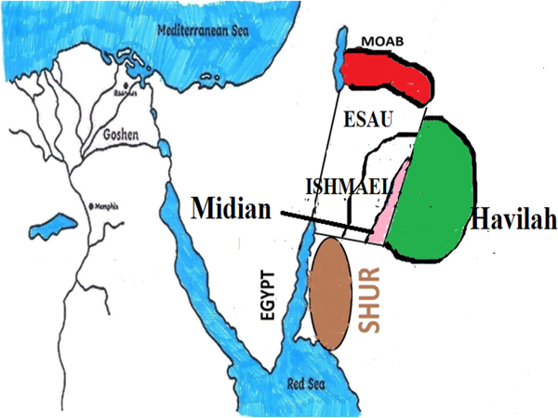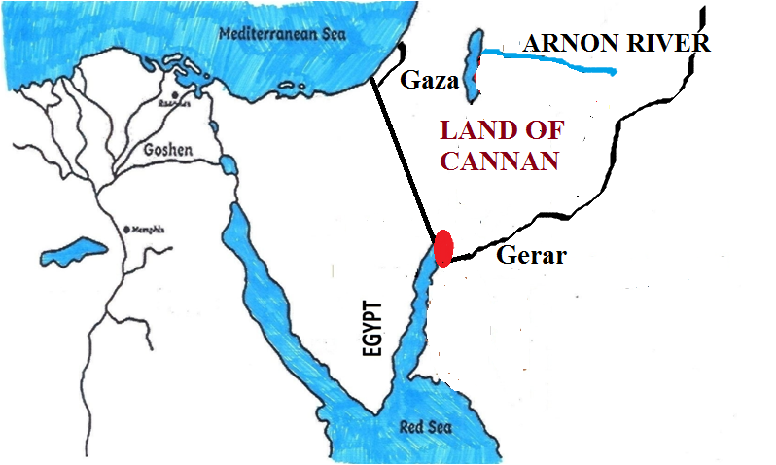

**2ehsh:14:9-14:** $\pd; re;jjpapdh; mNugpahtpd; Nkw;F gFjpapy; tho;e;jhh;fs; vd;gjw;F ,d;Dk;$l rpy Ntj Mjhuq;fis ghh;g;Nghk;. Mrh A+Njahtpd; uh[hthdNghJ (Mrhtpd; fhyk; fp.K.900) mtDf;F vjpuhf vj;jpNahg;gpa uh[h Nruh vd;gtd; 10 yl;rk; giltPuh;fSld; te;jhd; (2ehsh:14:9). Mrh me;j vj;jpNahg;gpa uh[hit Njhw;fbj;J mtid Nfuhh;tiu Juj;jp> NfuhiuAk; mjd; Rw;wpAs;s gl;lzq;fisAk; nfhs;isapl;lhd; vd;W nfhLf;fg;gl;bUf;fpd;wJ (2ehsh:14:13>14). Vd; Mrh me;j vj;jpNahg;gpa uh[hit Nfuhh; tiu Juj;jpdhd;. Vd; NfuhiuAk; mij Rw;wpAs;s gl;lzq;fisAk; nfhs;isapl;lhd;? Nfuhh; me;j vj;jpNahg;gpa uh[htpw;F nrhe;jkhd vj;jpNahg;gpa Njrj;ij rhh;e;j gl;lzkhf ,Ue;jJ. mjdhy; me;j gl;lzj;ijak; mij R+o;e;jpUe;j vj;jpNahg;gpa uh[htpw;F nrhe;jkhd gl;lzj;ijAk; A+jhtpd; uh[h nfhs;isapl;lhd;. Vj;jpNahg;gpa uh[htpw;F nrhe;jkhd ,e;j Nfuhiu fz;Lgpbj;Jtpl;lhy; vj;jpNahg;gpah vJ vd;W ehk; fz;Lgpbj;Jtplyhk;.

,e;j NfuhuhdJ vq;F ,Ue;jJ? ,e;j NfuhhpNy Mgpufhk; <rhf;F thrkhapUe;jhh;fs; (Mjp:20:1@26:6) Mgpufhk; <rhf;F Mg;gphpf;fhtpy; ,Ue;jhh;fsh? fz;bg;ghf ,y;iy. vdNt Nfhuhh; vd;gJ Mg;gphpf;fhtpy;iy. Nfuhh; Mg;gphpf;fhtpy; ,y;iy vd;why; vd;d mh;j;jk; Nfuhiu cs;slf;fpa vj;jpNahg;gpahTk; Mg;gphpf;fhtpy; ,y;iy vd;W mh;j;jk;.

,e;j vj;jpNahg;gpahit ehk; ,d;iwa Mg;gphpf;f gFjpfs; vd;W nfhz;NlhNkahdhy; 10 yl;rk; giltPuh;fs; vfpg;ij fle;J te;jpUf;fKbahJ. Vnddpy; ve;j xU uh[hTk; xU ngUk; gilia jdJ Njrj;ij fle;Jnry;Yk;gb mDkjpf;fkhl;lhd;. nrq;fliy fle;Jk; te;jpUf;fKbahJ. Vnddpy; 10 yl;rk; giltPuh;fs;> ujq;fs;> Fjpiufs; vy;yhtw;iwAk; Rke;Jnfhz;L nry;Yk; mstpw;F me;j fhyj;jpy; ngUk; flw;gilnay;yhk; fpilahJ. vdNt ,q;F nrhy;yg;gl;bUf;Fk; vj;jpNahg;gpah vd;gJ ,d;iwa vj;jpNahg;gpahNth ,d;iwa Mg;gphpf;fhNth my;y.

xUNtis Nfuhh; vfpg;jpy; ,Uf;f tha;g;G ,Uf;fpd;wjh? vfpg;jpYk; ,y;iy. mij vg;gb cWjpgLj;jyhk;. Njtd; <rhf;fplk; $Wk;NghJ eP vfpg;jpw;F nry;yhky; ehd; $Wk; ChpNy jq;fpapU vd;W Mjp:26:2y; $Wfpd;whh;. <rhf;F Njtd; $wpagb ele;jpUg;ghdh? fz;bg;ghf <rhf;F Njtd; $wpagb ele;jpUg;ghd;. vdNt mtd; vfpg;jpNy jq;fpapUf;fkhl;lhd;. mtd; vq;Nf jq;fpapUe;jhd;? NfuhhpNy jq;fp ,Ue;jhd; vd;W Mjp:26:6y; $wg;gl;bUf;fpd;wJ. mg;gbnad;why; vd;d mh;j;jk;? Njtd; $wpagb <rhf;F vfpg;jpw;F Nghfhky; NfuhhpNy jq;fpapUe;jhd;. Nfuhh; vfpg;jpYk; ,y;iy vd;gNj mjd; mh;j;jk;.

Mg;gphpf;fhtpYk; ,y;iy> vfpg;jpYk; ,y;iy. mg;gbnad;why; me;jNfuhh; vq;Nfjhd; ,Ue;jJ? NfhuhuhdJ fhdhdpd; xU vy;iy vd;W Mjp:10:19y; nfhLf;fg;gl;bUf;fpd;wJ. ,J Nfhuhiuf; Fwpj;J ekf;F fpilf;Fk; xU Kf;fpa jftyhf ,Uf;fpd;wJ. Mjp:10:19y; xU gpio fhzg;gLfpd;wJ. “Nfuhh; topahf fhrh kl;Lf;Fk;” vd;W jtwhf nkhopngah;f;fg;gl;bUf;Fk;. ,e;j nkhopngah;g;ggb ghh;j;jhy; Nfuhh; vd;gJ rPNjDf;Fk;> fhrhtpw;Fk; ,ilapy; ,Ug;gjhf vz;zj;Njhd;Wk;. mJ jtW. fhrh topahf Nfuhh; kl;Lf;Fk; vd;gNj rhp. me;j trdj;jpy; fhdhd; Njrj;jpd; Nkw;F vy;iy $wg;gl;bUf;fpd;wJ. fhdhd; Njrj;jpDila Nkw;F vy;iy rPNjhdpy; Muk;gpj;J Nfuhhpy; Kbtilfpd;wJ vd;W $wg;gl;bUf;fpd;wJ. fhdhd; Njrj;jpd; Nkw;F vy;iy KbAk; ,lj;jpy; Nfuhh; ,Uf;fpd;wJ. mjdhNy Nfuhiu cs;slf;fpa vj;jpNahg;gpahTk; fhdhd; Njrj;jpd; vy;iy KbAk; ,lj;jpNyjhd; Mrhtpd; fhyj;jpNy ,Ue;jpUf;fpd;wJ.

,e;j vj;jpNahg;gpa uh[hthdtd; N\gh Njrj;J uhzpapd; topj;Njhd;wyhfNt ,Uf;fNtz;Lk;. ,tdJ fhyk; N\gh Njrj;J uhzpapd; fhyj;jpypUe;J 50-75 Mz;Lfs; js;sp ,Ue;jJ. N\gh Njrj;J uhzp nkhj;j vj;jpNahg;gpahitAk; Mz;lJNghy mtsJ re;jjpahd ,tDk; VkdpypUe;J R+h; tdhe;juk; tiuf;Fk; cs;s (Nfuhh; tiuf;FKs;s) nkhj;j vj;jpNahg;gpahitAk; Mz;bUg;ghd; vd;w KbTf;F ehk; tuyhk;. vdNt $+h; tdhe;jpuk; mUNf (mNugpa jPgfw;gj;jpy;) $\pd; re;jjpapdh; Mrh fhyj;jpYk; ,Ue;jpUf;fpd;whh;fs;. Mrhtpd; fhyk; fp.K.900Mk; Mz;L. fp.K.900k; Mz;bYk; mNugpa jPgfw;gj;jpy; $\pd; re;jjpapdh; gj;J yl;rk; tPuh;fis nfhz;L MSif nra;Ak; mstpw;F typikNahL ,Ue;jpUf;fpd;whh;fs;.

**2ehsh:21:16:** mNugpahtpd; Nkw;fpNy fWg;gpdj;jhh; ,Ue;jhh;fs; vd;gjw;F ,d;DnkhU Ntj Mjhuj;ijAk; ehk; ghh;g;Nghk;.A+Njahtpd; uh[hthd Nahuhk; fhyj;jpy; mNugpah;fs; vj;jpNahg;gpahtpw;F mLj;j Njrj;jpypUe;jpUf;fpd;whh;fs; (“vj;jpNahg;gpahTf;fLj;j Njrj;jhuhd mugpahpd; MtpiaAk;”) vd;W Ntjj;jpy; $wg;gl;bUf;fpd;wJ. $\pd; re;jjpapdh; nrq;flYf;F Nkw;Nf cs;s Mg;gphpf;fhtpy; ,Ue;jpUe;jhy; mNugpah mth;fSf;F mLj;j ehlhf ,Uf;fKbahJ. Vnddpy; ,ilapy; nrq;fly; ,Uf;fpd;wJ. $\pd; re;jjpapdh; Nahuhk; fhyj;jpy; mNugpa jPgfw;gj;jpd; Nkw;F gFjpapy; ,Ue;jhh;fs;. mNugpah;fs; mNugpa jPgfw;gj;jpd; Nkw;F gFjp jtpu kw;w vy;yh gFjpfisAk; tpahgpj;J ,Ue;jhh;fs;. mjdhNyNa Ntjk; vj;jpNahg;gpahtpw;F mLj;j Njrkhd mNugpah vd;W $Wfpd;wJ. NahuhkpDila fhyk; (,td; MrhtpDila Ngud;) 9k; E}w;whz;bd; Kd;gFjp. vdNt fp.K.850 tiuapYk; $\pd; re;jjpapduhfpa fWg;gpdj;jhh; mNugpahtpd; Nkw;F gFjpapy; tho;e;jpUf;fpd;whh;fs; vd;gJ ekf;F ,e;j trdj;jpd; %ykhf njhpatUfpd;wJ.

**Ntjhfkj;jpw;F ntspNa Mjhuk;:** mNugpahtpd; Nkw;F fiuapYk; $\pd; re;jjpapdh; ,Ue;jhh;fs; vd;gjw;F Ntjhfkj;jpw;F ntspNaAk; ehk; xU Mjhuj;ij ghh;f;fyhk;. fp.K.8k; E}w;whz;by; tho;e;j Homer vd;w fpNuf;f mwpQh; nrq;flYf;F ,uz;L GuKk; $\pd; re;jjpah; FbapUe;jhh;fs; vd;W $wpapUf;fpd;whh;. mth; vj;jpNahg;gpah;fs; cyfj;jpd; fpof;F kw;Wk; Nkw;F Mfpa ,uz;L KidfspYk; tho;tjhfTk;> me;j ,uz;L KidfisAk; xU fly; gphpg;gjhfTk; $wpapUf;fpd;whh; mth; tho;e;j fhyj;jpy; kj;jpa Mrpa gFjpNa fpNuf;fh;fshy; cyfkhf fUjg;gl;lJ. mth; cyfj;ij gphpf;Fk; flyhf $WtJ nrq;flyhFk;. ,jd; %yk; mth; mNugpa jPgfw;gj;jpYk;> Mg;gphpf;fhtpYk; vj;jpNahg;gpah;fs; tho;fpd;whh;fs; vd;W $wpapUf;fpd;whh;. vdNt fp.K.750y; mNugpa jPgfw;gj;jpd; Nkw;F gFjpfspy; $\pd; re;jjpauhfpa fWg;gpdj;jhh; tho;e;jhh;fs; vd;gJ xU tuyhw;W cz;ikahfTk; ,Uf;fpd;wJ.

mg;gbnad;why; vg;NghJ mNugpahtpy; $\pdj;jh; mope;jhh;fs;?mjw;F Ntjhfkj;jpy; VjhtJ tpsf;fk; ,Uf;fpd;wjh? vj;jpNahg;gpah uh[hthd Nruh fhyj;jpy; A+Njahtpd; uh[hthd Nahuhkhy; “jpUk;g gyq;nfhs;s Kbahjgb” $\pd; re;jjp mopf;fg;gl;lJ vd;W Ntjj;jpy; xU tuyhw;W cz;ik gjpTnra;ag;gl;bUf;fpd;wJ (2ehsh:14:13). Mk; mNugpahtpy; $\; re;jjpaUila mopthdJ A+jh;fshy;jhd; Vw;gl;lJ. mth;fs; vj;jpNahg;gpah;fspd; uhZt gyj;ij Kw;wpYk; mopj;jg;Nghl;lhh;fs;. xU [hjpahUila uhZt gyk; mopf;fg;gl;lhy; mth;fs; jq;fsJ Njrj;ij ,oe;JtpLthh;fs;. mjNghy mNugpahtpd; Nkw;F fiuapy; ,Ue;j vj;jpNahg;gpah;fSk; A+jh;fshy; uhZt gyk; ,of;fg;gl;L> mjd; gpwF mUfpYs;s mNugpah;fs; tYngw nfhQ;rk; nfhQ;rkhf ,d;iwa Vkd; kw;Wk; XkDf;Fs; Klf;fg;gl;lhh;fs;. gpd;dh; mth;fs; nfhQ;rk; nfhQ;rkhf Vkd;> XkdpYs;s mNugpah;fSld; fye;Jtpl;lhh;fs;. ,g;NghJk; Vkd;> XkdpYs;s mNugpah;fspd; (goq;Fb kf;fspd;) [Pd;fspy; 20 rjtpfpjk; $\pah;fSila (Mg;gphpf;fh;fs;) [Pd;fshfNt ,Uf;fpd;wJ.

ghNgy; NfhGuk; fl;lg;gl;L kf;fs; rpjwbf;fg;gl;ljpypUe;Nj vfpg;jpw;F njw;Nf $\pd; re;jjpauhd Nrghtpd; re;jjpah; FbNawpdhh;fs;. MdhYk; Muk;gj;jpy; mJ vj;jpNahg;gpah vd;W miof;fg;gltpy;iy. gpw;fhyj;jpy;jhd; Ntjj;jpNy vfpg;jpw;F njw;Nf cs;s gFjpfs; vj;jpNahg;gpah vd;W miof;fg;gl;lJ. Vrhah jPh;f;fjhprpapd; fhykhdJ fp.K.8k; E}w;whz;lhFk;. mth; Mg;gphpf;fhtpd; ikag; gFjpapypUe;J cw;gj;jpahfp tUk; iey; ejpia vj;jpNahg;gpa ejp vd;Nw miof;fpd;whh; (Vrh:18:1). mNj Vrhahjhd; vj;jpNahg;gpahitAk; NrghitAk; jdpj;jdpahfTk; $Wfpd;whh; (Vrh:43:3). vdNt Vrhah fhykhfpa 8k; E}w;whz;bypUe;Jjhd; mjhtJ fp.K.750y; ,Ue;Jjhd; vfpg;jpw;F njw;Nf ,Uf;Fk; $\pd; re;jjpaUila gFjpfSk; vj;jpNahg;gpah vd;W miof;fg;gl;bUf;fpd;wJ. 8k; E}w;whz;bw;F gpwF $\pd; re;jjpah; mNugpahtpy; nfhQ;rk; nfhQ;rkhf Fiwe;j gpd;dh; NtjkhdJ mNugpahtpd; Nkw;F gFjpia vj;jpNahg;gpah vd;W miog;gij jtph;j;JtpLfpd;wJ. Gjpa Vw;ghL fhyj;jpy; mNugpahtpd; Nkw;F gFjpahdJ vj;jpNahg;gpah vd;W miof;fg;gltpy;iy. khwhf $\pd; re;jjpah; FbNawpa vfpg;jpw;F njw;Nf cs;s Mg;gphpf;fhtpd; gFjp kl;LNk vj;jpNahg;gpah vd;W miof;fg;gl;lJ. Mdhy; NkhNr fhyj;jpy; (fp.K.1500y;) mNugpa jPgfw;gj;jpd; Nkw;F gFjp kl;LNk vj;jpNahg;gpah vd;W miof;fg;gl;lJ.

**fPNfhd; MW vq;F XbaJ?** NkhNr fhyj;J vj;jpNahg;gpah vJ vd;W ehk; ,g;NghJ fz;Lgpbj;Jtpl;Nlhk;. fPNfhd; MW ,e;j NkhNr fhy vj;jpNahg;gpahit Rw;wpjhd; Xbajhf $wg;gl;bUf;fpd;wJ. Mdhy; ehk; ,q;F Fwpg;gpLk; NkhNr fhyj;J vj;jpNahg;gpah Njrj;jpd; Nkw;FGwk; nrq;flYk; njw;FGwk; mugpf;flYky;yth ,Uf;fpd;wJ. flyhy; R+og;gl;l vj;jpNahg;gpahit Rw;wp vg;gb xU MW XbapUf;f KbAk; vd;W ePq;fs; Nfl;fyhk;. Kjypy; ePq;fs; xd;iw njhpe;Jnfhs;sNtz;Lk;. fPNfhd; MwhdJ vj;jpNahg;gpahit Rw;wp XbajhdJ NkhNr fhyj;jpy; my;y.

NgNyfpd; fhyj;jpNy G+kpahdJ gFf;fg;gl;lJ vd;W Ntjj;jpy; $wg;gl;bUf;fpd;wJ (Mjp:10:25). gFf;fg;gl;lJ vd;why; vd;d? G+kpahdJ mjw;F Kd;dh; xNu epyg;gug;ghf ,Ue;jJ. mg;NghJ Mg;gphpf;fhTk;> mNugpa jPgfw;gKk; gphpf;fg;glhky; ,ize;Nj ,Ue;jJ. mg;NghJ mNugpa jPgfw;gj;jpw;gj;jpw;Fk; Mg;gphpf;fhtpw;Fk; ,ilNa nrq;fly; ,Uf;ftpy;iy. mg;NghJ Mg;gphpf;fhtpw;Fk;> mNugpa jPgfw;gj;jpw;Fk; ,ilNa fPNfhd; MWjhd; Xbf;nfhz;bUe;jJ. ,d;iwa Nahh;jhd; Mw;wpd; ePl;rpahfNt md;W fPNfhd; MW ,Ue;jJ. Mk; ,d;iwa Nahh;jhd; ejpahdJ fPNfhd; Mw;wpd; kpr;rNkahFk;. ,d;iwa nrq;flyhdJ Kjypy; xU

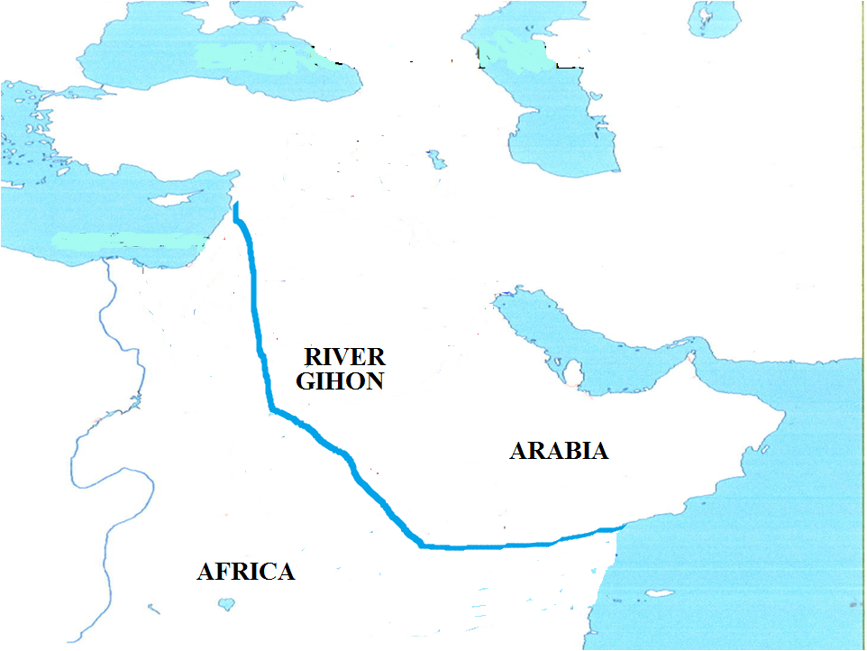

nghpa MwhfNt ,Ue;jJ. ,d;W Nahh;jhd; vd;W XLk; fPNfhd; MwhdJ Kjypy; fypNyah fliy cUthf;fp mLj;jjhf rhf;fly; cUthf;fp> mLj;jjhf nrq;fly; vd;w Vhpia cUthf;fp mNugpahtpd; njd; gFjpapy; mugpf; flypy; fye;jJ. mjdhy;jhd; NtjkhdJ fPNfhd; MwhdJ vj;jpNahg;gpa Njrj;ij Rw;wp XbaJ vd;W $Wfpd;wJ.

ve;j xU re;jjpapdUk; rKj;jpuf; fiuapNy FbapUf;fkhl;lhh;fs;. ejpf;fiuapNyjhd; ehfhPfq;fs; Njhd;wpdh;. nrq;flyhdJ $\pd; re;jjpapdh; FbNawpaNghJ flyhf ,Ue;jpUe;jhy; fz;bg;ghf mth;fs; mq;F FbNawpapUf;fkhl;lhh;fs;. nkhj;j $\pd; re;jjpapdUk; nrq;flypd; fiuapNy FbNawpapUg;gjhy; mJ mf;fhyj;jpy; MwhfNt ,Ue;jpUf;fKbAk; vd;gij ehk; cWjpnra;ayhk;.

**Nahh;jhd; jhd; Mjpahfk fPNfhd;:** ,];uNaypy; ,g;NghJ XLk; Nahh;jhd; jhd; Mjpahfk fPNfhd; vd;gjw;F rpy MjhuKk; Ntjj;jpy; ,Uf;fpd;wJ. Nahh;jhd; MW tUk; topapNyNa fPNfhd; vd;w ngah; nfhz;l gFjpfs; gy ,Ue;jjhf Ntjk; gjpTnra;jpUf;fpd;wJ.

* vUrNykpw;F mUfhNf fPNfhd; vd;w NtW xU MW ,Ue;jjhf $wg;gl;bUf;fpd;wJ (2ehsh:32:30). mJ vUrNykpw;F Nkw;Nf ,Ue;jJ (fPNfhd;jhd; fPNahd; vd;W jopopNy nkhopngah;f;fg;gl;bUf;fpd;wJ).
* vUrNykpw;F mUNf ,Uf;Fk; fPNfhd; vd;w Chpy;jhd; rhyNkhDf;F uh[hthf mgpN\fk; nra;ag;gl;lJ (1uh[h:1:33). ,JTk; vUrNykpw;F mUfhikapy;jhd; ,Ue;jpUf;fpd;wJ.
* fPNfhd; vd;W xU kiyAk; vUrNykpw;F mUNf ,Ue;jpUf;fpd;wJ (2ehsh:33:14).

fPNfhd; MW vd;gjw;F me;j ngah; vg;gb te;jpUf;Fk; vd;gJ mLj;j Nfs;tp. fPNfhd; MwhdJ jkpo; Ntjhfkj;jpy; xU ,lj;jpy; fPNahd; MW (2ehsh:32:30) vd;W miof;fg;gLfpd;wJ. ,Jjhd; fPNfhd; Mw;wpd; rhpahd cr;rhpg;ghFk;. ,e;j fPNahd; vd;w thh;j;ij vjpypUe;J te;jpUf;Fk;? ehk; vw;fdNt rPNahd; vd;w thh;j;ijia Muha;e;j ghh;j;Njhk;. vh;Nkhd; kiyf;Fk; rPNahd; vd;w ngah; cz;L vd;W ghh;j;Njhk;. rPNahd; kiyahfpa vh;Nkhd; kiyapy; cw;gj;jpahdjhy; me;j Mw;wpw;F Kjypy; rPNahd; MW vd;W ngah; Vw;gl;lJ. mJ ghAk; gFjpfSk; rPNahd; vd;Nw miof;fg;gl;lJ. Fwpg;ghf fPNfhd; MW gha;e;j vUrNykhdJ rPNahd; vd;Nw miof;fg;gl;lJ. mjd; gpwF me;j Mw;wpd; ngauhdJ fPNahd;> fPNfhd; vd;W khwpapUf;fyhk;. me;j MW gha;e;j gFjpapy; cs;s vUrNykhdJ njhlh;e;J rPNahd; vd;Nw toq;fg;gl;L te;jJ. rpy ,lq;fs; fPNahd;> fPNfhd; vd;W khwpaJ.

**Ig;gpuhj;J:**

mLj;jjhf Ntjhfkj;jpy; $wg;gl;l Ig;gpuhj;J ejpiaf; Fwpj;J ghh;g;Nghk;. VNjdpypUe;J xba ehd;fhk; MW ,J (,jw;F mLj;jjhf ehk; %d;whk; Mwhd ,njf;Nfy; Mw;iw Fwpj;J ghh;g;Nghk;).rhp ,e;j ejp vq;F XbaJ? ,g;NghJ Xbf;nfhz;bUf;Fk; Ig;gpuhj;Jjhd; Ntjhfkj;jpNy $wg;gLk; Ig;gpuhj;jh? vh;Nkhd; kiyjhd; VNjd; Njhl;lj;jpw;F ePiu nfhz;Lte;j MW cw;gj;jpahd kiy vd;W ehk; Vw;fdNt ep&gpj;jpUf;fpd;Nwhk;. vdNt Ntjhfk Ig;gpuhj;J ejp vd;gJ VNjd; Njhl;lj;jpd; mUNf cs;s ghpRj;j gh;tjhkhfpa vh;NkhdpypUe;Nj cw;gj;jpahfNtz;Lk;. Mdhy; ,g;NghJ Xbf;nfhz;bUf;Fk; Ig;gpuhj;J vd;gJ JUf;fpapy; cw;gj;jpahfpd;wJ. mJ vg;gb Ntjhfk Ig;gpuhj;jhf ,Uf;f KbAk;. vdNt Ntjj;jpNy nrhy;yg;gl;l Ig;gpuhj;Jk;> ,g;NghJ Xbf;nfhz;bUf;Fk; Ig;gpuhj;Jk; NtwhdJ. ,ij ehk; Ntj trdq;fisf;nfhz;L Muha;e;J ghh;g;Nghk;.

Njtd; Mgpufhkpw;F thf;Fjj;jk; nfhLj;jNghJ mtdJ re;jjpaUf;F vfpg;J ejp njhlq;fp Ig;gpuhj;JtiuAs;s gFjpfis jUNtd; vd;W thf;Fjj;jkhf $Wfpd;whh; (Mjp:15:18). me;j thf;Fjj;jj;jpNy ,];uNaYila tlf;F njw;F vy;iy $wg;gl;bUf;fpd;wJ. ,];uNaypd; njw;F vy;iyahf vfpg;jpd; ejp $wg;gl;bUf;fpd;wJ. vfpg;jpd; ejp vd;why; vJ? vfpg;jpd; ejp vd;why; iey; ejpia Fwpf;fpd;wjh? vfpg;jpd; ejp vd;gJ iey; ejp my;y. iey; ejpahdJ vj;jpNahg;gpahtpd; MW vd;Wjhd; Ntjj;jpNy miof;fg;gLfpd;wJ vd;W ehk; Kd;dNu ghh;j;jpUf;fpd;Nwhk;. mg;gbnad;why; ,];uNaypd; njd; vy;iyahd me;j vfpg;jpd; ejp vJ? vfpg;J kw;Wk; ,];uNaypd; vy;iyfspy; ,Uf;Fk; rPNfhh; ejpjhd; vfpg;jpd; ejp mFk;. NahRth:13:2y; “vfpg;Jf;F vjpuhd rPNfhh; MW” vd;W $wg;gl;bUf;fpd;wJ (vfpg;jpw;F cs;shf XLk; iey; ejp my;y). vdNt vfpg;jpd; MW vd;gJ vfpg;jpw;F vjpuhf> ,];uNaYf;Fk; vfpg;jpw;Fk; vy;iyahf ,Uf;Fk; rPNfhh; MNw MFk;. ,JNt Ntjj;jpy; gy ,lq;fspy; vfpg;jpd; ejp vd;W miof;fg;gLfpd;wJ. vdNt ,];uNaypd; njd; vy;iyahdJ rPNfhh; MW MFk;. ,J frhtpw;F njw;fhf cs;sJ.

rPNfhh; ejpahdJ ,];uNaypd; njd; vy;iy vd;why; Ig;gpuhj;J ejpahdJ ,];uNaypd; tl vy;iyahf ,q;F $wg;gl;bUf;fpd;wJ. NkhNrAk; tlf;Nf Ig;gpuhj;J ejptiu ,];uNayh;fis Nghfr;nrhy;Yfpd;whh; (cgh:1:7 - ,jpypUe;J NkhNr fhyj;jpy; Ntjhfk Ig;gpuhj;J ejp XbaJ vd;W njhpfpd;wJ). vdNt ,];uNayh;fSila tl vy;iyahdJ Ig;gpuhj;J ejpNa. Ntjj;jpNy ejp vd;W nghJthf $wpdhy; mJ ,];uNaypd; tl vy;iyahf ,Ue;j me;j Ig;gpuhj;J ejpiaNa Fwpf;Fk; vd;gijAk; ehk; epidtpy; nfhs;sNtz;Lk; (ahj;:23:31). Ntjhfk Ig;gpuhj;J vd;gJ ,];uNaypd; (fhdhd; Njrj;jpd;) tl vy;iyapy; ,Ue;jjhy;> Ig;gpuhj;J ejp vq;Nf XbaJ vd;W fz;Lgpbf;fNtz;Lnkd;why; ,];uNaypd; tl vy;iyapy; cs;s gFjpfs; vd;dntd;gij ehk; ghh;f;fNtz;Lk;.

Njtd; ,];uNayh;fSf;F fhdhdpah; FbapUe;j Njrj;ijjhd; Rje;jukhf nfhLg;gjhf thf;Fjj;jk; nfhLj;jhh; (Mjp:17:8). fhdhDila NjrkhdJ tlf;Nf xUNghJk; jk];Fit jhz;b ,Uf;ftpy;iy. vdNt ,];uNayh;fspd; tlvy;iyahdJ jk];Ftpw;F tlf;fhf ,Uf;f tha;g;gpy;iy. MfNt jk];Ftpw;F gy E}W fpNyhkPl;lh; tlf;fhf cs;s ,d;iwa rphpahtpYs;s Ig;gpuhj;ij ,];uNaypd; tlvy;iy vd;W ehk; vz;zf;$lhJ. ,d;iwa Ig;gpuhj;J ejpahdJ jk];FtpypUe;J Rkhh; 1500 fp.kPl;lh; J}uj;jpy; ,Uf;fpd;wJ. Ntjhfkj;jpy; $wg;gl;l ehyhk;; Mwhfpa Ig;gpuhj;jhdJ vh;Nkhd; kiyapy; cw;gj;jpahfp jk];Ftpw;F

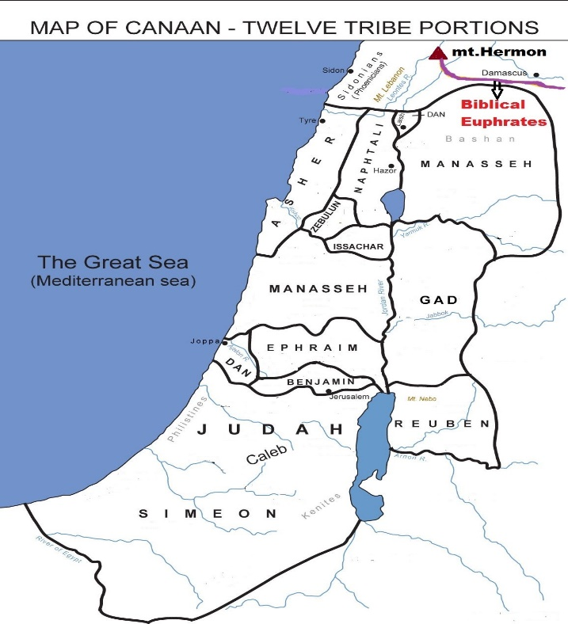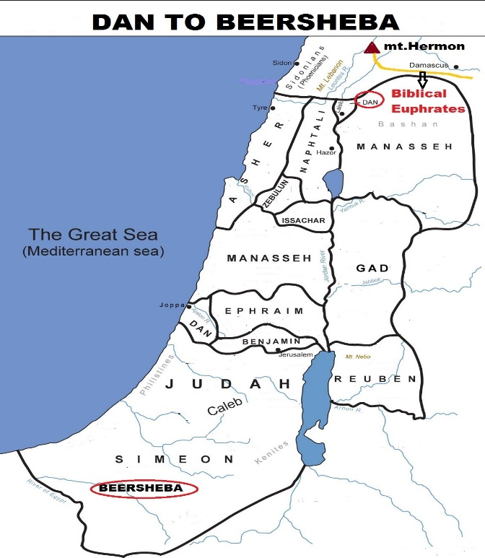

njw;fhf Xba ejpahfNt ,Ue;jpUf;fNtz;Lk;.

,];uNaypd; tl kw;Wk; njd; vy;iy jhz; Kjy; ngnah;nrgh tiu vd;W gy ,lq;fspy; nfhLf;fg;gl;bUf;fpd;wJ (epah:20:1@ 1rhK:3:20@ 2rhK:17:11@ 24:2>11>15@ 1uh[h:5:5@ 1ehsh:21:2@ 2ehsh:30:5). jhz; vd;gJ vh;Nkhd; kiyaUNf vh;NkhidAk; cs;slf;fpajhf ,Uf;fpd;wJ (jk];Ftpw;F njw;fhfNt ,Uf;fpd;wJ). jhz;jhd; ,];uNayh;fSila tlvy;iy vd;W mj;jid trdq;fSk; njspthf $Wfpd;wJ. vdNt ,];uNaypd; tl vy;iyapy; Xba Ig;gpuhj;J ejpAk; ,e;j jhzpd; mUNfjhd; XbapUf;f Ntz;Lk;. jhzhdJ vh;Nkhd; kiyaUNf ,Ug;gjhy; Ntjhfk Ig;gpuhj;Jk; vh;Nkhd; kiyapNy cw;gj;jpahfp> jk];Ftpw;F njw;fhf XbapUf;fNtz;Lk;.

Ntjj;jpy; ,];uNaYila tlf;F vy;iy Mkhj; vd;Wk; gy ,lq;fspy; nfhLf;fg;gl;bUf;fpd;wJ (1uh[h:8:65@1ehsh:13:5@ 2ehsh:7:8@ vz;:13:21@ Vrh:11:11):

* Mkhj;jpw;F tlf;Nf jk];Ftpd; vy;iy ,Uf;fpd;wJ vd;W vNr:48:1y; $wg;gl;bUf;fpd;wJ. vdNt Mkhj; vd;gJ jk];Ftpd; njw;fhf ,Uf;fpd;w xU gl;lzkhFk;.
* Mkhj; tiu Vtpah;fSila Fbapg;G gFjpahf ,Ue;jJ (epah:3:3). Vtpah;fs; vd;gth;fs; fhdhdpah;fNs. NahR:11:3y; vh;Nkhd; kiyabthuj;jpy; Vtpah; FbapUe;jhh;fs; vd;W $wg;gl;bUf;fpd;wJ. vdNt Mkhj; vd;gJ vh;NkhDf;F mUNfAk;> fhdhd; Njrj;jpw;F cl;gl;l xU CuhfTNk Ntjk; $Wfpd;wJ.
* NahR:13:5y; Mkhj;jhdJ yPgNdhdpd; vy;iyapy; cs;sJ vd;W $wg;gl;bUf;fpd;wJ.

Mkhj; vd;gJ vy;yh tifapYk; jk];Ftpw;F njw;fhf cs;sJ vd;W Nkw;fz;l trdq;fs; %yk; tpsf;fpAs;Nshk; (rphpahtpYk; xU Mkhj; cz;L. me;j Mkhj; ,q;F $wg;gltpy;iy). Ig;gpuhhj;ij Nghd;W Mkhj;Jk; ,];uNaypd; xU tl vy;iy Mjyhy; Mjpahfk Ig;gpuhj;J ejpAk; jk];Ftpw;F njw;fhf Mkhj;jpw;F mUfhfNt XbapUf;fNtz;Lk;.

,Jtiu Ig;gpuhj;jhdJ vh;Nkhd; kiyapy; njhlq;fp jk];Ftpw;F njw;fhf> ,];uNay; Njrj;jpd; tlvy;iyahf XbaJ vd;W ghh;j;Njhk;. mjd; gpwF me;j Ig;gpuhj;J ejpahdJ vg;gb XbaJ vd;gjw;F Ntjhfkj;jpy; VjhtJ tpsf;fk; ,Uf;fpd;wjh? Ig;gpuhj;J ejp ,];uNaYf;F fpof;F vy;iyahfTk;> Fwpg;gplg;gl;bUf;fpd;wJ (cgh:11:24@ NahR:1:4@ 1ehsh:5:9).

**1.cgh:11:24.** *cq;fs; cs;sq;fhy; kpjpf;Fk; ,lnky;yhk; cq;fSilajhapUf;Fk;@ tdhe;juj;ijAk; yPgNdhidAk; njhlq;fp> Igpuhj;J ejpiaAk; njhlq;fp> filrpr; rKj;jpuk; tiuf;Fk; cq;fs; vy;iyahapUf;Fk;.*

Deu 11:24  Every place whereon the soles of your feet shall tread shall be yours: from the wilderness and Lebanon, from the river, the river Euphrates, even unto the uttermost sea shall your coast be.

Mq;fpyj;jpy; ,e;j trdk; kpfnjspthf GhpAk;gb ,Uf;fpd;wJ. ,];uNaypd; njw;F vy;iy rPd; tdhe;jukhFk;. tlf;F vy;iy yPgNdhd; (vh;Nkhd; kiy KOtJk; NahR:13:11). fpof;F vy;iy Ig;gpuhj;J Nkw;F vy;iy kj;jpajiuf; fly; (filrp rKj;jpuk;) vd;W $wg;gl;bUf;fpd;wJ. ehk; Vw;fdNt ,];uNayh;fSila tlf;F vy;iy Ig;gpuhj;J vd;W ghh;j;Njhk;. ,q;F ,];uNayh;fSila fpof;F vy;iyAk; Ig;gpuhj;J vd;Nw $wg;gl;bUf;fpd;wJ. vh;Nkhdpy; cw;gj;jpahfp ,];uNaypd; tlvy;iyahf Xbf;nfhz;bUe;j Ig;gpuhj;J ejpahdJ njw;F Nehf;fp tise;J ,];uNay; Njrj;jpw;fhd fpof;F vy;iyahfTk; ,Ue;jJ vd;gij ehk; ,jd; %yk; njhpe;Jnfhs;syhk;.

**2.NahR:1:4:** *tdhe;juKk; ,e;j yPgNdhDk; njhlq;fp Igpuhj;J ejpahd nghpa ejpkl;LKs;s Vj;jpahpd; Njrk; midj;Jk;> #hpad; m];jkpf;fpw jpirahd nghpa rKj;jpuk;tiuf;Fk; cq;fs; vy;iyahapUf;Fk;.*

Jos 1:4  From the wilderness and this Lebanon even unto the great river, the river Euphrates, all the land of the Hittites, and unto the great sea toward the going down of the sun, shall be your coast.

,e;j trdKk; Mq;fpyj;jpy; rhpahf Ghpe;Jnfhs;Sk;gb ,Uf;fpd;wJ. fpof;fpypUe;J Nkw;fhf ,];uNaypd; vy;iyia nrhy;Yk;NghJ Ig;gpuhj;J ejpapy; Muk;gpj;J> nkhj;j Vj;jpaUila ehL KOtJk; nrd;W Nkw;Nf kj;jpajiuf;flypy; Kbfpd;wJ vd;W $wg;gl;bUf;fpd;wJ. mjhtJ Ig;gpuhj;J ,];uNaYf;F fpof;F vy;iyahfTk; kj;jpa jiuf;fly; (nghpa rKj;jpuk;) Nkw;F vy;iyahfTk; ,Ue;jJ vd;W $wg;gl;bUf;fpd;wJ.

3.&gd; Nfhj;juj;jhUf;F Ig;gpuhj;J ejpf;fiuahdJ fpof;F vy;iyahf ,Ue;jJ vd;W Ntjk; $Wfpd;wJ. 1ehsh:5:9. *“fpof;Nf Ig;gpuhj;J ejpnjhlq;fp tdhe;juj;jpd; vy;iykl;Lk; mth;fs; thrk;gz;zpdhh;fs;@ ,th;fs; MLkhLfs; fPNyahj;Njrj;jpy; kpFjpahapw;W”.* ,jpNy &gd; Nfhj;jpuj;jpd; fpof;F vy;iy $wg;gl;bUf;fpd;wJ. &gdpd; njw;F vy;iy mh;Ndhd; ejpahFk; (cg;Gf;flypd; kj;jpa gFjp). Nkw;F vy;iy rhf;fly; kw;Wk; mij rhh;e;j Nahh;jhd; MW MFk;. Mdhy; &gd; Nfhj;jpuj;jhhpd; fpof;F vy;iy Ig;gpuhj;J ejp vd;W nfhLf;fg;gl;bUf;fpd;wJ. ,ijgpbj;J nfhz;L rpyh; ,];uNaYf;F fpof;Nf ,d;W <uhf;fpy; Xbf;nfhz;bUf;Fk; Ig;gpuhj;J tiu ,];uNaypd; vy;iy vd;W NfhUfpd;whh;fs;. mitnay;yhk; ghgpNyhDf;Fk;> mrPhpahtpw;Fk; nrhe;jkhd ,lkhf ,Ue;jJ. xUNghJk; &gd; Nfhj;jpuj;jhh; ,d;iwa Ig;gpuhj;Jtiu FbapUf;ftpy;iy. rhf;flypypUe;J ,d;iwa Ig;gpuhj;jpw;F nry;yNtz;Lnkd;why; Fiwe;jgl;lk; 1000 fp.kP. tUk;. ,];uNayh;fSf;F nfhLf;fg;gl;l Njrj;jpd; nkhj;j ePsNk (tlf;F njw;fhf) 500 fp.kPl;lUf;Fs;jhd; tUk;. &gd; Nfhj;jpuj;jhUf;F nfhLf;fg;gl;l Njrj;jpd; tlnjd; jpirapd; ePsk; mjpfgl;rk; 150 fp.kPl;lh; jhdpUf;Fk;. mg;gbapUf;f &gd; Nfhj;jpuj;jhUf;F nfhLf;fg;gl;l Njrj;jpd; mfyk; kl;Lk; 1000 fp.kPl;luhf ,Uf;Fk; vd;gJ ajhh;j;jj;jpd;gbAk; rhj;jpkpy;iy> Ntjj;jpd;gbAk; jtW> tuyhw;wpYk; ve;j MjhuKk; ,y;iy.

&gdpd; njw;F vy;iy mh;Ndhd; ejpahFk;. Nkw;F vy;iy rhf;fliy kw;Wk; mij rhh;e;j Nahh;jhd; MW MFk;. tlf;F vy;iy fhj; Nfhj;jpukhFk;. 1ehsh:5:9y; &gdpd; fpof;F vy;iy gw;wp kl;LNk $wg;gl;bUf;fpd;wJ. &gd; Nfhj;jpuj;jpd; fpof;F vy;iy Nky; ghjp Ig;gpuhj;J ejpahFk;. fpof;F vy;iyapd; ,d;DnkhU gFjp mNugpa tdhe;jukhFk;. mjhtJ &gd; Nfhj;jpuj;jpd; fpof;F vy;iyapy; xU gFjpjhd; Ig;gpuhj;J ejp ,Uf;fpd;wJ. kWghjp tdhe;juk; vd;W nfhLf;fg;gl;bUf;fpd;wJ. &gd; Nfhj;jpuj;jpw;F fpof;F vy;iyahf ,Ue;j Ig;gpuhj;J ejp> &gd; Nfhj;jpuj;jpd; fpof;F vy;iyapy; ghjp J}uk; Xb gpd;dh; tlfpof;F jpirapy; tise;jpUf;fpd;wJ (gpd;dh; ,d;iwa Ig;gpuhj;jpd; topjlj;jpy;; Xl;lj;jpNy XbapUf;f Ntz;Lk;) vd;gij ,jd; %ykhf ehk; Ghpe;Jnfhs;s Kbfpd;wJ. ,ijNa “Ig;gpuhj;J ejpnjhlq;fp tdhe;jpuj;jpd; vy;iykl;Lk;” mth;fsJ fpof;F vy;iy vd;W nfhLf;fg;gl;bUf;fpd;wJ.

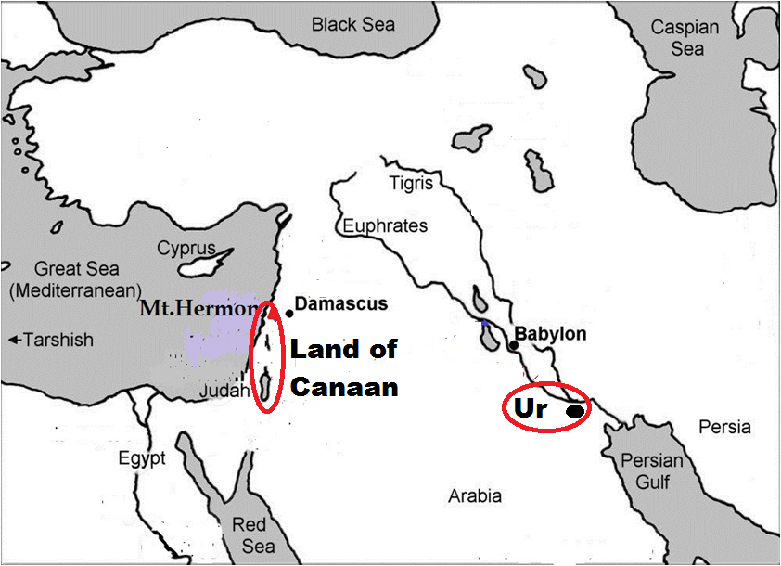 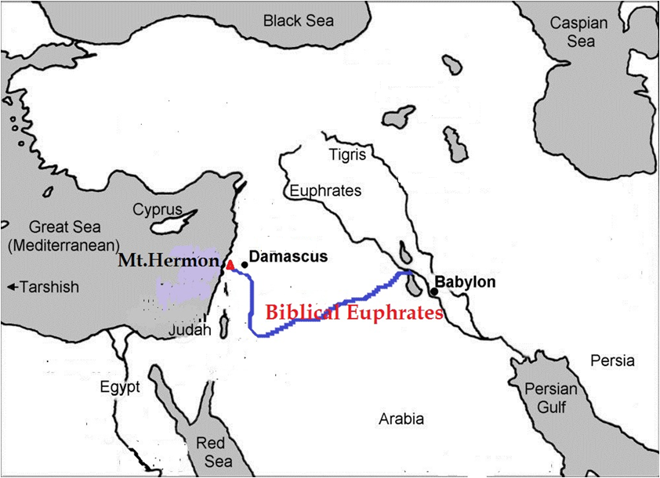

Njtd; ,];uNayh;fSf;F fhdhd; Njrj;ijNa thf;Fjj;jk; nra;jhh;. ,th;fs; $w;Wgb ghh;j;jhy; fhdhd; NjrkhdJ ,d;iwa <uhf; tiu ,Ue;jpUf;f Ntz;Lk;. Xd;W njhpAkh cq;fSf;F> Mgpufhk; ,];uNaYf;F Neh; fpof;Nf ,g;NghJ ,Uf;fpd;w Ig;gpuhj;jpd; fiuapNy Ch; vd;w ,lj;jpy;jhd; tho;e;jhd;. ,th;fs; $w;Wgb ghh;j;jhy; Mgpufhk; Vw;fdNt fhdhd; Njrj;jpNyjhd; tho;e;jpUf;fpd;whd;. mtd; ,Ug;gNj fhdhd; Njrk; vd;why; gpd;dh; vjw;F Njtd; mtid mq;fpUe;J fhdhd; Njrj;jpw;F mioj;Jnry;yNtz;Lk;. mtdJ Njrj;ijNa kPz;Lk; mtDf;F nfhLf;f mtid Njtd; vj;jidNah fpNyhkPl;lh;fs; mtid $l;btuNtz;ba mtrpakpy;iyNa. ,];uNaypd; fpof;F vy;iy ,d;iwa Ig;gpuhj;J vd;W nrhy;Ygth;fs; Mgpufhk; fhdhd; Njrj;jpNyjhd; ,Ue;jhd; vd;W $Wgth;fSf;F xg;ghdth;fNs.

vdNt Ig;gpuhj;jhdJ vh;Nkhdpy; (VNjd; kiy) cw;gj;jpahfp jk];Ftpw;F njw;fhf> ,];uNaypd; tl vy;iyapy; Xb gpd;dh; njw;fhf tise;J ,];uNaYf;F fpof;F vy;iyahfTk; Xb> &gd; Nfhj;jpuj;jpd; fpof;Nf vy;iyapy; ghjpapy; tise;J gpd;dh; ,d;iwa Ig;gpuhj;Jld; ,ize;J ngh;rpa tisFlhtpy; fye;jpUf;f Ntz;Lk;.

Njtd; NkhNrf;F ehd;F ejpfis gw;wp tpthpf;ifapy; Ig;gpuhj;J jtpu kw;w %d;W ejpfSk; ve;j gf;fj;jpy; XbaJ vd;W tpthpf;fpd;whh;. Mdhy; Ig;gpuhj;J ejpia gw;wp kl;Lk; tpthpf;fNt ,y;iy. mJ vq;F XbaJ vd;Wk; nrhy;ytpy;iy. Vnddpy; mg;NghJ (NkhNr fhyj;jpy;) Ig;gpuhj;J ejp Xbnfhz;bUe;jjhy; mij mjpfkhf tpthpf;f mtrpakpy;iy. kiwe;jNghd kw;w %d;W ejpfs; Fwpj;Nj me;j ejpfs; vt;topahf XbaJ vd;W tpthpj;J $Wfpd;whh;. me;j Ig;gpuhj;J ejp NkhNr fhyj;jpy; Xbf;nfhz;bUe;j fhuzj;jpdhNyjhd; Ig;gpuhj;J ejptiu nry;Yk;gb Njtd; ,];uNayh;fSf;F $Wfpd;whh; (cgh:1:7). VNjdpypUe;J Xbte;j Ig;gpuhj;J ejpkl;LNk [yg;gpusaj;jpw;F gpd;dUk; NkhNr fhyj;jpYk; Xbf;nfhz;bUe;jJ vd;gjw;F ,itnay;yhk; Mjhukhf ,Uf;fpd;wJ. kw;w %d;W ejpfSk; [yg;gpusaj;NjhL Kw;wpYk; my;yJ XusT mope;Jtpl;lJ.

**,njf;Nfy; MW:**

VNjd; topahf Xba ehd;F MWfspy; %d;whtJ MW ,njf;NfyhFk;. “mJ mrPhpahTf;Ff; fpof;Nf XLk;” vd;W $wg;gl;bUf;fpd;wJ (Mjp:2:14). ,njf;Nfy; vt;topahf XbaJ vd;gijf; Fwpj;J ekf;F ,Uf;Fk; xNu Ntjhfkj; jfty; ,JNt. ,d;iwf;F Xbf;nfhz;bUf;Fk; ilf;hP]; ejp jhd; Ntjhfk ,njf;Nfy; vd;W gyUk; vz;Zfpd;whh;fs;. ehk; mrPhpa uh[;[paj;jpd; glj;ij tiue;J ghh;j;NjhNkahdhy; ,g;Nghija ilf;hPrhdJ mrPhpahtpw;F fpof;fhf Xltpy;iy. khwhf mrPhpahtpw;F cs;shf Xbf;nfhz;bUf;fpd;wJ vd;W njhpatUk;. vdNt ,d;iwa ilf;hP]; MwhdJ fz;bg;ghf Ntjhfk ,njf;Nfyhf ,Uf;fKbahJ.

ehk; Vw;fdNt VNjd; Njhl;lk; yPgNdhd; gs;sj;jhf;fpy; ,Ue;jJ vd;Wk;> mjw;F ePiu nfhz;Lte;j MWfs; mjd; mUNf cs;s ghpRj;j gh;tjkhfpa vh;Nkhd; kiyapy;jhd; cw;gj;jpahfpapUf;f Ntz;Lk; vd;Wk; ep&gpj;jpUf;fpd;Nwhk;. Mdhy; ,d;W Xbf;nfhz;bUf;Fk; ilf;hP]; ejpahdJ JUf;fpapy; cw;gj;jpahfpd;wJ. vdNt ,d;W Xbf;nfhz;bUf;Fk; ilf;hP]hdJ Ntjhfk ,njf;Nfy; my;y.

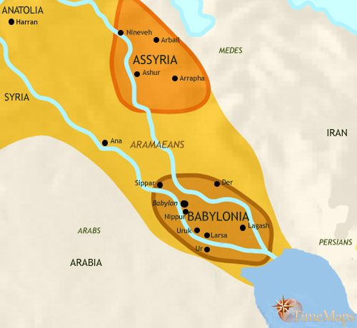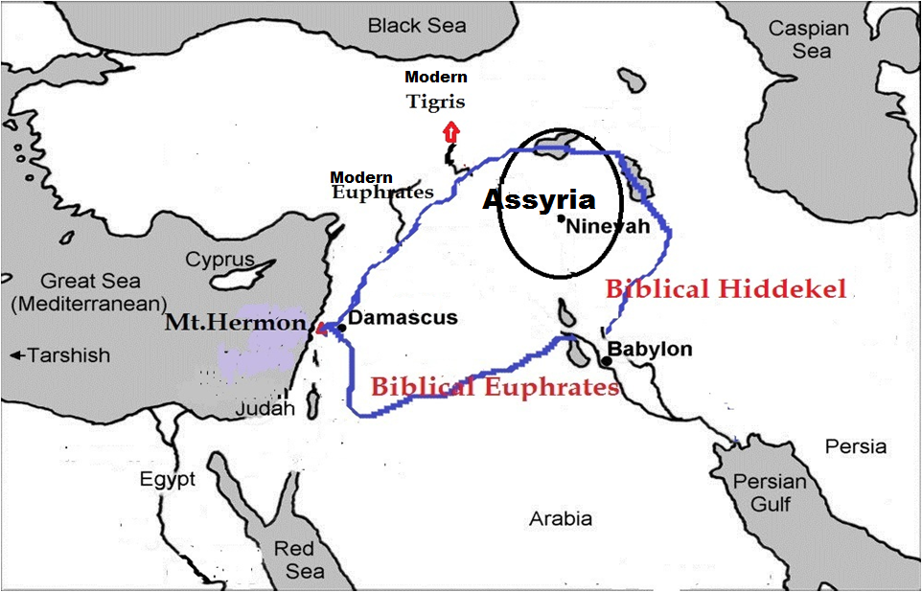

Ntjhfk ,njf;Nfy; MwhdJ vh;Nkhd; kiyapy; cw;gj;jpahfp tlfpof;fhf Xb mrPhpah Njrj;ij Rw;wp> mjd; fpof;fhf Xb gpd;dh; njw;F Nehf;fp tise;J ,d;iwa ilf;hP]; Mw;wpd; ghijapy; nrd;wJ. NkYk; ,d;W Xbf;nfhz;bUf;Fk; A+g;ul;B]; kw;Wk; ilf;hP]; Mfpa ejpfs; ,d;W Nghy mf;fhyj;jpy; JUf;fpapypUe;J ngh;rpa tisFlhtiu xNu ePskhf Xltpy;iy. mit ,uz;Lk; JUf;fpapy; cw;gj;jpahfp njw;fhf Xbte;J Ntjhfk ,njf;NfYld; ,ize;jd. mitfs; Ntjhfk ,njf;NfYf;F xU Jiz ejpNghyNt ,Ue;jJ.

NkhNrfhyj;jpy; ,njf;Nfy; MW ,y;iy. vdNtjhd; mrPhpahtpd; fpof;Nf XLk; vd;W Chpd; ngiur; nrhy;yp Ntjj;jpy; $wg;gl;bUf;fpd;wJ. NkhNr fhyj;jpy; ,Ue;jpUe;jhy; ,e;j topahf XbaJ vd;W Chpd; ngaiur; nrhy;yp tpsf;fNtz;ba mtrpakpy;iy. vdNt ,e;j ejpahdJ NkhNr fhyj;jpw;F Kd;dh; kiwe;jpUf;f Ntz;Lk;. ,njf;Nfy; jilgl;lTld; ,njf;Nfypd; xU fpisejpahf ,Ue;j ilf;hP]; MwhdJ jdJ ghijia njw;F Nehf;fp Neuhf;fp mrPhpa Njrj;jpw;F cs;shf Xb> mrPhpahtpd; njw;Nf te;j gpwF gioa ,njf;Nfypd; ghijapy; XbaJ. ilf;hP]pd; njd; gFjpahdJ ,njf;Nfypd; ghijapNyNa njhlh;e;J ,Ue;jjhy; ,njf;Nfypd; njw;F gFjpapy; ,Ue;j ngh;rpah;fSk;> kw;wth;fSk; njhlh;e;J me;j ejpia ,njf;Nfy; vd;Nw mioj;jhh;fs;. mth;fisg; nghWj;jtiu ,njf;Nfy; ejpapy; ve;j khw;wKk; Vw;gltpy;iy. mjdhNyNa ngh;rpahtpy; ,Ue;j jhdpNaYk; ngh;rpah;fs; mioj;jJNghy ilf;hP]; Mw;iw ,njf;Nfy; MW vd;Nw miof;fpd;whh; (jhdp:10:4).

ehk; fhtphp nly;lhtpy; tho;e;J tUfpd;Nwhk; vd;W itj;Jf;nfhs;Nthk;. fhtphp Mw;wpd; Nkw;F gFjpapy; mjhtJ fh;ehlhfh gFjpapy; mjd; Xl;lj;jpy; khw;wk; Vw;gl;lhy; ehk; mij ve;jtpjj;jpyhtJ fz;Lnfhs;Nthkh. mjd; cw;gj;jp ];jhdkhdJ FlfpypUe;J ePyfphpf;F khwptpl;lJ vd;whYk; ehk; mij fz;Lnfhs;sg;Nghtjpy;iy. mjd; ngaiu ehk; khw;wp miog;gjpy;iy. Vnddpy; ek;ikg; nghWj;jtiu nly;lhtpy; Xbf;nfhz;bUg;gJ fhtphpNa. mNjNghy ,njf;Nfypd; njw;Nf ,Ue;j ngh;rpah;fis nghWj;jtiu ,njf;Nfypd; ,e;j khw;wk; mth;fis ve;jtpjj;jpYk; ghjpf;ftpy;iy. mth;fs; njhlh;e;J me;j Mw;iw ,njf;Nfy; vd;Nw mioj;jhh;fs;. jhdpNaypy; ,njf;Nfy; vd;W $wg;gl;bUg;gjhy; ,d;iwa ilf;hPi] ehk; Ntjhfk ,njf;Nfy; vd;W vz;zf;$lhJ.

VNjdpy; ,njf;Nfy; jilgl;lTld; JUf;fpapypUe;J Xba ,njf;Nfypd; ,d;DnkhU fpis ejpahdJ NkYk; njw;F Nehf;fp Neuhf Xb Ntjhfk Ig;gpuhj;Jld; fye;J XbaJ. mJtiu ,njf;Nfypd; fpis ejpahf Xba me;j MW mJKjy; Ig;gpuhj;J ejpapd; fpis ejpahdJ. vdNt me;j ejpAk; Ig;gpuhj;J vd;W nrhy;yg;gl;lJ. Mk; NkhNr fhyj;jpy; Ig;gpuhj;jhdJ JUf;fpapYk;> yPgNdhdpYk; cw;gj;jpahdJ. gpd;dh; Ntjhfk Ig;gpuhj;J (vh;NkhdpypUe;J cw;gj;jpahd Ig;gpuhj;J) kiwe;jJ. mjd; gpd; ,njf;Nfypd; fpisahW kl;LNk ngh;rpa tisFlh tiu Neuhf Xbf;nfhz;bUe;jJ. mJKjy; me;j ejp kl;LNk Ig;gpuhj;J vd;W nrhy;yg;gl;lJ. Mdhy; Ntjhfk Ig;gpuhj;J kiwe;Jtpl;lJ.

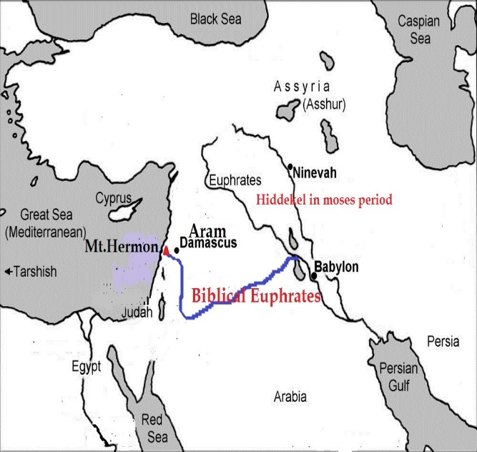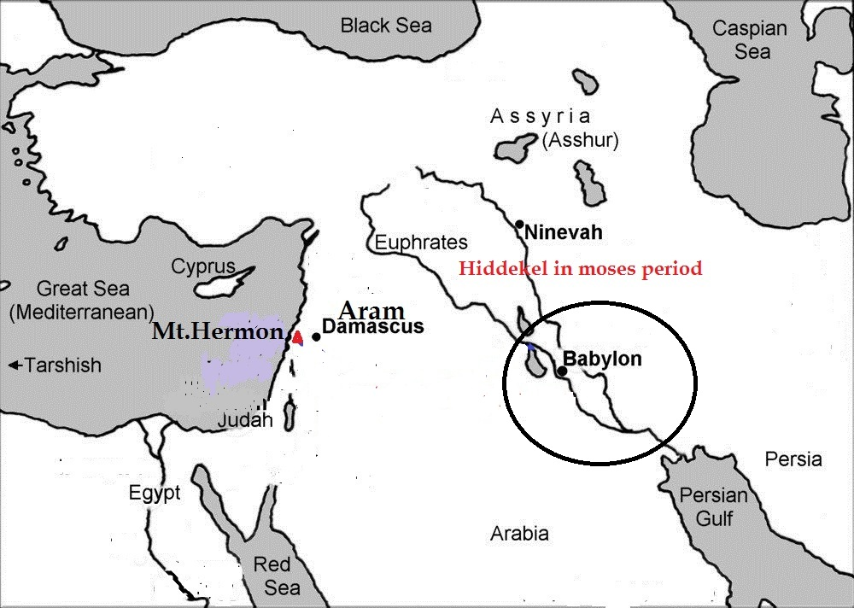

,d;W Xbf;nfhz;bUf;Fk; Ig;gpuhj;J kw;Wk; ilf;hP]pd; njd;ghjp kl;LNk VNjdpypUe;J cw;gj;jpahd cz;ikahd Ig;gpuhj;J kw;Wk; cz;ikahd ,njf;Nfy; MWfspd; topj;jlq;fshFk;. Ntjhfk Ig;gpuhj;Jk;> Ntjhfk ,njf;NfYk; VNjdpy; jilgl;l gpwF> ,njf;Nfypd; fpis ejpfs; Neuhf njw;F Nehf;fp Xb> njd; gFjpapy; gioa Ig;gpuhj;J kw;Wk; ,njf;Nfypd; topj;jlj;jpy; XbaJ. mjdhNyNa me;j ,uz;L MWfSf;Fk; Ig;gpuhj;J kw;Wk;> ,njf;Nfy; vd;w gioa ngah;fs; epiyj;jJ.

**ehd;F MWfSk; vg;NghJ kiwe;jd?**

vh;Nkhd; kiyapy; cw;gj;jpahfp> VNjd; Njhl;lj;jpd; topahf Xba ehd;F MWfSk; vg;gb XbaJ vd;gij Fwpj;Jk;> mitfs; vy;yhk; kiwe;JNghdJ vd;Wk; ehk; ,Jtiu ghh;j;Njhk;. mg;NghJ me;j MWfs; vg;NghJ kiwe;jd? vg;gb kiwe;jd? vd;gJ Fwpj;J NtjMjhuj;Jld; ghh;g;Nghk;.Ig;gpuhj;J jtpu kw;w vy;yh MWfSk; NkhNr fhyj;jpy; Xltpy;iy. me;j %d;W MWfSk; NkhNr fhyj;jpw;F Kd;dNu tw;wpaJ vd;W ghh;j;Njhk;. NkhNr fhyj;jpw;F Kd;dh; vg;NghJ tw;wpaJ? mJ NgNyF fhyj;jpNyNa tw;wpaJ. NgNyF nuFit ngw;w gpd;dh; 209 tUlk; kl;LNk capNuhL ,Ue;jpUf;fpd;whd; (Mjp:11:19). nuFit 30k; tajpy; ngw;wpUf;fpd;whd;. vdNt mtd; jdJ 239k; tajpy; khpj;Jg;Nghdhd;. NgNyFf;F Ke;ja jiyKiwapdh; vy;yhk; 400 tUlj;jpw;F Nky; tho;e;jpUf;fpd;whh;fs;. Mdhy; NgNyFf;F gpwF cs;sth;fs; midtUk; fpl;ljl;l 200 tUlk; kl;LNk caph; tho;e;jpUf;fpd;whh;fs;. mjd; gpwF xt;nthUtUila MASk; nfhQ;rk; nfhQ;rkhf Fiwe;Jnfhz;Nl te;jpUf;fpd;wJ. ,jpypUe;J NgNyF fhyj;jpy; VNjh xU khw;wk; Vw;gl;bUf;fpd;wJ vd;gij ek;khy; czuKbfpd;wJ. mJ vd;d khw;wk;? MWfs; mJtiu [Ptjz;zPiu nfhz;L te;Jnfhz;bUe;jd. vdNt mij Fbj;j kDf;Fyj;jpd; [Ptd; ePbj;jpUe;jJ. NgNyF fhyj;jpw;F gpwF fly; ePh; cl;GFe;jjhYk;> MWfs; kiwe;jjhYk;> fPNfhd; MW rpw;whwhf khwpajhYk; mtw;wpy; [Ptjz;zPh; ,y;yhky; NghdJ. vdNt mq;F tho;e;j kDf;Fyj;jpd; MAshdJ Fd;wpNghdJ. NgNyFtpypUe;J kDf;Fyj;jpd; MAshdJ Fiwe;JNghdjpypUe;J> mtd; fhyj;jpNyNa [Ptejpfshd VNjdpd; MWfs; (Ig;gpuhj;ij jtpu) kiwe;jd vd;gij ehk; cWjpgLj;jKbAk;.

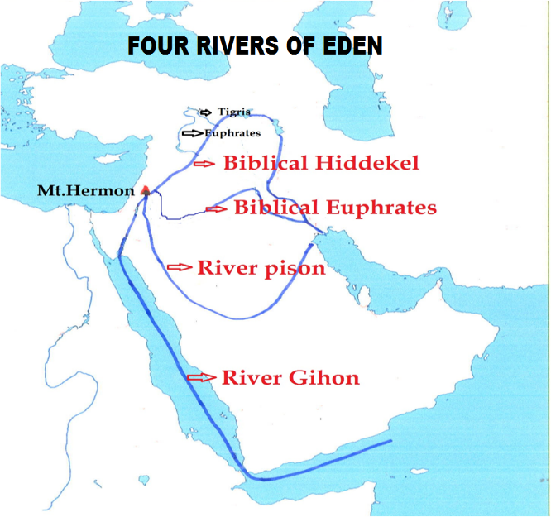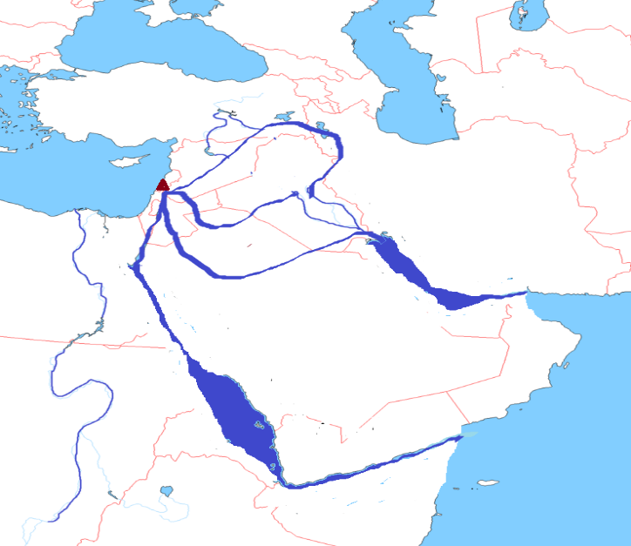

NgNyF fhyj;jpy; G+kp gFf;fg;gl;lJ (gpsTw;wJ) vd;W $wg;gl;bUf;fpd;wJ (Mjp:10:25). gFf;fg;gl;lJ vd;why; vd;d? mJtiu ,ize;jpUe;j epyg;gug;Gfs; gpse;J> flyhy; me;j gpsTfs; epug;gg;gl;L> flyhy; gphpf;fg;gLjNy G+kp gFf;fg;gLjyhFk;. NgNyF fhyj;jpw;F Kd;dh; mNugpa jPgfw;gKk; Mg;gphpf;fhTk; ,ize;Nj ,Ue;jd. ,uz;Lf;Fk; ,ilNajhd; fPNfhd; MW Xbf;nfhz;bUe;jJ. fypNyah fly;> rhf;fly; Nghy nrq;flYk; ,d;iwf;F ,Ug;gijtpl rw;W rpwpajhf xU ed;dPh; Vhpahf ,Ue;J fPNfhd; Mw;wpd; xU filrp VhpahfNt ,Ue;jJ. NgNyF fhyj;jpy; xU nghpa G+kp mjph;r;rp Vw;gl;L Mg;gphpf;fhtpw;Fk;> mNugpahtpw;Fk; ,ilNa G+kp gpsTw;wJ. mg;NghJ fPNfhd; MW flypy; fyf;Fk; ,lj;jpy; fly; ePh; cl;GFe;jJ. mg;NghJ fPNfhd; Mw;wpd; filrp VhpahdJ fly; ePuhy; epiwe;J nrq;flyhdJ. ,t;thNw nrq;fly; cUthdJ. me;j nrq;flNy mNugpahitAk;> Mg;gphpf;fhitak; gphpj;jJ. mj;Jld; fPNfhd; Mw;wpd; Xl;lj;jpYk; khw;wk; Vw;gl;L rpwpa Mwhfp> rhf;flYld; epd;WNghdJ. ,e;j rhf;flYk; cg;ghf ,Uf;f mg;NghJ G+kp gpse;J fPNfhd; Mw;wpd; topahf fly; ePh; cl;GFe;jNj fhuzkhFk;. kPjkhapUe;j fPNfhd; MWjhd; Nahh;jhd; Mwhf ,d;Wtiu Xbf;nfhz;bUf;fpd;wJ.

mNjNghy NgNyF fhyj;jpw;F Kd;dh; mNugpa jPgfw;gKk;> <uhDk; ,ize;Nj ,Ue;jd. ,it ,uz;bw;Fk; ,ilNa igNrhd;> Ig;gpuhj;J> ,njf;Nfy; Mfpa 3 MWfSk; ,ize;J Xbf;nfhz;bUe;jd. mjd; ,Wjpg; gFjpapy; mit xU Vhpia Vw;gLj;jpaJ. ,d;W ngh;rpa tisFlh vd;W miof;fg;gLk; flyhdJ xU fhyj;jpy; xU nghpa ed;dPh; VhpahfNt ,Ue;jJ. igNrhd;> Ig;gpuhj;J> ,njf;Nfy; Mfpa %d;W ejpfSk; ,ize;J ,e;j ed;dPh; Vhpia cUthf;fpapUe;jJ. NgNyF fhyj;jpy; G+kp gpsTgl;lNghJ ,e;j ed;dPh; VhpapNy xU gpsT Vw;gl;lJ. mjdhy; me;j %d;W MWfs; flypy; fyf;Fk; Kfj;Jthuk; topahf fly; ePh; cl;GFe;J me;j MWfs; cUthf;fpapUe;j nghpa ed;dPh; Vhpia epug;gp> ngh;rpa tisFlh cUthdJ. ,e;j ngh;rpa tisFlhNt <uhidAk;> mNugpahitAk; gphpj;jJ. mj;Jld; Ig;gpuhj;J ejpiaj; jtpu kw;w ,uz;L MWfSk; epd;W NghdJ.

NgNyF vd;gjw;F rpw;whW vd;W mh;j;jk; (brook). mtd; fhyj;jpy; Vw;gl;l G+kpapd; gpstpdhy; fly; ePuhdJ MWfs; topahf cs;Ns te;J> MWfspd; filrp Vhpfs; epuk;gp G+kp flyhy; gphpf;fg;gl;lJ. vdNt vNjdpypUe;J Xba nghpa 4 MWfspy; ,uz;L kiwe;J kw;w ,uz;Lk; (fPNfhd;> Ig;gpuhj;J) rpw;whWfshf khwpd. mtd; fhyj;jpy; G+kp gpse;J MWfs; rpw;whWfshf khWk; vd;gij Njtd; Vw;fdNt mwpe;jpUe;j fhuzj;jpdhy;jhd; rpw;whW vd;W nghUs;gLk; NgNyF vd;w ngaiu itf;Fk;gbf;F NgNyFtpd; jfg;gDf;F fl;lisapl;bUf;fyhk;. Ntjhfk ngah;fs; vy;yhNk mh;j;jk; cilaitfNs. ,g;gbahf NgNyF vd;w ngahpd; (rpw;whW) %yKk;> NgNyF fhyj;jpy; G+kp gFf;fg;gl;lJ vd;w trdj;jpd; %yKk;> NgNyF fhyj;jpypUe;J [dq;fSila mAs; Fiwanjhlq;fpaJ vd;w cz;ikapd; %yKk; NgNyF fhyj;jpy;jhd; VNjd; Njhl;lj;J ejpfs; kiwe;Jk;> rpWj;Jk; Nghapd vd;gij ek;khy; Ghpe;Jnfhs;s Kbfpd;wJ.

G+kp gpse;jjhy; MWfspd; Kfj;Jthuk; topahf fly; ePh; cs;NswpaJ. mjdhy; MWfs; rpw;whWfshf khwpd. rpy MWfs; kiwe;Jtpl;lJ. rhp. G+kp gpsTw;wjhy; MWfs; vg;gb kiwe;J Nghapd? G+kp gpsg;gjw;Fk; MWfs; kiwjYf;Fk; vd;d rk;ge;jk;? G+kp gpsg;G vd;gJ rhjhuzkhd tp\ak; my;y. G+kp gpsf;fNtz;Lnkd;why; vt;tsT nghpa G+kp mjph;r;rp Vw;gl;bUf;fNtz;Lk; vd;W Nahrpj;J ghUq;fs;. Mk; me;j fhyj;jpy; ekJ fw;gidf;F vl;lhj mstpw;F kpf gaq;fukhd epyeLf;fk; Vw;gl;bUf;Fk;. me;j G+kpajph;r;rpahdJ vh;Nkhd; kiyapYk; jhf;fj;ij Vw;gLj;jpapUf;Fk;. mjd; tpisthf VNjdpd; ejp cw;gj;jpahd vh;Nkhd; kiy kw;Wk; yPgNdhd; gs;sjhf;fpy; kpfg;nghpa khw;wk; Vw;gl;bUf;Fk;. me;j khw;wq;fspd; %ykhf vh;Nkhd; kiyapypUe;J cw;gj;jpahfpa igNrhd; kw;Wk;> ,njf;Nfy; MWfs; Kw;wpYkhf jilgl;bUf;Fk;. fPNfhd; Mw;wpw;F jz;zPh; tuj;J Fiwe;jpUf;Fk;. G+kp mjph;r;rpapdhy; vh;Nkhd; kiyapy; Vw;gl;l khw;wNk VNjdpd; MWfspy; rpy jilgLtjw;F fhuzkhFk;.

**Ig;gpuhj;J vg;NghJ kiwe;jJ?** VNjd; Njhl;lj;jpd; ,uz;L MWfs; (igNrhd;> ,njf;Nfy;) NkhNr fhyj;jpw;F Kd;dNu kiwe;Jtpl;lJ. fPNfhd; MW kl;Lk; Nahh;jhdhf RUq;fp Xbf;nfhz;bUf;fpd;wJ. Mdhy; NkhNr fhyj;jpYk;> mjd; gpwF 1000 tUlk; fopj;J vNukpah fhyj;jpYk; Ntjhfk Ig;gpuhj;J ejp kl;Lk; Xbf;nfhz;bUe;jJ. mJ ,g;NghJ ,y;iy. mJ vUrNykpw;F ,Wjp epahaj;jPh;g;G nfhLf;fg;gl;l fp.gp.135y; kiwe;jpUf;fyhk; vd;gJ vdJ mDkhdk;.

**VNjdpd; MWfs; kPz;Lk; Njhd;Wk;**

,g;NghJ VNjdpypUe;J Xba ehd;F ejpfSk; kiwe;Jtpl;lJ. fPNfhd; kl;Lk; Nahh;jhdhf rpWj;J Xbf;nfhz;bUf;fpd;wJ. kPz;Lk; ,e;j ehd;F ejpfSk; vh;Nkhd; kiyapy; Njhd;wp XLk; vd;W Ntjk; njspthf $Wfpd;wJ. mjw;fhd xU rpy trdq;fis ehk; ,g;NghJ ghh;g;Nghk;.

**igNrhd; MW kPz;Lk; Njhd;Wk; (NahNt:3:18):** igNrhd; MW kPz;Lk; cw;gj;jpahFk; vd;gjw;F xU Ntj trdj;ij Kjypy; ehk; ghh;g;Nghk;.xU Cw;W fh;j;jUila Myaj;jpypUe;J Gwg;gl;Lr; rpj;jPk; vd;Dk; gs;sj;jhf;if ePh;g;gha;r;ryhf;Fk;” vd;W NahNt:3:18y; $wg;gl;bUf;fpd;wJ. fh;j;jUila Myak; vd;gJ Njtd; thrkhapUf;Fk; ,lkhFk;. vUrNyk; Myaj;jpy; Njtd; thrkhapUe;jhh;. mJ ,bf;fg;gl;Ltpl;lJ. ,q;F nrhy;yg;gl;l fh;j;jUila Myak; vd;gJ ,d;iwa vUrNyk; my;y. ,d;iwa vUrNyk; xU rpW Fd;Wjhd;. mjpypUe;J MWfs; gputhfpj;J tuKbahJ. vdNt fh;j;jUila Myak; vd;gJ ,d;iwa vUrNyk; my;y vd;gij ehk; Kjypy; Ghpe;Jnfhs;sNtz;Lk;. NahNt:3:18y; $wg;gl;l fh;j;jUila Myak; vd;gJ vh;Nkhd; kiyapd; Nky; ,wq;fptu ,Uf;fpd;w guk vUrNykhFk;. Mjpfhyj;jpy; Njtd; Mjhk; Vths; kj;jpapNy thrkhapUe;jJNghy> kPz;Lk; Njtd; ,uz;lhk; Mjhkhfpa ,NaR kw;Wk; ,uz;lhk; Vthshfpa rigahh; kj;jpapy; thrkhapUg;ghh;. vdNt vh;NkhDk;> VNjDk; mg;NghJ fh;j;jUila Myakhf (fh;j;jh; thrkhapUf;Fk; ,lk;) ,Uf;Fk;.

fh;j;jUila Myaj;jpypUe;J Gjpjha; xU Cw;W Njhd;wp mJ rpj;jPk; gs;sj;jhf;if ePh;gha;r;ryhf;Fk; vd;W $wg;gl;bUf;fpd;wJ. rpj;jPk; Nkhthgpd; mUfpy; cs;sJ vd;W vz;:25:1 $Wfpd;wJ. Nahh;jhdpd; fpof;Nf xU ehs; gpuahz J}uj;jpy; cs;sJ vd;W NahR:3:1 $Wfpd;wJ. ,J Nahh;jhDf;F fpof;Nf cs;s xU gs;sj;jhf;fhFk;. rpj;jPk; gs;sjhf;if ePh;gha;ryhf;f Ntz;Lnkd;why; ,g;NghJ Vw;fdNt Xbf;nfhz;bUf;Fk; Nahh;jhidj; jtpu NtW xU MW vh;NkhdpypUe;J cw;gj;jpahf Ntz;Lk;. me;j MW fPNfhDf;F (Nahh;jhDf;F) fpof;fhf Xba> Mtpyh Njrj;ij Rw;wp Xba igNrhd; MwhfNt ,Uf;fNtz;Lk;. ,e;j trdj;jpd; %yk; igNrhd; MW kPz;Lk; vh;NkhdpypUe;J cw;gj;jpahFk; vd;gJ cWjpahfpd;wJ.

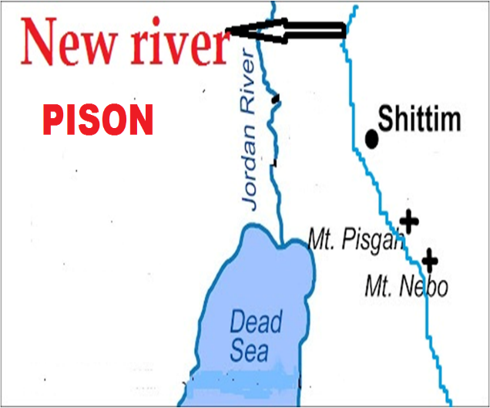

**ntsp:16:12>13:** ntspg;gLj;jy; 16k; mjpfhuk; KOtJk; ,];uNayh;fSf;fhd epahaj;jPh;g;G Fwpj;J NgRfpd;w xU mjpfhukhf ,Uf;fpd;wJ. mjpNy nfhLf;fg;gl;l VO thijfSk; ,];uNayh;fSf;F filrp fhyj;jpy; nfhLf;fg;NghFk; kfhcgj;jputq;fshFk;. mjpNy Mwhk; thij Cw;wg;gLk;NghJ ,NaR jpUlidNghy tUtjhf $wg;gl;bUf;fpd;wJ (,ij Fwpj;J ehk; gpd;dh; tphpthf ghh;g;nghk;). Mwhk; thijapd; fhyj;jpNyNa fpof;fpypUe;J tUk; uh[hf;fSf;F topia Maj;jg;gLj;jYf;fhf Ig;gpuhj;J ejpahdJ tw;wpg;NghdJ. vdNt Mwhk; thijf;F Kd;dNu Ig;gpuhj;J ejp cw;gj;jpahfpapUf;f Ntz;Lk;.

*Mwhk; J}jd; jd; fyrj;jpYs;sij Igpuhj; vd;Dk; nghpa ejpapd;Nky; Cw;wpdhd;@ mg;nghOJ #hpad; cjpf;Fe; jpirapypUe;JtUk; uh[hf;fSf;F top Maj;jkhFk;gb me;j ejpapd; jz;zPh; tw;wpg;Nghapw;W.*

*mg;nghOJ> tYrh;g;gj;jpd; thapYk; kpUfj;jpd; thapYk; fs;sj;jPh;f;fjhprpapd; thapYkpUe;J jtisfSf;F xg;ghd %d;W mRj;j Mtpfs; Gwg;gl;Ltuf; fz;Nld;.*

**Vrh:27:12:** Ig;gpuhj;J ejp kPz;Lk; Xlnjhlq;Fk; vd;gjw;F NtW xU trdj;ijAk; ehk; ,g;NghJ Mjhukhf ghh;g;Nghk;. Vrh:27:12y; “*mf;fhyj;jpNy> fh;j;jh; Mw;wq;fiuapd; tpisTnjhlq;fp vfpg;jpd; ejpkl;Lk; Nghubg;ghh;@ ,];uNty; Gj;jpuNu> ePq;fs; xt;nthUtuha;r; Nrh;f;fg;gLtPh;fs;”.*

Nghubj;jy; vd;gJ epahaj;jPh;g;G nfhLj;jyhFk; (fisAk;> NfhJik kzpAk; gphpf;fg;gLjy;). ,e;j trdj;jpy; ,];uNaYf;fhd epahaj;jPh;g;G Fwpj;J nfhLf;fg;gl;bUf;fpd;wJ. mJ ,dp tUk; epahaj;jPh;g;ghFk;. me;j epahaj;jPh;g;gpy; ,];uNaypy; kde;jpUe;jpath;fs; Njtuh[;[paj;jpy; epj;jpa [PtDf;F jFjpngWthh;fs;. kde;jpUe;jjhj ,];uNayh;fs; mopf;fg;gLthh;fs;.

ehk; Vw;fdNt ,];uNaypd; njd; vy;iy vfpg;jpd; ejp vd;Wk;> tl vy;iyahdJ Ig;gpuhj;J ejp vd;Wk; ghh;j;jpUf;fpd;Nwhk;. ,q;Fk; mNj tl njd; vy;iyfNs nfhLf;fg;gl;bUf;fpd;wd. ,q;F MW (Mw;wq;fiu tpisT) vd;W nfhLf;fg;gl;bUg;gJ ,];uNaypd; tl vy;iyapy; Xba Ig;gpuhj;J ejpNaahFk;. MW vd;whNy mJ Ntjhfkj;jpy; ,];uNaypd; tl vy;iyahf ,Ue;j Ig;gpuhj;J ejpiaNa Fwpf;Fk;. ,];uNaypd; tl vy;iyapypUe;J njd; vy;iy tiu epahaj;jPh;g;G elf;Fk; vd;W ,e;j trdj;jpNy $wg;gl;bUf;fpd;wJ. ,jpypUe;J ,];uNaYf;F epahaj;jPh;g;G njhlq;Fk; Kd;dh; vh;NkhdpypUe;J Ig;gpuhj;J ejp Xlnjhlq;fpapUf;Fk; vd;W ehk; cWjpahf ek;gyhk;. Ig;gpuhj;J ejp kPz;Lk; cUthjyhdJ filrp fhyj;jpw;fhd milahsq;fSs; kpfTk; Kf;fpakhdJ.

**ehd;F MWfSk; kPz;Lk; XLk; (ntsp:22:1):**

igNrhd;> kw;Wk; Ig;gpuhj;J ejp kl;Lk; kPz;Lk; XLk; vd;W ehk; vz;zf;$lhJ. ehd;F MWfSk; kWgbAk; XLk; vd;gjw;Fk; Ntj trdq;fs; ,Uf;fpd;wd. ntsp:22:1I ehk; Muha;e;J ghh;g;Nghk;. *“gpd;G> gspq;ifg;Nghy; njspthd [Ptj;jz;zPUs;s Rj;jkhd ejp NjtDk; Ml;Lf;Fl;bahdtUk; ,Uf;fpw rpq;fhrdj;jpypUe;J Gwg;gl;LtUfpwij vdf;Ff; fhz;gpj;jhd;”.* ntsp:22:11y; Njtd; thrkhapUf;Fk; Myakhfpa vh;Nkhd; kiyapypUe;J kPz;Lk; ejp cw;gj;jpahfpd;wJ vd;gJ Fwpj;J $wg;gl;bUf;fpd;wJ. Mjhk; fhyj;jpy; xNu MW kl;LNk vh;NkhdpypUe;J Gwg;gl;L mJ VNjd; Njrj;ij fle;J ehd;F MWfshf gphpe;J XbaJ. me;j xNu MW [Pt jz;zPUld; kPz;Lk; vh;Nkhd; kiyapYs;s> guk vUrNykpy; ,Ue;J Gwg;gLk; vd;W ntsp:22:1y; $wg;gl;bUf;fpd;wJ. ,e;j MW kPz;Lk; yPgNdhd; gs;sj;jhf;if fle;J ehd;F MWfshf khWk;. kPz;Lk; ehd;F MWfSk; cw;gj;jpahFk;. kPz;Lk; mjpy; [Ptjz;zPh; XLk;. mij Fbf;Fk; kf;fs; [PtNdhL ,Ug;ghh;fs;.

**VNjdpd; NtW ngah;fs;**

VNjd; Njhl;lk; vq;fpUe;jJ vd;Wk;> mjpypUe;J Xba ehd;F MWfs; vt;topahf XbaJ vd;Wk; ,Jtiu ehk; Ntj Mjhuj;Jld; ghh;j;Njhk;. VNjdhdJ Ntjj;jpy; gy;NtW ngah;fspy; miof;fg;gl;bUf;fpd;wJ. VNjDf;F Ntjk; vd;dnty;yhk; ngah; nfhLj;jpUf;fpd;wJ vd;gij ehk; ,g;NghJ ghh;g;Nghk;.

1.**vUrNykpd; vy;yh ngah;fSk; VNjDf;Fk;> vh;NkhDf;Fk; nghUe;Jk;:**

**vUrNyk;> guk vUrNyk;:** VNjdpy; Njtd; thrkhapUe;jhh;. mtiu Rw;wp NfUgPd;fs; ,Ue;jJ. mq;Nf MjhKk; VthSk; ,Uf;fNtz;Lk; vd;gJk; mq;fpUe;J mth;fs; mth;fsJ re;jjpaiuAk;> G+kpapd; rfy [PtuhrpfisAk; Mz;Lnfhs;sNtz;Lk; vd;gJ NjtDila jpl;lkhFk;. Mdhy; MjhKk; VthSk; tpOe;JNghdjhy; NjtdJ jpl;lkhdJ nray;ghl;bw;F tuhky; Ngha;tpl;lJ. vdNt Njtd; xU ,ul;rpg;gpd; jpl;lj;ij Vw;gLj;jpdhh;. me;j ,ul;rpg;gpd; jpl;lj;jpy; ,uz;lhk; Mjhkhf ,NaRitAk;> ,uz;lhk; Vthshf rigahiuAk; Vw;gLj;jpdhh;. mth;fs; %yk; jilgl;l jdJ jpl;lj;ij Njtd; njhlu Mjhik rpU\;bf;Fk; Kd;dNu jpl;lk; jPl;b itj;jpUe;jhh;. Vnddpy; Mjhk; tpOe;JNghthd; vd;gJ mtid rpU\;bf;Fk; Kd;dNu NjtDf;F njhpAk;. vdNt cyfNjhw;wj;jpw;F Kd;dNu Ml;Lf;Fl;bahd ,NaRitAk;> rigahiuAk; Njtd; ,uz;lhk; MjhkhfTk;> ,uz;lhk; VthshfTk; epakpj;J mth;fis VNjdpNy thrkhapUf;fr; nra;J mth;fs; %ykhf Mjhkpd; re;jjpaiu Mz;Lnfhs;s Njtd; rpj;jk; nfhz;lhh;. Mjhk; Vthisg;Nghy mth;fs; VNjdpNy ,Ue;Nj ,ul;rpf;fg;gl;l Mjhkpd; re;jjpaiu MsNtz;Lk; vd;gNj NjtDila jpl;lkhFk;. guNyhfj;jpypUe;J MSif nra;tnjy;yhk; xU jw;fhypf Vw;ghLjhd;. ,uz;lhk; cyfk; KbtilAk;tiu ,NaRTk; rigahUk; guNyhfj;jpypUg;ghh;fs;. ,uz;lhk; cyfk; Kbtile;jTld; ,th;fs; %d;whk; cyfj;ij (Nkrpahtpd; uh[;[pak;> Njtuh[;[pak;) MStjw;F guNyhfj;jpypUe;J ,wq;fp tUthh;fs;. mJNt guk vUrNyk; guNyhfj;jpypUe;J ,wq;fptUjyhFk;. ,];uNaypd; jiyefUk; vUrNyk; vd;W miof;fg;gLfpd;wJ. vh;Nkhd; kiykPJ ,wq;f ,Uf;fpd;w ,NaRTk; rigAk; Nrh;e;j mikg;Gk; gukvUrNyk; vd;W miof;fg;gLfpd;wJ.

**gioa vUrNyk;> Gjpa vUrNyk;:** Njtd; Muk;gj;jpy; ,];uNaypd; jiyefuhd vUrNykpy; thrkhapUe;jjhh;. Njtuh[;[pak; G+kpapy; ];jhgpf;fg;gl;l gpwF Njtd; vh;NkhdpYs;s guk vUrNykpy; thrkhapUg;ghh;. vdNt mJ Gjpa vUrNyk; vd;W miof;fg;gLk; (ntsp:21:2).

**rPNahd; (vh;Nkhd;):** vUrNyk; rPNahd; vd;W miof;fg;gLfpd;wJ. VNjDk; (vh;Nkhd; kiy) rPNahd; vd;W miof;fg;gLfpd;wJ vd;gij ehk; Vw;fdNt tphpthf ghh;j;Jtpl;Nlhk;.

**ghpRj;j efuk;:**

vUrNykhdJ ghpRj;j efuk; vd;W miof;fg;gl;lJ (neNf:11:1@ Vrh:48:2). vh;Nkhdpy; ];jhgpf;fg;gLk; guk vUrNyKk; ghpRj;j efuk; vd;W miof;fg;gLk; (ntsp:21:2@ 22:19).

**fh;j;jhpd; gh;tjk; (mountain of LORD):** vUrNykpw;F fh;j;jUila gh;tjk; vd;w ngah; ,Uf;fpd;wJ (Vrh:30:29@ rf:8:3). VNjDk; (vh;NkhDk;) fh;j;jUila gh;tjk; vd;W miof;fg;gLfpd;wJ (Vrh:2:2>3). Njtd; xU gh;tjj;jpy; thrkhapUe;jhy;jhd; mJ fh;j;jUila gh;tjk; vd;W miof;fg;gLk;. Njtd; vUrNyk; kiyapy; cs;s Myaj;jpy; thrkhapUe;jjhy; vUrNyk; fh;j;jUila gh;tjk; vd;W miof;fg;gl;lJ. mNjNghy Mjhk; Vths; ghtk; nra;Ak; Kd;dh; Njtd; vh;Nkhd; kiyapy; thrkhapUe;jjhy; mJTk; fh;j;jUila gh;tjk; vd;W miof;fg;gl;lJ. ,dp tUq;fhyj;jpYk; mt;thNw miof;fg;gLk;.

**Njtgh;tjk; (Mountain of God):** vUrNykpw;F Njtgh;tjk**;** vd;Wk; xU ngah; ,Uf;fpd;wJ (jhdp:9:20). Njtd; thrkhapUf;fpd;w vy;yh kiyAk; Njtgh;tjk; vd;W miof;fg;gLk;. me;jtifapy; Njtd; thrkhapUe;j vh;NkhDk; Njtgh;tjNk (vNr:28:14). rPdha; kiyapNy (XNug;) Njtd; thrkhapUe;J ,];uNayh;fSf;F epahag;gpukhzj;ij nfhLj;J> mth;fis topelj;jpajhy;> ,];uNayh;fs; me;j kiyapy; Njtid Muhjid nra;jjhy;> rPdha; kiyahfpa XNug; kiyf;Fk; Njtgh;tjk; vd;W ngah; ,Uf;fpd;wJ (ahj;:3:1>12). ePq;fs; ,e;j %d;W kiyfisAk; (vh;Nkhd;> vUrNyk;> rPdha;) tiuglj;jpNy tiue;J ghh;j;jPh;fnsd;why; ,e;j %d;W kiyfSk; xNu Neh;Nfhl;by; ,Uf;Fk;.

**ghpRj;j gh;tjk;:** ghpRj;j gh;tjk; vd;w ngah; vUrNykpw;F cz;L (jhdp:9:16@NahNt:2:1). ,];uNaypd; cah;e;j kiyjhd; jdJ ghpRj;j kiy vd;W Ntjk; $Wfpd;wJ (vNr:20:40). vh;Nkhd; kiyNa ,];uNaypy; kpfcah;e;j kiy (vUrNyk; kiy my;y). ,jpypUe;J VNjdpYs;s vh;NkhDk; ghpRj;j gh;tjk; vd;W miof;fg;gLfpd;wJ vd;gJ ekf;F GhpatUfpd;wJ. jPU uh[hit ghpRj;j gh;tjj;jpy; itj;Njd; vd;W Njtd; $Wfpd;whh; (vNr:28:14). jPU uh[hthdtd; vh;Nkhd; kiyia Mz;lijNa ,e;j trdk; Fwpf;fpd;wJ. VNjdpYs;s vh;Nkhd; kiyf;Fk; ghpRj;j gh;tjk; vd;w ngah; ,Uf;fpd;wJ vd;gjw;F ,J $Ljy; MjhukhFk;.

**NjtDila efuk;** vUrNyk; NjtDila efuk; vd;W miof;fg;gLfpd;wJ. mJNghy VNjDk; NjtDila efuk; vd;W miof;fg;gLfpd;wJ (vgp:12:22@ rq;:46:4@ 48:1>2).

**fh;j;jUila Myak; (House of the LORD** -rq;:92:13@ NahNt:3:18): ,];uNaypd; jiyefuhfpa vUrNykpypUf;Fk; MyakhdJ fh;j;jUila Myak; vd;W miof;fg;gLk;. NjtDila uh[;[pak; vh;NkhdpNy ];jhgpf;fg;gLk; (guk vUrNyk;). guk vUrNykhfpa me;j fh;j;jUila Myaj;jpypUe;J xU MW Gwg;gLk; vd;W NahNt:3:18y; $wg;gl;bUf;fpd;wJ. Njtd; thrkhapUf;Fk; ,lNk fh;j;jUila MyakhFk;. vUrNyk; Myaj;jpy; Njtd; thrkhapUe;jjhy; mJ fh;j;jUila Myak; vdg;gl;lJ. RtpNr\ Afj;jpy; rigahhplj;jpy; Njtd; thrkhapUe;jjhy; rigahh; jdpg;gl;l Kiwapy; fh;j;jUila Myakhf ,Ue;jhh;fs;. Njtuh[;[pak; vh;NkhdpNy ];jhgpf;fg;gLk;NghJ mq;Nf ,Ue;j guk vUrNykpy; Njtd; thrkhapUg;gjhy; vh;NkhDk; fh;j;jUila Myak; vd;W miof;fg;gLk;.

vUrNykpw;Fk;> VNjDf;Fk; gy ngah;fs; xd;WNghyNt ,Uf;Fk;. jPh;f;fjhprdq;fis ehk; tpahf;fpahdk; gz;Zk;NghJ vUrNyik Fwpf;fpd;wjh my;yJ VNjid (guk vUrNyik) Fwpf;fpd;wjh vd;W Muha;e;J tpahf;fpahdk; nra;aNtz;Lk;.

**2.ahNtapd; Njhl;lk; (****garden of LORD):**

VNjd; Njhl;lj;jpy; Njtd; thrkhapUe;jjhy; mJ ahNt Njtdpd; Njhl;lk; vd;Wk; miof;fg;gl;lJ. Mq;fpyj;jpy;garden of LORD vd;W nfhLf;fg;gl;bUf;Fk; (ahNt vd;w ngaNuLORD vd;W nkhopngah;j;jpUf;fpd;whh;fs;) mjdhy;jhd; gpw;fhyq;fspy; VNjidg;Nghy nropg;ghf ,Ue;j gFjpfs;> Njrq;fs; vy;yhk; ahNt Njtdpd; Njhl;lk; Nghy ,Ue;jjhf Ntjj;jpy; $wg;gl;lJ (Mjp:13:10@ Vrh:51:3).

**3.NjtDila Njhl;lk; (garden of God):**

Njtd; thrkhapUe;j Njhl;lkhjyhy; mJ NjtDila Njhl;lk; vd;W miof;fg;gl;lJ (vNr:28:13@ 31:8>9).

**4.gujPR: paradise (ntsp:2:7@ 2nfhhp:12:3@ Y}f;:23:43):**

gujPR vd;gJ VNjd; Njhl;lj;ij Fwpf;f gad;gLj;jg;gl;bUf;fpd;wJ. pardes vd;w vgpNua thh;j;ijahdJ tdk; vd;W neNf:2:8Yk;> rpq;fhu tdk; vd;W gpu:2:5Yk;> cd;:4:13y; Njhl;lk; vd;Wk; nfhLf;fg;gl;bUf;fpd;wJ. nropg;ghd Njhl;lk; vd;gjhy; vgpNua nkhopapy; VNjd; Njhl;lkhdJ gujPR vd;W miof;fg;gl;lJ. ntsp:2:7y; “gujPrpd; kj;jpapypUf;fpw [PttpUl;rj;jpd; fdpiag;Grpf;ff; nfhLg;Ngd;”; vd;W nfhLf;fg;gl;bUf;fpd;wJ. VNjdpd; kj;jpapy;jhd; [PttpUl;rk; ,Ue;jJ. vdNt gujPR vd;why; vgpNua nkhopapYk;> fpNuf;f nkhopapYk; VNjNd.

**5.thdk; (guNyhfk; - Heaven)**

Mq;fpyj;jpy; n`td; vd;W nkhopngah;f;fg;gl;l vy;yh ,lj;jpYk; jkpo; Ntjj;jpNy guNyhfk; my;yJ thdk; vd;W nkhopngah;f;fg;gl;bUf;Fk;. guNyhfkhfpa thdj;jpy; Njtd; thrkhapUg;ghh;. mq;F mth; thdJ}jh;fspd; kj;jpapy; thrkhapUg;ghh;. VNjd; vd;gJ guNyhfj;jpd; (thdj;jpd;) xU rpW khjphp. guNyhfj;jpy; thdJ}jh;fSf;fhf mth;fs; kj;jpapy; Njtd; thrk;nra;tJNghy VNjDk; kdpjh;fs; kj;jpapy; Njtd; thrk;nra;tjw;F rpU\;bf;fg;gl;l ,lkhFk;. mJ xU rpW guNyhfk; vd;gjhy; VNjDk; gy ,lq;fspy; thdk; (guNyhfk;) vd;W miof;fg;gLfpd;wJ.

**Vrh:14:13>14@** *“ehd; thdj;Jf;F VWNtd;> NjtDila el;rj;jpuq;fSf;F Nkyhf vd; rpq;fhrdj;ij cah;j;JNtd;@ tlGwq;fspYs;s Muhjidf; $l;lj;jpd; gh;tjj;jpNy tPw;wpUg;Ngd; vd;Wk;*

*ehd; Nkfq;fSf;F Nkyhf cd;djq;fspy; VWNtd;@ cd;djkhdtUf;F xg;ghNtd; vd;Wk; eP cd; ,Ujaj;jpy; nrhd;dhNa”*

**“**thdj;jpw;F VWNtd;” vd;w trdkhdJ ghgpNyhd; uh[h jPU uh[htpd; Njrj;ij ifg;gw;wpajhy; mtDf;F Vw;gl;l ngUikiaf; Fwpj;J $wg;gl;l jPh;f;fjhprdkhFk;. NeGfj;Ner;ruhdtd; jPU kPJ gilnaLj;J jPU vd;Dk; jPitj;jtpu mtdplkpUe;j kw;w vy;yhg; gFjpfisAk; ifg;gw;wpdhd;. jPUit ifg;gw;w Njtd; mtid mDkjpf;ftpy;iy. mjw;F gjpy; vfpg;ij <Lfpuakhff; nfhLf;fpd;whh;(vNr:29:18-21). NeGfj;Ner;rh; jPU uh[htplkpUe;J VNjid (vh;NkhidAk; mjid rhh;e;j gFjpfisAk;) ifg;gw;wpajd; %yk; thdj;jpw;F Vwpdhd; (VNjid ifg;gw;WjNy thdj;jpw;F VWjy;). ,jd; %yKk; VNjDf;F thdk; vd;w xU thh;j;ijAk; Ntjj;jpNy gad;gLj;jg;gl;bUf;fpd;wJ vd;gij ehk; njhpe;Jnfhs;syhk;.

**thdk; vdJ rpq;fhrdk;> G+kp vdJ ghjgb (Vrh:66:1@ mg;:7:49):**

kdpjh;fs; kj;jpapy; NjtDila thr];jyk; VNjdpy; ];jhgpf;fg;gLk; (ntsp:21:3). mq;Nfjhd; NjtDila rpq;fhrdk; ,Uf;Fk; (ntsp:22:1>3). vdNt thdk; vdJ rpq;fhrdk; vd;why; VNjd; NjtdJ rpq;fhrdk; vd;W mh;j;jkhFk;. G+kp vd;why; ,];uNay; NjrkhFk; (Vrh:60:13).

**thdj;jpd; ehd;F jpirfs;:**

jhdp:11:4y**;** mnyf;]hz;lhpd; uh[;[pak; thdj;jpd; ehd;F jpirfspYk; gFf;fg;gLk; vd;W $wg;gl;L ,Uf;fpd;wJ. Ntjj;jpy; jpirfs; vd;gJ VNjid ikakhff;nfhz;Nl Fwpg;gplg;gLfpd;wd vd;W ehk; Vw;fdNt ghh;j;jpUf;fpd;Nwhk;. ,q;Fk; thdk; vd;gJ VNjidNa Fwpf;fpd;wJ.

Nkw;nrhd;d trdq;fis ehk; Muha;e;J ghh;j;J VNjd; vd;gjw;F Ntjj;jpy; thdk; (guNyhfk;) vd;w xU thh;j;ijAk; nfhLf;fg;gl;bUf;fpd;wj vd;gij ehk; Ghpe;Jnfhs;syhk;. thdk; (guNyhfk;) vd;gjw;F gy mh;j;jq;fs; ,Uf;fpd;wJ. mjpy; xU mh;j;jkhdJ VNjdhFk;.

**6.cah;e;j kiy:**

VNjdpYs;s vh;Nkhd; kiyia Ntjk; cah;e;j kiy vd;Wk; $Wfpd;wJ. ehk; ,d;W ,];uNaypYs;s vy;yh kiyfspd; cauj;ij mse;J ghh;j;jhYk; vh;Nkhd; kiyjhd; caukhd kiyahfTk; ,Uf;fpd;wJ. ,ij Fwpj;J $wg;gl;bUf;Fk; rpy trdq;fis ,g;NghJ ehk; ghh;g;Nghk;.

**vNr:17:22:***fh;j;juhfpa Mz;lth; nrhy;YfpwJ vd;dntd;why;: ehd; cah;e;j NfJUtpd; Edpf;fpisfspy; xd;iw vLj;J> mij eLNtd;@ mjpd; ,sq;fpisapYs;s nfhOe;Jfspy; ,srhapUf;fpw xd;iwf; nfha;J> mij cauKk; cd;djKkhd xU gh;tjj;jpd;Nky; ehl;LNtd;.*

NfJUtpd; Edpf;fpis vd;gJ ghgpNyhd; uh[;[paj;ijf; Fwpf;Fk;. caukhd kiyapNy eLNtd; vd;why; vd;d mh;j;jk;? VNjid cs;slf;fpapUf;Fk; ,];uNay; Njrj;ij ghgpNyhdhy; ifg;gw;wr;nra;Ntd; vd;gNj ,jd; mh;j;jkhFk;. ,q;F caukhd kiy vd;gJ vh;Nkhd; kiyahfpa VNjidNa Fwpf;Fk;. ,e;j trdkhdJ VNjid cs;slf;fpa ,];uNaiy MSif nra;tjw;F ghgpNyhd; uh[;[paj;jpw;F xg;Gf;nfhLj;jiyf; Fwpg;gjhf ,Uf;fpd;wJ. VNjid cs;slf;fpa ,];uNaiy ghgpNyhDf;F xg;Gf;nfhLj;jNy cah;e;j kiyapy; NfJUtpd; Edp fpisia eLjyhFk;.

**Vrh:13:2*.*** *“cah;e;j gh;tjj;jpd;Nky; nfhbNaw;Wq;fs;@ cuj;j rj;jkpl;L [dq;fis tutioAq;fs;@ mth;fs; gpuGf;fspd; thry;fSf;Fs; gpuNtrpg;gjw;Fr; irif fhl;Lq;fs;”.* Vw;fdNt cah;e;j gh;tjkhfpa vh;Nkhdpy; ,Uf;Fk;ghgpNyhid mopf;f Nkjpa ngh;rpa uh[htpw;F Njtd; nfhLf;Fk; miog;Ng ,q;F $wg;gl;bUf;fpd;wJ. vdNt cah;e;j kiy vd;gJ VNjdpy; cs;s vh;Nkhd; kiyNa.

**kj;:4:8:** “*kWgbAk;> gprhR mtiu kpfTk; cah;e;j kiyapd;Nky; nfhz;LNgha;> cyfj;jpd; rfy uh[;aq;fisAk; mitfspd; kfpikiaAk; mtUf;Ff; fhz;gpj;J”*

Nrhjidapy; rhj;jhd; rhPugpufhkhf ,NaRit kiyapd; cr;rpf;F nfhz;L NghapUf;f KbahJ. ghpRj;jMtpia ngw;w xU kdpjid rhj;jhd; jdJ ,\;lj;jpw;nfy;yhk; Ml;btpf;f KbahJ. ,NaRTk; rhj;jhd; $g;gpLk; ,lj;jpw;nfy;yhk; NghFk; msTf;F gytPdkhd kdpjdy;y. ,NaRtpd; kdjpy; VNjd; Njhl;lj;jpy; mth; kfpikaile;j epiyapy; ,Uf;Fk; uh[;[paj;jpd; fhhpaq;fis rhj;jhd; mtuJ epidtpy;nfhz;L te;jpUg;ghd;. rhj;jhdhdtd; jhprdj;jpy; ,NaRit (kd vz;zj;jpy;) vh;NkhDf;F nfhz;LNghdhd; vd;gJjhd; rhpahd fUj;jhf ,Uf;fKbAk;. me;j VNjdpd; uh[;[pakhdJ G+kp KOtJk; cs;s uh[;[paq;fis MSifnra;af;$ba uh[;[pakhFk;. vdNt kdjpd; vz;zj;jpy; VNjdpd; uh[;[paj;ij (%d;whk; cyfj;jpy; ,NaRthy; Msg;gLk; uh[;[pak; kw;Wk; mjd; kfpik) fhl;LjNy “rh;tuh[;[paj;ijAk; mjd; kfpikiaAk; fhl;LjyhFk;”. ,NaR khk;rj;ij gypnra;Jjhd; me;j uh[;[paj;ij ngwNtz;Lk;. rhj;jhid gzpe;Jnfhz;lhy; ehk; vspjpy; khk;rj;ij Nkw;nfhs;shky;> gypfspypy;yhky; uh[;[paj;ij Rje;jhpj;Jf;nfhs;sshk; vd;w Nahridiaj;jhd; rhj;jhd; ,NaRtpw;F mq;F Nrhjidahf nfhz;Lte;jhd;. ,NaR me;j NrhjidiaAk; Nkw;nfhz;lhh;. VNjdpNyjhd; Njtuh[;[pak; ];jhgpf;fg;glNghfpd;wJ vd;gijNa mJ fhl;Lfpd;wJ. ,q;Fk; cah;e;j kiyahdJ vh;Nkhd; mlq;fpa VNjidNa Fwpf;fpd;wJ.

**kj;:17:1.** “*MWehisf;Fg; gpd;G> ,NaR NgJUitAk; ahf;NfhigAk; mtDila rNfhjudhfpa NahthidAk; $l;bf;nfhz;L jdpj;jpUf;Fk;gb cah;e;j kiyapd;Nky; Ngha;”* ,NaR fypNyah fliy fle;J gpypg;G nrrhpahtpw;F Ngha; (kj;:16:13) mq;fpUe;J vh;NkhDf;F nrd;Wnfhz;bUf;Fk;NghJjhd; mth;fsJ rP\h;fSf;F mtNu fpwp];J vd;W Njtdhy; ntspg;gLj;jg;gl;lJ. mjpypUe;J Mwhk; ehs;jhd; ,NaR jdJ rP\h;fis $l;bf;nfhz;L cah;e;j kiyf;F Nghfpd;whh;. nrrhpahtpw;F kpf mUfpNyNa vh;Nkhd; ,Uf;fpd;wJ. ,NaR kW&gkhd kiy vh;Nkhd; kiyjhd; vd;W vy;yh fpwp];jt Muha;rpahsh;fSk; Vw;Wf;nfhs;fpd;whh;fs;. mg;.NgJUTk; jhq;fs; me;j jhprdj;ij ghpRj;j kiyapy; fz;Nlhk; vd;W $Wfpd;whh; (2NgJ:1:18). ghpRj;j kiy vd;why; mJ vh;Nkhd; kiy vd;W ehk; Vw;fdNt ghh;j;jpUf;fpd;Nwhk;. me;j ghpRj;j kiyahfpa vh;Nkhd; kiyjhd; kj;:17:1y; cah;e;j kiy vd;W nfhLf;fg;gl;bUf;fpd;wJ.

Nkw;nrhd;d trdq;fisnay;yhk; Muha;e;J ghh;f;Fk;NghJ cah;e;j kiy vd;gJ vh;Nkhid Fwpf;Fk; vd;W ehk; Ghpe;Jnfhs;syhk;.

**7.rpq;fhu Njrk;:**

VNjDf;F rpq;fhu Njrk; vd;Wk; xU ngah; Ntjj;jpNy $wg;gl;bUf;fpd;wJ. jhdpNay; fhyj;jpw;F gpwF VNjd; vd;w ngah; ,y;yhky; Ngha;tpl;lJ. jhdpNay; fhyj;jpypUe;J Nghpd;gk; nfhLf;ff;$ba> nropg;ghd Gy;ntspfs; epiwe;j me;j VNjd; NjrkhdJ rpq;fhu Njrk; vd;W miof;fg;gl;lJ.

**jhdp:8:8-12 “rpq;fhu Njrj;jpw;F vjpuhfTk; nghpjhapw;W”:** jhdp:8:9k; trdj;jpy; “mitfspy; xd;wpypUe;J rpd;djhd xU nfhk;G Gwg;gl;lJ” vd;W $wg;gl;bUf;fpd;wJ “mitfs;” vd;gJ mnyf;rhz;lhpd; ehd;fhf gphpf;fg;gl;l uh[;[paj;jpy; xd;wpypUe;J vd;gjhFk;. mJ Nfhgj;jpd; KbTf; fhyj;jpy; rk;gtpg;gJ vd;W $wg;gl;bUg;gjhy; mJ fz;bg;ghf mnyf;rhz;lh; uh[;[paj;jpw;F mLj;J te;j Nuhk uh[;[pak; fhyj;jpy; rk;gtpf;Fk; fhhpak; ,y;iy. vnddpy; Nuhk uh[;[pakhdJ mnyf;rhz;lhpd; me;j ehd;F gphpTfSf;Fs;NsNa mlq;fhJ. Vnddpy; mnyf;rhz;lh; Nuhik ifg;gw;wNt ,y;iy. mg;gbahdhy; mnyf;rhz;lhpd; uh[;[paj;jpd; ehd;F gphpTfspy; xd;wpypUe;J vOk;gpa rpd;dnfhk;G vJ? mJ fp.gp.1948y; ];jhgpf;fg;gl;l ,];uNayhFk;. mnyf;rhz;lhpd; ehd;fhf gphpf;fg;gl;l njd;jpir uh[;[paj;jpypUe;Nj me;j rpd;d nfhk;ghfpa ,];uNay; Njrk; vOe;jJ. 1948y; me;j ehlhdJ ,d;W ,Ug;gijtpl rpwpajhfNt ,Ue;jJ. mJ MW ehs;Nghhpy; fpof;Nf Nkw;Ffiuia ,izj;Jf;nfhz;lJ. tlf;Nf Nfhyd; i`l;il ,idj;Jf;nfhz;lJ. Nfhyd; i`l;lhdJ rpq;fhu Njrkhd VNjdpd; xU gFjpNa. ,];uNay; ,d;dKk; tlf;NfAk;> fpof;NfAk;> Nkw;NfAk; tphptila ,Uf;fpd;wJ. VNjd; KOtJk; (rphpahtpd; jk];Ftpw;F njw;Nf cs;s gFjp> ,d;iwa nygdhdpy; njw;F gFjp) ,];uNaYf;F tu ,Uf;fpd;wJ. VNjid ,];uNay; ,izj;Jf;nfhs;SjNy rpq;fhuNjrj;jpw;F vjpuhfTk; nghpjhapw;W vd;W nfhLf;fg;gl;bUf;fpd;wJ. ,jd; xU gFjp fp.gp.1967y; epiwNtwptpl;lJ. xU gFjp ,d;dKk; epiwNtw ,Uf;fpd;wJ (vh;Nkhd; kiyia gpbf;Fk;NghJ mJ epiwNtWk;). vdNt VNjNd rpq;fhu NjrkhFk;. ,e;j nra;jpia ehd; tPbNahthf NgRk;NghJ vh;Nkhid ,];uNay; gpbf;ftpy;iy. ,e;j Gj;jfj;ij vOjpnfhz;bUf;Fk; xU thuj;jpw;F Kd;dh; ,];uNay; rphpahtplkpUe;J vh;Nkhd; kiyia ifg;gw;wpaJ. vdNt ,g;NghJ rpq;fhu Njrj;jpw;F vjpuhf nghpjhapw;W vd;w jPh;f;fjhpkhdJ epiwNtwptpl;lJ.

**jhdp:11:16:**“*Mifahy; mtDf;F tpNuhjkhf tUfpwtd; jd; ,\;lg;gbr; nra;thd;@ mtDf;F Kd;ghf epiyepw;gtd; xUtDk; ,y;iy@ mtd; rpq;fhukhd Njrj;jpy; jq;Fthd;@ vy;yhk; mtd; iftrkhFk;”* %d;whk; me;jpNahf]; Fwpj;J ,e;j trdk; $Wfpd;wJ. mnyf;]hz;lUf;F gpwF nrY}f;f]; uh[;[paNk VNjid ifg;gw;wp itj;jpUe;J (rpy fhyk; Ntz;Lkhdhy; mJ vfpg;jpd; iftrk; ,Ue;jpUf;fyhk;). Mdhy; %d;whk; me;jpNahf]; VNjdpy; jdJ Mjpf;fj;ij epiyepWj;jpdhd;. VNjid %d;whk; me;jpNahf;f]; ifg;gw;Wfpd;w fhhpaNk “rpq;fhu Njrj;jpy; jq;Fthd;” vd;W $wg;gl;bUf;fpd;wJ. ahh; VNjid ifg;gw;wpapUf;fpd;whh;fNsh mth;fSf;Nf NjtDila fpUigAk;> mq;fPfhuKk; ,Uf;Fk; vd;gjhy; ,e;j rpq;fhu Njrj;ij ifg;gw;Wjiyf; Fwpj;J Ntjk; mOj;jkhf $Wfpd;wJ. VNjd; mtd; iftrkhdjhy; NjtDila fpUig mtDf;F jpUk;gpaJ. vdNt mtd; fhhparpj;jp cilatdhf ,Ug;ghd;. vy;yhk; mtd; iftrkhFk;.

VNjDf;Fk; mjpylq;fpa vh;Nkhd; kiyf;Fk; Ntjj;jpNy ,j;jid NtWngah;fs; nfhLf;fg;gl;bUf;fpd;wd.

**VNjid MSjypd; Kf;fpaj;Jtk;**

cld;gbf;ifapd; Afj;jpy; (,];uNaypa Afk;) VNjdpy; ,Uf;fNtz;bath;fs; ,];uNayh;fNs (cld;gbf;ifapd; [dq;fNs). Mdhy; mth;fsJ mf;fpukj;jpd; epiwtpdpkpj;jk; ,];uNaypa Afj;jpy; gyNeuq;fspy; Gw[hjpfs; VNjid Mz;lhh;fs;. VNjd; (vh;Nkhd; kiy) ahhplk; ,Uf;fpd;wNjh mth;fs; Njtdhy; MrPh;tjpf;fg;gl;lth;fs;. Njtdhy; mq;fPfhpf;fg;gl;lth;fs;. mth;fNs ,];uNaYf;F epahaj;jPh;g;G nfhLg;gjw;Nfh my;yJ ,];uNaiy MrPh;tjpg;gjw;Nfh Njtdhy; epakpf;fg;gl;lth;fs; vd;W mh;j;jkhFk;. mth;fs; NjtDila fUtpfshf epakpf;fg;gl;lth;fs;. MdhYk;; ,];uNayh;fs; kPJ fhpridNahLk;> NjtDf;F Kd; jho;ikNahLk; ,Uf;Fk;tiujhd; me;j Gw[hjpfSf;F VNjDk;> NjtDila mq;fPfhuKk;> MrPh;thjKk; jq;Fk;. VNjd; xU Gw[hjpapdkplkpUe;J gpLq;fp kw;w Gw[hjpaDf;F nfhLf;fg;gLfpd;wJ vd;why; NjtDila mq;fPfhuk; mtdplkpUe;J kw;wtDf;F khw;wg;gLfpd;wJ vd;W mh;j;jkhFk;.

ghgpNyhd; uh[;[pakhdJ VNjid ifg;gw;wpaNghJ jhq;fs; NjtDila fUtpfNs vd;w jho;ikapy;yhky; thdj;jpw;F VwpNdd; vd;W ngUik nfhz;ljpdpkpj;jk; (Vrh:14:13>14) VNjd; Nkjpangh;rpa uh[;[paj;jpw;F khw;wg;gLfpd;wJ. ghgpNyhDf;F Nkjpah;fs; %yk; epahaj;jPh;g;G nfhLf;fg;gl;lJ. Nkjpa ngh;rpa uh[;[pakhdJ ,];uNayh;fSf;F RahjPdk; nfhLj;Jtpl;ljhy; VNjd; ,];uNayh;fs; trk; te;jJ. vdNt Nkjpa ngh;rpa uh[h fhyj;jpy; ,];uNay; NjtDila mq;fPfhuk; ngw;wjhfTk;> NjtDila MrPh;thjj;ij ngw;wjhfTk; ,Ue;jJ. mnyf;]hz;lh; (fp.K.333) kw;Wk; mnyf;]hz;lUf;F gpd;te;j nrY}f;f]; uh[;[paj;jpd; NghJk; (fp.K.322) rpq;fhu Njrkhd VNjd; mth;fs; iff;F khwpaJ. (jhdp:8:8-12). mnyf;]hz;lUk;> nrY}f;f]; uh[;[paKk; NjtDila mq;fPfhuk; ngw;wjhfTk;> NjtDila fUtpahfTk;> Njtdhy; MrPh;tjpf;fg;gl;lth;fshfTk; ,Ue;jhh;fs;. mjd; gpwF ,];uNaiy kf;fNgah;fs; Mz;lhh;fs;. kf;fNgah; MSiff;F gpwF vh;Nkhd; kiyahdJ Nuhkh;fs; iff;Fg;NghdJ. Nuhkh;fs; Njtdhy; MrPh;tjpf;fg;gl;lth;fshfTk;> mq;fPfhpf;fg;gl;lth;fshfTk;> NjtDila fUtpahfTk; ,Ue;jhh;fs;. Njtd; ,e;j Nuhkh;fs; %yhfNt ,];uNaYf;F ,];uNaypa Afj;jpd; (cld;gbf;if [dq;fspd; Afk;) Kbtpy; epahaj;jPh;g;G nfhLj;jhh;. ,e;j fhhpaNk kj;:24k; mjpfhuj;jpy; gjpTnra;ag;gl;bUf;fpd;wJ.

VNjid ifg;gw;wp itj;jpUe;j Nkw;nrhd;d vy;yhUNk NjtDila fUtpahf mf;fhyj;jpy; gad;gLj;jg;gl;lhh;fs;. vdNt mth;fs; fhhpa rpj;jp cilath;fshf ,Ue;jhh;fs;. mjd; gpwF (,];uNaypa Afj;jpw;F gpwF) VNjid Mz;lth;fSf;F NjtDila mq;fPfhuk; ,Ue;jjh vd;gij MuhAk; nghWg;ig thrfh;fsplNk tpl;LtpLfpd;Nwd;.

* fp.gp.313- 636 Byzantine rule
* fp.gp.636-1099 Arab rule
* 1099-1291 crusader domination (latin kingdom of Jerusalem)
* 1291-1516 Mamluk rule (vfpg;J Ry;jhd; uh[;[pak;)
* 1517-1917 ottoman rule
* 1918-1948 British rule

1948y; ,];uNayh;fSf;F NjtDila fpUig jpUk;gpaJ. vdNt ,];uNay; vd;w xU Njrk; cUthdJ. ,g;NghJ VNjd; Njhl;lj;jpd; xU gFjp kl;LNk (Nfhyd; i`l;) ,];uNayplk; ,Uf;fpd;wJ. ,g;NghJ NjtdJ fpUig nfhQ;rk; nfhQ;rkhf ,];uNaYf;F jpUk;gpf;nfhz;bUf;fpd;wJ. vdNt ntFtpiutpy; ,];uNayhdJ vh;Nkhdpd; kPjKs;s gFjpfisAk; rphpahtplkpUe;J ifg;gw;Wk; vd;W ehd; cWjpahf ek;Gfpd;Nwd; (,e;j Gj;jfj;ij ehd; tPbNahthf NgRk;NghJ vh;Nkhd; kiy rphpah trk; ,Ue;jJ. fle;j thuk; ,];uNayhy; vh;Nkhd; kiy ifg;gw;wg;gl;l). nygdhd; kw;Wk; rphpahtpd; kPJ ,];uNay; Nghh; njhLf;Fk;NghJ vh;Nkhdpd; kPjp cs;s nrhw;g;g gFjpfSk; ,];uNaYf;F fpilj;JtpLk; (,ij ehd; tPbNahthf NgRk;NghJ ,];uNay NjrkhdJ; nygdhd; kPNjh> rphpah kPNjh Nghh; njhLf;ftpy;iy).